Student Handbook

RHS Level 2 Certificate in the Principles of Plant Growth and Development

## Online, self-paced, start anytime

### Two-year enrolment

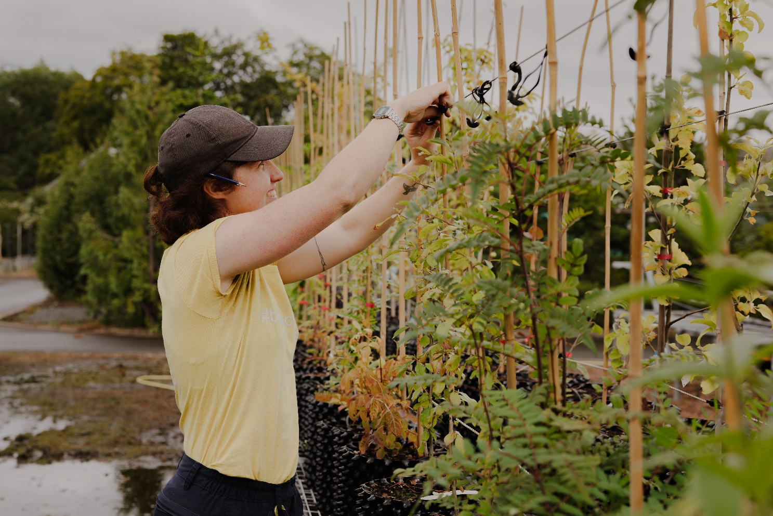

Photographer: Eilidh Cameron

Table of Contents

Welcome 3

1. Course structure 4

2. Course format 4

3. Course content 6

4. Learning online 9

5. Examinations 13

6. Entry requirements 14

7. Course costs 14

8. How to register 15

9. Terms and conditions 15

# Welcome

Welcome to the Royal Botanic Garden Edinburgh. This document gives you information on the RHS Level 2 Certificate in the Principles of Plant Growth and Development online course.

The RHS Level 2 awards are among the most widely regarded entry-level horticulture qualifications. This course is the ideal starting point or first qualification for those wishing to pursue a career or business in any branch of horticulture or garden design. It is also great for leisure gardeners who would like to expand their knowledge and have it formally assessed.

The award of the RHS Level 2 Certificate in the Principles of Plant Growth and Development is based on written examinations. These are externally set and marked by the RHS. The certificate is accredited by OFQUAL (The Office of Qualifications and Examinations Regulation) in England and Wales.

When you complete the course, you may be able to develop your skills further through our range of other courses such as the HN or BSc in Horticulture with Plantsmanship.

This handbook introduces you to the RHS Level 2 course at the Royal Botanic Garden Edinburgh. We hope it answers all your questions, but please don’t hesitate to contact us at the details below if you have any further queries.

|  |  |
| --- | --- |
| Logo | Biodiversity Education and Training Department 20a Inverleith Row Edinburgh  EH3 5LR, [rbge.org.uk/rhslevel2](http://www.rbge.org.uk/rhslevel2)  [rhslevel2@rbge.org.uk](mailto:rhslevel2@rbge.org.uk) |

The Royal Botanic Garden Edinburgh is a charity (registration number SC007983)

# 1. Course structure

The RHS Level 2 Certificate in the Principles of Plant Growth and Development is a course made up of two units, each of which has one exam associated with it. Both exams need to be passed to gain the qualification. You need to achieve 50% in each unit examination.

This course is a theory Certificate and is designed to be combined with the RHS Level 2 Certificate in Practical Horticulture. Together, these qualifications make up the Level 2 Certificate in the Principles and Practices of Horticulture. Please note that we do not deliver the RHS Level 2 Certificate in Practical Horticulture, and our own Certificate in Practical Horticulture does not count towards the RHS award.

Each unit contains four topics, and each topic contains between four and seven elements. Each of these topics covers a broad subject area, with the elements focusing on particular aspects within that area.

We provide you with a complete set of course resources and learning support to help you pass the exams.

# 2. Course format

We now offer weekly enrolments to this online course, meaning you can start at a time that suits you. We will upload new students once a week so you may need to wait a few days after payment for access.

You can then work at your own pace - we give you access to the online course for **two years.** You can contact tutors with questions at any time, and we will respond within three working days, normally much sooner!

This course is assessed by the two online unit exams. You need to opt-in to register for each exam when you are ready to do so. Exams take place in February, June and October.

## How much time do I need to dedicate to this course?

The RHS has estimated that the **Guided Learning Hours** for this course are 120 hours. This time includes all study time covered by the course materials we provide, tutor support via forums, and exam time.

The RHS has estimated that the **Total Qualification Time** required for learners to study this Certificate is 180 hours (around 90 hours per unit). This includes everything covered by the Guided Learning Hours, plus the time learners use for self-study.

As a guide, if you wish to complete the course in one year, we recommend that you commit to four hours per week on average – this includes guided learning as well as self-study.

For example, if you start in October 2025 and spend four hours studying each week, you can aim to sit the first exam in June 2026 and the second exam in October 2026.

This is just an example, and you can of course work at a faster or slower pace, whichever is convenient for you. We will provide you with guidance and suggested study plans. **You have access to the course for two years.**

## Is all content available to me immediately?

You will receive access to the first topic immediately. Thereafter you will work in order through the remaining topics where each one opens up after completion of a knowledge test to ensure you are ready to proceed.

## What if I need more time?

* There will be the option to pay and register for extended access to the online materials, should you require access beyond the two years. You may also need to pay an additional RHS registration fee. Please see the full Terms and Conditions for more details.

# 3. Course content

This course is designed to give you the knowledge and understanding of horticulture needed to:

* Begin a career in horticulture
* Develop a current career in horticulture
* Develop transferable skills
* Progress to further learning

The course Assessment Outcomes break down how the subjects in the course are covered and how each will be assessed. There are three broad categories of assessment outcomes, which are:

* AO1 – knowledge recall of scientific ideas, processes, techniques, procedures, and making correct use of terms, symbols and units of measurement
* AO2 – application of knowledge, concepts, theories and facts to different situations and contexts, through presentation of reasoned explanations, and analysis and interpretation of information and ideas
* AO3 – application of knowledge and understanding in an integrated and holistic way in order to reach conclusions and make judgements and recommendations

The Assessment Outcomes and other detailed course information are available to view in the [RHS qualification specification](https://www.rhs.org.uk/education-learning/pdf/qualifications/level-2/level-2-cert-in-the-principles-of-plant-growth.pdf) (this link will download a file). It is very important to read through the qualification specification as this details what the course will cover and what information and skills you need to learn to pass the exams. It will also help you decide if this course is right for you.

## 3.1 Topic descriptors

All these topics are studied in the context of health and safety, sustainability, professional best practice, and equality and diversity.

### 

### **Unit 1**

#### Topic 1 - Plant Science 1

This is an introduction to plants, how they are named, described, and identified, their internal and external structures and their functions. This topic provides a foundation to build on for the rest of the course. We look at photosynthesis, respiration, pollination, fertilisation and the movement of water and nutrients within the plant – the processes that allow a plant to survive. Knowledge of these processes allows us to choose or create the environment in which a plant will thrive.

#### Topic 2 - Plant Health

In this topic, we look at the factors that affect plant health, including the weather and climate, the environment in a greenhouse, pests, weeds and diseases. We look at how to prevent plant health problems and what to do when they arise. Plant health is a fast-moving area of horticulture with the introduction of new pests and diseases and the increasing resistance to existing controls.

#### Topic 3 - Plant Nutrition

In this topic we look at the nutrients that plants need to grow and thrive. The soil provides plants with nutrients, so we begin by focusing on soil types and the maintenance of healthy soil. We learn about the essential nutrients that plants need and how plants use and obtain them. Finally, we learn about the ingredients that can be included in growing media, their benefits and limitations, and their environmental impacts.

#### Topic 4 - Plant Specification

When creating a garden or designed landscape, it is important that the site and the plants are well-suited to each other. Though it is possible to make some changes to a site to allow the growing of plants that are less suited to it, it may be better to choose sites and plants that work well together without too much intervention, to reduce the inputs needed. As well as looking at plant selection, planting and care, we look at sourcing and specifying plants in good condition, taking into account biosecurity and the sustainability of how they are grown and transported.

### 

### **Unit 2**

#### Topic 1 - Plant Science 2

Plants have adapted to a wide range of environments. This is achieved through modifications to their lifecycles, and adaptations to their leaves, stems, roots, flowers, seeds and growth habits that allow them to survive. In this topic we look at the range of plant adaptations, their role in plant survival and their garden merit. We see how plant breeders have enhanced plant adaptations to optimise aesthetic value, disease-resistance, and productivity.

#### Topic 2 - Planting Styles

Gardens and designed landscapes take a huge range of forms. This topic introduces garden styles from the Renaissance to the present day, short-term plantings, as well as edible landscapes. We will look at the concepts of formal and informal planting, the characteristics that define different garden styles, and how to use plants functionally and to create an attractive and cohesive garden. Through the unit we consider the effects on biodiversity and how we can use gardens to tell stories about history and heritage.

#### Topic 3 - Horticulture and Society

This topic looks at the role of horticulture in wellbeing, the environment, the economy and community. We look at the social and health benefits of gardening and nature in historical as well as modern-day contexts. The positive and negative impacts of horticulture on the environment are explored. We look at the effect of climate change, sustainable practices and how horticulture can have a net positive effect on the world. We look at key sectors in the UK horticultural industry and consider their economic impact and the additional value they bring to social inclusion, health and wellbeing, biodiversity and reduced crime. Community horticulture projects and their benefits are investigated.

#### Topic 4 - Biodiversity

In this topic, we focus on biodiversity, what it is and why it is important. We look at the impact horticulture can have on biodiversity, both positive and negative, and how we can create habitats to encourage diversity. We consider how climate change is affecting both new and existing plantings and how we can make gardens more resilient to a changing climate. We look at how changes to biodiversity are monitored and reported through citizen science projects and species surveys.

# 4. Learning online

The course is accessed via our online learning platform, PropaGate Learning. You will have your own account created, and you will log into this site to access your course. PropaGate Learning allows you to study from anywhere with an internet connection, and is a place for learning, for discussing topics and communicating with your tutors and fellow learners.

Most of the course is delivered via asynchronous distance learning, meaning you can study the materials at a time that suits you – you are not required to log in at a specific time and there are no deadlines for the submission of work.

Occasional live sessions are offered to assist you with exams. Students do find these helpful for exam preparation and we recommend you come along if you can. They will be recorded for anyone who can’t attend at the time.

The course itself consists of lessons, activities, discussions, quizzes, practice exam questions and additional resources such as videos and links to useful sources of further information. A sample element, [Pollination and fertilisation](https://propagatelearning.rbge.ac.uk/course/view.php?id=386) is available for you to review online so you can review the types of resources that will be offered. Enter the key ‘Anther24’ to gain access.

We aim to make all our course lessons and resources as accessible as possible. We include captions for videos and create online resources in line with accessibility standards. We also provide additional Microsoft Word versions of lessons for you to keep and download for viewing offline.

PropaGate Learning is available 24/7. Occasionally, site maintenance is required, however, we will ensure this is communicated in advance.

## 4.1 How can I prepare for studying online?

With this course being entirely online, you will need to be a competent computer user with a basic understanding of standard computer applications. Familiarity with browsing and navigating websites, engaging in online forums/discussions, reading/editing word processing documents and viewing media will stand you in good stead for learning online.

Our [Help and support for online learning](https://propagatelearning.rbge.ac.uk/course/view.php?id=273)  pages will help you to identify any digital skills you may need to brush up on.

When you are first given access to PropaGate Learning, please take time to complete the ‘Getting started with online learning’ and ‘Course overview’ lessons. These will give you an essential introduction to the tutors on your course, finding your way around, advice on learning independently and the best ways to communicate with tutors and other learners.

Online courses require a much more self-motivated learning style than traditional attended classes. You should plan to set aside dedicated time per week to log into the course lessons and carry out activities.

Participation in online discussions is also a key part of the course. Online learning can be more sociable than you might think!

## 4.2 What hardware or software will I need?

You will need a desktop or laptop computer. While most of the course will be accessible via a mobile device, we recommend using a laptop or desktop computer. You may find many aspects of the course easier to use on a computer. It will **not** be possible to sit the exams using a mobile phone or tablet. Please keep your device up to date.

You will need an up-to-date internet browser such as Google Chrome, Microsoft Edge or Safari. You will also need software that will open Word documents. Most importantly, you will need a reliable, strong internet connection suitable for streaming videos.

A laptop or desktop computer, a reliable internet connection and a webcam will be required for sitting online exams.

### System requirements for the online exams

More information will be sent to you closer to the exams

* The latest version of Google Chrome or Microsoft Edge
* A screen resolution of at least 1280x800
* An internet speed of at least 1mbps per candidate
* A webcam (minimum 320x240 VGA resolution)
* At least 2GB of free RAM
* At least 250MB of free disk space
* Processor (CPU) – minimum 1.5GHz
* Operating system – Windows 10+, MacOS12+

The RHS uses two pieces of software for online exams. Cirrus assessment is the actual platform that hosts the examination, and Proctorio is the invigilation software that is used to meet the regulatory requirements to run online examinations in an appropriate manner.

Candidates will be invigilated online using the Proctorio software and you will be asked to install the Proctorio extension on your browser. The system will guide you through setting this up. Proctorio offers a helpdesk which is accessed through a live chat, they can help candidates who experience problems setting up the Proctorio software or who experience connection issues during their exam.

Candidates will have their identities verified using the online system.

The set-up process will check that you have the minimum system requirements to run the software and there is no software running in the background to interfere with the exam test.

## 4.3 Support for learners

We encourage everyone to make the most of the course forums. They provide a way for you to talk to one another and to ask tutors and learning technologists questions. They are also used to share information about exam registration and other course-related news. You can contact us directly by email if you need to.

Our PropaGate Learning team of learning technologists are available if you ever feel you are stuck with a course-related technical problem. They can be contacted via the forums or by emailing [propagate@rbge.org.uk](mailto:propagate@rbge.org.uk) and aim to reply within one working day (with the exception of Christmas and public holidays).

# 5. Examinations

This qualification will be entirely assessed by a written examination for each unit. Examination one will cover unit 1 (topics 1 - 4) and examination two will cover unit 2 (topics 1 – 4). In each examination, all assessment outcomes specified in the unit will be covered.

If RHS examinations are not passed, then you will not be awarded an RHS Qualification and will not receive a formal certificate. In addition, you will not be able to state achievement to employers if you are looking to enter the industry as a career. Course providers are not permitted to issue a certificate of attendance or statement of participation for RHS courses.

## 5.1 Exam format

The RHS use two pieces of software for online exams. Cirrus assessment is the actual platform that hosts the examination, and Proctorio is the invigilation software which the RHS need to use to meet the regulatory requirements to run online examinations in an appropriate manner.

Candidates will be invigilated online using the Proctorio software, you will be asked to install the Proctorio extension on your browser. Candidates’ identities will be verified using the online system. For more information, please read section 4.2 above.

The set-up process will check that you have the minimum system requirements to run the software, and you haven’t anything running in the background to interfere with the exam test. More information will be made available in the lead-up to the exams.

## 5.2 Registering for exams

We will contact you in advance of the registration deadline - we ask all students to confirm whether they wish to opt-in or opt-out of each round of exams. You must opt in to sit an exam, so it is very important you respond.

## 5.3 Examination fees

The exam registration and online registration fees for one sitting of unit 1 and unit 2 exams are included in the course fees. If you need to re-sit either of the units, the RHS has additional fees of £85 plus the online registration fee of £20 per re-sit. If you later decide not to sit exams, we will not be able to refund the exam fees.

## 5.4 Examination dates

The exams run three times a year, usually in early October, early February and late June. We will announce the exact dates as soon as the RHS confirm.

# 6. Entry requirements

The RHS Level 2 Certificate does not require any existing qualifications or experience. All you need is an interest in the subject and a commitment to set aside time each week and keep to the pace of the course. We are looking for keen, enthusiastic people of all ages, who would value the opportunity to study with us online at the Royal Botanic Garden in Edinburgh.

We do advise that you should have some basic confidence using websites, as the course makes use of PropaGate learning, our online learning environment. You must be self-motivated, have access to the internet and have an e-mail account.

# 7. Course costs

The fee for the full course is £975. This is payable on acceptance to the course. Unfortunately, it is not possible pay for this course in instalments.

Course fees include access to the online course materials, tutor support via forums and email, as well as the following exams and RHS registration:

* Exam and Certification Fees for unit 1 and unit 2 (£160, £80 per exam)
* Online Exam Administration Fee (£40, £20 per exam)
* Learner Registration Fee (£20)

These fees are set by the RHS and paid to them on your behalf at the start of your course.

# 8. How to register

To register and pay please complete the [course registration form](https://forms.office.com/e/eMbxrURcxF) which will be available on the webpage from 9.00am on Wednesday 1st October 2025/

Please contact us by email at [rhslevel2@rbge.org.uk](mailto:rhslevel2@rbge.org.uk) if you have any questions.

# 9. Terms and conditions

* The Royal Botanic Garden Edinburgh (RBGE) reserves the right to cancel this course
* RBGE cannot be liable for additional costs incurred in the event of cancellation.
* If the course does not go ahead, any money paid to the RBGE would be refunded in full.
* Fees will not be refundable should you not complete or pass the course.

## Course completion / Extensions

There will also be the option to pay and register for extended access to the online materials for a further two exam sittings should you need it, to help you complete your exams. The fee for the extension is £150. This may be subject to RBGE and RHS fees. You can extend your studies only once.

## What if I change my mind?

You will receive a refund minus a £50 administration fee if you withdraw from the course within 14 days of access.

If you wish to exercise your right to cancel, you must inform us of your decision within the 14-day cancellation period. Cancellation by email is effective from the date on which you send us your message.

Fees will not be refundable should you not complete or pass the course.

### Privacy Notice

RBGE will process your personal data for the administration of your course, to create your account on PropaGate Learning and to take payment (where relevant). RBGE will also process your personal data to inform you of any updates to the course, the admissions procedure, course dates, as well as any special offers.

### Live sessions

A few live pre-exam sessions will be offered during this course. We use Microsoft Teams to deliver these sessions. We record these so that that other students can catch up if they are unable to attend. If you are an attendee/student, you may have the option of sharing your image and audio during the session. If you choose to do so, this will be captured in the recording. Some events will feature a chat. If you choose to interact with the chat, your comments may be published to others at the event and may also form part of the recording.

For more information see our [privacy notice](https://www.rbge.org.uk/privacy-notice/education-privacy-notice/).