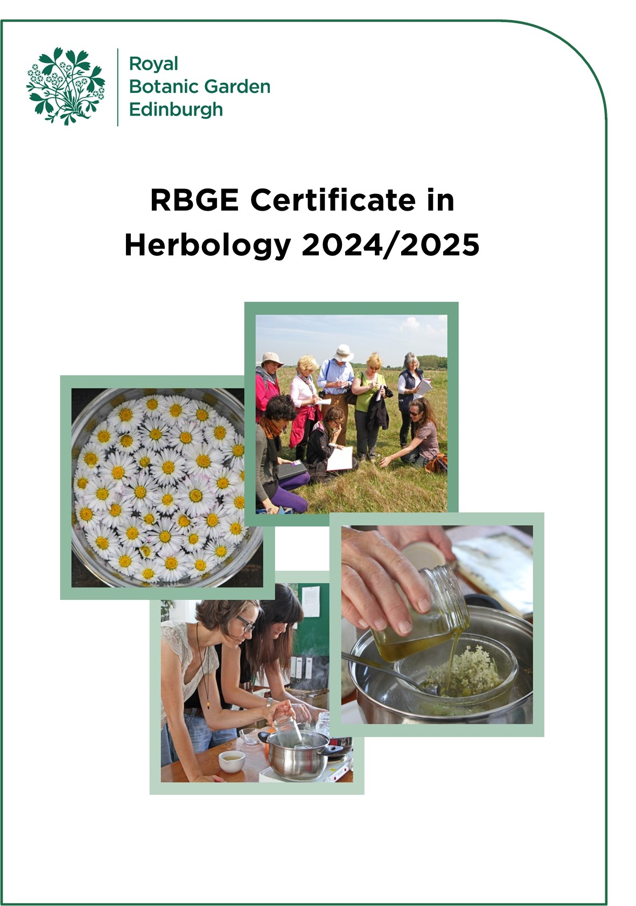
RBGE Certificate in Herbology Handbook 2024-25

Introduction

The RBGE Certificate in Herbology is a great way to learn about medicinal plants – how to find, recognise and use them. The focused content of this ten day programme takes you on a journey through some of the more intriguing moments to be found within the history of Western Herbal Medicine, and these are used as inspiration for further study and research, combined with a complementary physic garden visit, wild herb gathering and the exploration of a myriad of different herbal habitats.

This is the perfect way to begin to develop your Materia Medica (knowledge of healing botanicals), botanising and green pharmacy (herbal remedy making). It will also provide the perfect steppingstone for those wishing to progress on to the RBGE Diploma in Herbology or simply further existing knowledge after completing one or more of our introductory herbal programmes.

As with all the Herbology programmes being delivered here at RBGE, the Certificate in Herbology affords a wonderful opportunity to study herbs in one of the most holistic of environments – the Garden itself. The practical content of the course is intended to be uniquely therapeutic, from the mixing and making of herbal remedies, to herb gathering walks, and especially our field trips to explore medicinal plants in wild habitats.

RBGE Diploma in Herbology

This course will introduce you to many of the key RGBE Diploma in Herbology subjects of study and will give you the ‘herbal’ confidence required to make the most of your further studies in this field. If you wish to progress onto the Diploma, further details may be found by visiting our website: www.rbge.org.uk/dipherb

Contents

1. Course Structure 4
2. Dates, Times & Location for 2024/25 5
3. Methods of Assessment & Submission of Work 6
4. Study Subject Descriptors 10
Complementary Study Subjects 11
Green Pharmacy Remedy 12
Medicine Wheel Garden Design 13
Physic Garden Horticulture … (Not Assessed) 14
5. Attendance & Missed Class Procedure 15
6. Equipment & Ingredients Required 15
7. Course Fees 15
8. Application Procedure 16
9. Terms and Conditions 17

Cover photos by Brenda White

1. Course Structure

The RBGE Certificate in Herbology runs for 10 full days over 5 designated weekends August – December 2024 or February – May 2025.

The course presents students with a selection of research-based and practical projects that will take in many of the Garden’s ‘wild’ herb and arboreal collections.

Each day of the course will comprise a balanced mix of illustrated talks or demonstrations and self-directed study, along with practical activities including remedy-making, visits and field trips. The history of Western Herbal Medicine will be covered throughout the course with especial reference to the unique contributions of such defining figures as Galen, Culpepper and Dr Edward Bach.

Students will also learn how to approach the design of a theoretical ‘Medicine Wheel Garden’ based on a bespoke collection of herbs and directly referencing a chosen holistic tradition.

Students who attend all ten classes and complete the work required for their assessment are awarded the RBGE Certificate in Herbology.

2. Dates, Times & Location for 2024/25

All Herbology courses are taught in our dedicated Herbology Room at Royal Botanic Garden Edinburgh. Unless advised otherwise please enter via main reception at 20a Inverleith Row, EH3 5LR and do contact us if you have any special access requirements.

On occasions you will need to walk through or beyond the gardens, (e.g. for herb gathering), and do please also note that field trips where considerable walking may be required will take place outside the Botanics, and that these are a key feature of this particular Herbology course.

Option 1

Autumn 2024

Week | Dates | Time
Weekend 1 | Saturday 31st August &  Sunday 1st September 2024 | Sat: 10am – 4pm  Sun: 10am – 4pm
Weekend 2 | Saturday 28th &  Sunday 29th September 2024 | Sat: 10am – 4pm  Sun: 10am – 4pm
Weekend 3 | Saturday 26th &  Sunday 27th October 2024 | Sat: 10am – 4pm  Sun: 10am – 4pm
Weekend 4 | Saturday 16th &  Sunday 17th November 2024 | Sat: 10am – 4pm  Sun: 10am – 4pm
Weekend 5 | Saturday 14th &  Sunday 15th December 2024 | Sat: 10am – 4pm  Sun: 10am – 4pm

Option 2

Spring 2025

Week | Dates | Time
Weekend 1 | Saturday 1st &  Sunday 2nd February 2025 | Sat: 10am – 4pm  Sun: 10am – 4pm
Weekend 2 | Saturday 1st &  Sunday 2nd March 2025 | Sat: 10am – 4pm  Sun: 10am – 4pm
Weekend 3 | Saturday 29th &  Sunday 30th March 2025 | Sat: 10am – 4pm  Sun: 10am – 4pm
Weekend 4 | Saturday 26th &  Sunday 27th April 2025 | Sat: 10am – 4pm  Sun: 10am – 4pm
Weekend 5 | Saturday 17th &  Sunday 18th May 2025 | Sat: 10am – 4pm  Sun: 10am – 4pm

3. Methods of Assessment & Submission of Work

The RBGE Certificate in Herbology is a formally assessed course and therefore requires students to successfully pass assignments in order to achieve the award.

The 4 pieces of work that need to be completed to achieve your Certificate are:
- Herbal Journal (not assessed)
- 8 Complementary Study Assignments
- Medicine Wheel Garden Design
- Green Pharmacy Remedy

3.1 Submission of Work
All work must be completed and submitted for assessment during the final weekend of the course, with the exception of your Green Pharmacy Remedy, which is to be prepared in class on the final Saturday morning.

The course concludes with an informal and collective presentation of all student work completed throughout the preceding 5 months.

3.2 The Herbal Journal (not assessed)
As part of your non-assessed work for the Certificate in Herbology you are asked to compile a Herbal Journal, a hand written compilation of your own herbology experiences.

Ideally, this is something that should be completed regularly to form a compendium of all your notes, complementary research, herbaria, green pharmacy recipes, physic garden horticulture and herbology observations, together with any related articles, cuttings, visual images etc.
Most importantly, it should be a book of reflections on your learning.

Herbal Journals afford a creative medium of expression for your own herbology experiences throughout the course.

3.3 Complementary Study Assignments
(70% of the assessment grade)

You will be asked to complete eight Complementary Study Assignments (CSAs) to augment your learning in key subjects of study, these will include:

- Entheogenic & Sacred Herbs
- The Humours, Herbaria & Theriaca
- Flower Essence Remedies
- Glasshouse Materia Medica
- Herbal Candies & Confections
- Native Woodland Herbs
- Herbal Elixirs
- Seashore Botanicals or Physic Garden Botanicals (depending on season)

3.4 Medicine Wheel Garden Design
(20% of assessment grade)

To complement your studies, you are asked to design a theoretical ‘Medicine Wheel’ Garden.
This should be accompanied by a detailed Plant List of all the herbs that are included in your design and the reasons for their selection.
You will be asked to consider the following points while creating this design:

- Choice of Herbs
- Colours & Structures
- Sensory perception/stimulation (e.g. fragrance from aromatic herbs)
- Focal features
- Ecology (e.g. are you creating a wildlife sanctuary for honeybees or other creatures?)
- References to one or more of the healing traditions or themes covered during the course (e.g. Humoral Medicine, the 17th Century Apothecary, Bach Flower Remedies, Sacred Healing Herbs)
- The therapeutic nature of your garden as a whole

3.5 Green Pharmacy Remedy
(10% of assessment grade)

On the penultimate morning of the course, you will be asked to make a herbal remedy - adapting a simple recipe already explored in class. This forms part of your assessed work and takes the form of a self-directed practical.

Preparatory research will need to be undertaken at home during the previous weeks, when your recipe, and choice of ingredients to be used, will be agreed with your tutor.

You are expected to experiment and practise your remedy-making skills at home throughout the course and bring your own ingredients for the Green Pharmacy assessment session. Your course tutor will be able to advise on suppliers and quantities – and on any ingredients that may be available from Herbology supplies. All equipment for the assessment session will be provided by RBGE.

3.6 Final Assessment Weekend
On the final weekend of the course, all students are required to give a simple table-top presentation of their own course work to their fellow herbologists and tutor/s. This is an essential element of the programme and enables students to receive valuable feedback and guidance for their future development and herbal endeavours.

Mornings:
- Green Pharmacy (Remedy Making)) Self-Directed Practical
- Green Pharmacy Assessment

Afternoons:
- Table-Top Presentations
- Group & Tutor Feedback
- Submission of Completed Work

3.7 Certificate Award & Grades
Successful candidates will be awarded the ‘RBGE Certificate in Herbology’, which will be graded as follows:

- Referral: <50%
- Pass: 50-59%
- Merit: 60-69%
- Distinction: 70% and above

N.B. Deferred candidates may retake assessment the following year, subject to the running of the programme.

4. Study Subject Descriptors

Descriptors for all the subjects are given below – each includes the following:

- Learning objectives
- Key knowledge and practical activities to be covered
- Recommended completion or assessment guidelines

Subject: Complementary Study Subjects

Learning Objectives:
On completion of these study subjects students will be able to:
- Evaluate healing theories behind selected forms of Western Herbal Medicine
- Recognise a variety of Materia Medica, physic garden and wild habitat botanicals
- Interpret a range of traditional herbal formularies and more contemporary recipes
- Confidently prepare a selection of Green Pharmacy remedies
- Identify a range of medicinal glasshouse botanicals and their therapeutic value

Key Knowledge, Resources & Practical Activities:
- Slide shows, visits, demonstrations, remedy making, discourses and dialogues
- Compiling herb profiles and focused self-directed studies
- Understanding the ancient spiritual significance of entheogenic and sacred herbs
- Materia medica/ingredient handling and sampling
- The creation of herbarium pressings, spirit and carpological collections
- The Flower Essences - flower gathering walk and the preparation of solar infusions
- Herbal comfits, candies and confections – formulation and creative lozenge making
- Native woodland walk and botanical identification skills
- Elixirs - what they are and how to make them
- Seashore / Physic Garden botanicals – exploring a myriad of medicinal habitats

Recommended Assessment Guidelines:
- Note recipes and experiments in your Herbal Journal
- Complete all the related Complementary Study Assignments
- Complete the Green Pharmacy Assessment (Remedy Making)

Subject: Green Pharmacy Remedy

Learning Objectives:
On completion of this study subject students will be able to:
- Work with some highly original herbal remedy-making techniques
- Confidently experiment with recipes
- Handle herbal ingredients safely and sustainably

Key Knowledge, Resources & Practical Activities:
- Slide shows, visits, demonstrations, remedy making, discourses and dialogues
- Materia medica and herbal remedy ingredient exploration
- Learning an eclectic mix of Green Pharmacy methodologies
- Herbal and base ingredient compounding
- Creative recipe adaptation and formulation
- Herbal remedy preparations

Recommended Assessment Guidelines:
- Note recipes and experiments in your Herbal Journal
- Complete remedy related Complementary Study Assignments
- Complete the Green Pharmacy Assessment (practical remedy making)

Subject: Medicine Wheel Garden Design

Learning Objectives:
On completion of this study subject students will be able to:

- Define the cultural significance of Native American Medicine Wheels
- Recognise sacred herbs, colours and creatures associated with this healing tradition
- Draw up a working proposal with appropriate herbal plantings for a therapeutic environment
- Create a template design for a ‘Medicine Wheel Garden’.

Key Knowledge, Resources & Practical Activities:

- Slide show, notes, visit, discourses and dialogues
- Medicine Wheel origins, significance and structures
- Simple physic garden design principles and how to apply them
- Choice of herbs
- Sacred herb handling and discussion
- Visit to The Secret Herb Garden
- Talk and guided tour around the herb beds, discussion of design concepts
- Collating herbal sources of inspiration
- Drawing up a Medicine Wheel Garden design

Recommended Assessment Guidelines:

- Add design ideas, images and notes to Herbal Journal
- Create a Medicine Wheel Garden mood board
- Complete Medicine Wheel Garden Design Assignment

Subject: Physic Garden Horticulture (not assessed)

Learning Objectives:
On completion of this study subject students will be able to:
- Collect seed for sowing or storage
- Mix an organic compost suitable for seed culture
- Practice correct seed sowing techniques for a variety of herbs
- Nurture a selection of medicinal and culinary herbs from seed to seedling
- Understand the basic principles behind good herbal husbandry

Key Knowledge, Resources & Practical Activities:
- Explore historical and contemporary concepts of a physic garden - visuals and talk
- Explore botanical husbandry - practical activities with seeds
- Recognise quintessential features of early (monastic) physic gardens
- Herbology physic garden herb, seed and tool handling
- Seed gathering with guidance on how to collect, sort and store herbal seeds
or
- Seed sowing demonstration and practical
- Handouts detail techniques to be practiced as appropriate
- Complementary visual imagery from a variety of sources e.g. library herbals.

Recommended Assessment Guidelines:

None Required

Please note that there may be some necessary seasonal variations to the content of this subject - depending on the time of year you choose to study for your Certificate in Herbology.

5. Attendance & Missed Class Procedure

All students who wish to pass this Certificate must attend all of the classes. If you miss a class or are unable to attend, you need to tell us as soon as possible.

It may possible to arrange for a catch up day. There is a fee of £150* for this, except under exceptional circumstances and by prior arrangement with RBGE. Please note it will not be possible to arrange catch up days for off site visits.

If you are unable to attend a class or miss a class, please contact the Education
Office in the first instance by emailing: education@rbge.org.uk

*If more than one student is attending the catch-up day this fee will be reduced
accordingly.

6. Equipment & Ingredients Required

All equipment and materials needed to complete this programme of study are provided by RBGE, with the exception of the ingredients for your chosen Green Pharmacy Assessment remedy.

7. Course Fees

The cost for the course is £775. Full payment for the course is required on acceptance of a place.

8. Application Procedure

Spaces on this course are limited. Candidates will be selected on the basis of the answers given to the questions on the application form. If all applications are of a high standard, applications may be allocated based in the order they were received.

Applications will only be open for one intake at a time. To apply for the course, you must complete our online application form.

Course | Applications Open | Applications Close
August 2024 Intake | Monday 15th April 2024 | Sunday 14th July 2024
February 2025 Intake | Monday 29th July 2024 | Sunday 17th November 2024

Applications will open at 9:00am on the first day and close at 5.00pm on the last day. These times are UK times, so please take this into account if applying from outside the UK.

Applicants will be notified whether their application has been successful or not within 2 weeks of the application deadline date.

9. Terms and Conditions
- RBGE reserves the right to cancel this course
- RBGE cannot be liable for additional costs incurred in the event of cancellation
- If the course does not go ahead, any money paid to the RBGE would be refunded in full
- Fees will not be refundable should you not complete or pass the course.

What if I change my mind? (Refunds)
You will receive a refund minus a £50 administration fee if you withdraw from the course prior to more than two weeks before the course begins.
If you wish to withdraw from the course, you must inform us of your decision by email. Cancellation by email is effective from the date on which you send us your message.
Attended Courses: We will be unable to offer a refund after the start of the course.

Privacy Notice
RBGE will process your personal data for the administration of your course, to create your account on PropaGate Learning and to take payment (where relevant). RBGE will also process your personal data to inform you of any updates to the course, the admissions procedure, course dates, as well as any special offers. For more information see our privacy notice.

