Gender Pay Gap 2024
14/02/2025

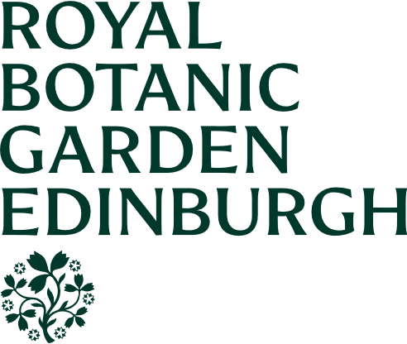


GENDER PAY GAP REPORT 2024

Introduction
The Equality Act 2010 (Gender Pay Gap Information) Regulations 2017 apply to all employers with 250 or more staff, and as such impact on RBGE.
Gender pay reporting legislation requires employers to publish statutory calculations every year showing how large the pay gap is between their male and female employees. RBGE adheres to these requirements.
Following the legislative requirements, all staff who were deemed to be ‘full-pay relevant employees’ have been included in the calculations. Full-pay relevant employees are all members of staff employed on our snapshot reporting date who are paid their usual full basic pay, excluding employees on:
- maternity, paternity, adoption, parental, or shared parental leave
- sick Leave
- special leave
Both mean and median pay gaps are calculated as the percentage difference in female pay compared to male pay. The mean is the total salary of men / women divided by the number of men / women respectively. The median is the salary of the middle-ranked woman compared to the middle-ranked man across all pay grades when the salaries are arranged in order.
The data required to be published is as follows:
1. Percentage of men and women in each hourly pay quarter.
2. Mean (average) gender pay gap using hourly pay.
3. Median gender pay gap using hourly pay.
4. Percentage of men and women receiving bonus pay.
5. Mean (average) gender pay gap using bonus pay.
6. Median gender pay gap using bonus pay.

Gender Pay gap at the Royal Botanic Garden Edinburgh (RBGE)
The current gender pay gap results for RBGE are set out in Tables 1 to 4 at Appendix 1 and have been derived from salary information excluding overtime as of 5 April 2024. It should be noted that no bonuses are paid to any of our staff and therefore there is no data to be made available in this respect.

At the snapshot date of 5 April 2024, we employed 184 women (59%) and 130 men (41%), making our female to male gender ratio as 1.41:1.

The mean hourly pay for men among our staff is £20.76 and for women it is £19.95. The current mean gender pay gap for all staff across our published pay is therefore £ 0.81 or 3.9% in favour of men. The median hourly pay rate for men is £17.25 and for women it is the same at £17.25. The median gender pay gap is therefore £0 or 0%.

Signed by the Regius Keeper

Appendix 1

Table 1
Gender Pay Gap Statistical Analysis
 | Mean | Median |  |  | Lower Quartile | Lower Middle Quartile |  | Upper Middle Quartile |  | Upper Quartile
Men | £20.76 | £17.75 |  | min | £12.00 | £14.02 |  | £17.75 |  | £21.44
Women | £19.95 | £17.75 |  | max | £14.02 | £17.75 |  | £21.27 |  | £59.00
Pay Gap | £0.81 | £0.00 |  | % Men | 45% | 37% |  | 34% |  | 50%
% Pay Gap | 3.9% | 0.0% |  | % Women | 55% | 63% |  | 66% |  | 50%

Table 2

Table 3

Table 4

The Royal Botanic Garden Edinburgh
is a charity (registration number SC007983).

Contact Us
0131 5527171
secretariat@rbge.org.uk
rbge.org.uk

