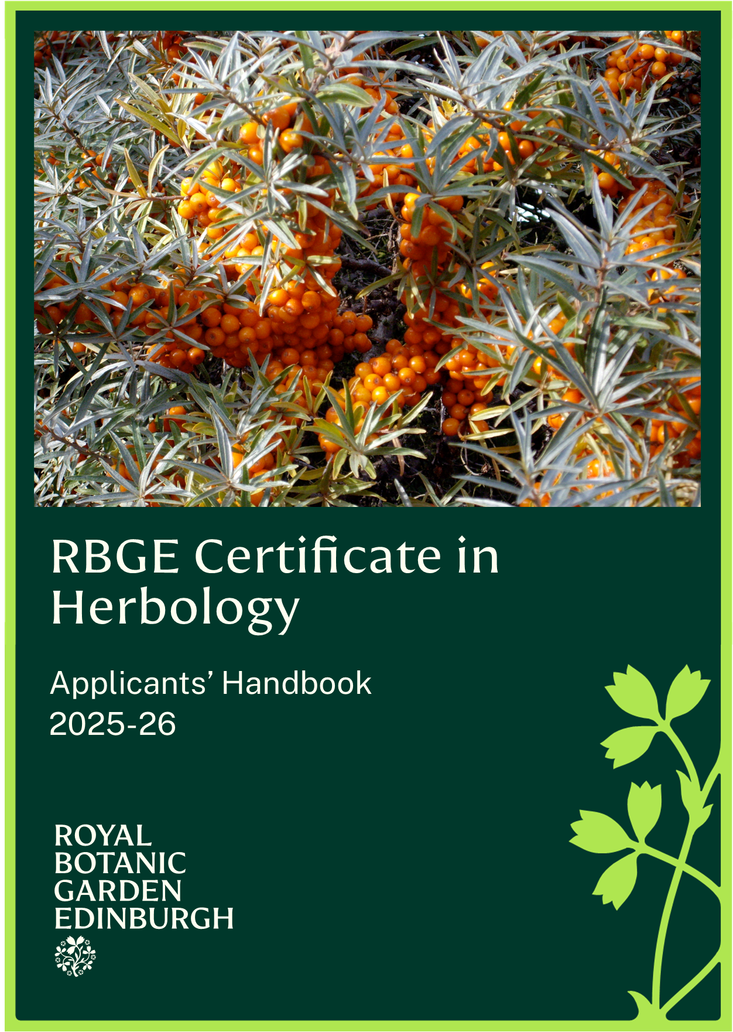
RBGE Certificate in Herbology Handbook 2025-26

Introduction
The Royal Botanic Garden Edinburgh (RBGE) Certificate in Herbology is a great way to learn about medicinal plants - how to work with them appreciatively, explore and sustain them. The focused content of this ten-day programme takes you on a journey through some of the more intriguing moments to be found within the history of Western Herbal Medicine, and these are used as inspiration for further study and research, combined with a complementary physic garden visit, wild herb gathering and the exploration of a myriad of different herbal habitats.

This is the perfect way to begin to develop your Materia Medica (knowledge of healing botanicals), botanising and green pharmacy (herbal remedy making). It will also provide the perfect steppingstone for those wishing to progress on to the RBGE Diploma in Herbology or simply further existing knowledge after completing one or more of our introductory herbal programmes.

As with all the Herbology programmes being delivered here at RBGE the Certificate in Herbology affords a wonderful opportunity to study herbs in one of the most holistic of environments – the Garden itself. The practical content of the course is intended to be uniquely therapeutic, from the mixing and making of herbal remedies, to herb gathering walks, and especially our field trips to explore medicinal plants in their rural wild habitats and our behind-the-scenes visit to the RBGE glasshouse.

RBGE Diploma in Herbology
This course will introduce you to many of the key RGBE Diploma in Herbology subjects of study and will give you the ‘herbal’ confidence required to make the most of your further studies in this field. If you wish to progress onto the Diploma, further details may be found by visiting our website: www.rbge.org.uk/dipherb.

Contents
Introduction 2
RBGE Diploma in Herbology 2
1. The Course Structure 4
2. Dates, Times & Location for 2025/26 5
3. Methods of Assessment & Submission of Work 6
4. Study Subject Descriptors 10
5. Attendance & Missed Class Procedure 15
6. Equipment & Ingredients Required 15
7. Course Fees 15
8. Application Procedure 16
9. Terms and Conditions 17

1. The Course Structure
We offer both weekend and weekday study options for the RBGE Certificate in Herbology.

Weekend Course
This runs for 10 full days over 5 designated weekends, either September 2025 - January 2026 or February – May 2026.

The Weekday Certificate in Herbology
Alternatively, you can now choose to study on our weekday Certificate programme.
This is delivered on Thursdays and Fridays (both days together) in January - February 2026.

The course presents students with a selection of research-based and practical projects that will take in many of the Garden’s ‘wild’ herb and arboreal collections.

Each day of the course will comprise a balanced mix of illustrated talks or demonstrations and self-directed study, along with practical activities including remedy-making, visits and field trips. The history of Western Herbal Medicine will be covered throughout the course with especial reference to the unique contributions of such defining figures as Galen, Culpepper and Dr Edward Bach.

Students will also learn how to approach the design of a theoretical ‘Medicine Wheel Garden’ based on a bespoke collection of herbs and directly referencing a chosen holistic tradition.

Students who attend all ten classes and complete the work required for their assessment are awarded the RBGE Certificate in Herbology.

2. Dates, Times & Location for 2025/26
All Herbology courses are taught in our dedicated Herbology Room at Royal Botanic Garden Edinburgh. Unless advised otherwise please enter via main reception at 20a Inverleith Row, EH3 5LR and do contact us if you have any special access requirements.

Please do note that on occasions you will need to walk through or beyond the gardens (e.g. for herb gathering or on one of our visits), our field trips - where considerable walking may be required over rough and uneven or soft sandy ground, take place outside the Botanics - and these are a key feature of this particular Herbology course.

Study Option 1 – Autumn/Winter Weekends
Week | Dates | Time
Weekend 1 | Saturday 27th &  Sunday 28th September 2025 | 10:30am – 4:30pm
Weekend 2 | Saturday 8th &  Sunday 9th November 2025 | 10:30am – 4:30pm
Weekend 3 | Saturday 29th &  Sunday 30th November 2025 | 10:30am – 4:30pm
Weekend 4 | Saturday 13th &  Sunday 14th December 2025 | 10:30am – 4:30pm
Weekend 5  (New Date) | Saturday 10th &  Sunday 11th January 2026 | 10:30am – 4:30pm

Study Option 2 – Weekdays
Week | Dates | Time
Block 1 | Thursday 15th & Friday 16th January 2026 | 10:30am – 4:30pm
Block 2 | Thursday 22nd & Friday 23rd January 2026 | 10:30am – 4:30pm
Block 3 | Thursday 29th & Friday 30th January 2026 | 10:30am – 4:30pm
Block 4 | Thursday 5th & Friday 6th February 2026 | 10:30am – 4:30pm
Block 5 | Thursday 12th & Friday 13th February 2026 | 10:30am – 4:30pm

Study Option 3 – Spring Weekends
Week | Dates | Time
Weekend 1 | Saturday 7th &  Sunday 8th March 2026 | 10:30am – 4:30pm
Weekend 2 | Saturday 28th &  Sunday 29th March 2026 | 10:30am – 4:30pm
Weekend 3 | Saturday 25th &  Sunday 26th April 2026 | 10:30am – 4:30pm
Weekend 4 | Saturday 9th &  Sunday 10th May 2026 | 10:30am – 4:30pm
Weekend 5 | Saturday 30th &  Sunday 31st May 2026 | 10:30am – 4:30pm

3. Methods of Assessment & Submission of Work
The RBGE Certificate in Herbology is a formally assessed course and therefore requires students to successfully pass assignments in order to achieve the award.

The 4 pieces of work that need to be completed to achieve your Certificate are:
Course content | Award
5 Complementary Study Assignments & 3 Reflective Assignments | 70%
1 theoretical Medicine Wheel Garden Design | 20%
1 Green Pharmacy (herbal) remedy | 10%
Herbal Journal (not graded) | n/a

3.1 Submission of Work
All work must be completed and submitted for assessment during the final weekend of the course, with the exception of your Green Pharmacy Remedy, which is to be prepared in class on the final Saturday morning.

The course concludes with an celebratory presentation of all student work.

3.2 The Herbal Journal
As part of your non-assessed work for the Certificate in Herbology you are asked to compile a Herbal Journal, a hand written compilation of your own herbology experiences.

Ideally, this is something that should be completed regularly to form a compendium of all your notes, complementary research, herbaria, green pharmacy recipes, physic garden horticulture and herbology observations, together with any related articles, cuttings, visual images etc. Most importantly, it should be a book of reflections on your learning.

Herbal Journals afford a creative medium of expression for your own herbology experiences throughout the course, some of your study assignments can be completed in your Herbal Journal.

3.3 Complementary Study Assignments
You will be asked to complete five Complementary Study Assignments (CSAs) and three Reflective Assignments to augment your learning in key subjects of study, these will include:

- Entheogenic & Sacred Herbs
- The Humours, Herbaria & Theriaca
- Flower Essence Remedies
- Glasshouse Materia Medica
- Herbal Candies & Confections
- Native Woodland Herbs
- Herbal Elixirs
- Seashore Botanicals or Physic Garden Botanicals (depending on season)

3.4 Medicine Wheel Garden Design
To complement your studies, you are asked to design a theoretical ‘Medicine Wheel’ Garden.

This should be accompanied by a detailed Plant List of all the herbs that are included in your design and the reasons for their selection.

You will be asked to consider the following points while creating this design:

- Choice of Herbs
- Colours & Structures
- Sensory perception/stimulation (e.g. fragrance from aromatic herbs)
- Focal features
- Ecology (e.g. are you creating a wildlife sanctuary for honeybees or other creatures?)
- References to one or more of the healing traditions or themes covered during the course (e.g. Humoral Medicine, the 17th Century Apothecary, Bach Flower Remedies, Sacred Healing Herbs)
- The therapeutic nature of your garden as a whole

3.5 Green Pharmacy Remedy
On the penultimate morning of the course, you will be asked to make a herbal remedy - adapting a simple recipe already explored in class. This forms part of your assessed work and takes the form of a self-directed practical.

Preparatory research will need to be undertaken at home during the previous weeks, when your recipe, and choice of ingredients to be used, will be agreed with your tutor.

You are expected to experiment and practise your remedy-making skills at home throughout the course and bring your own ingredients for the Green Pharmacy assessment session. Your course tutor will be able to advise on suppliers and quantities – and on any ingredients that may be available from Herbology supplies. All equipment for the assessment session will be provided by RBGE.

3.6 Final Assessment Weekend
On the final weekend of the course, all students are required to give a simple table-top presentation of their own course work to their fellow herbologists and tutor/s. This is an essential element of the programme and enables students to receive valuable feedback and guidance for their future development and herbal endeavours.

Mornings:
- Green Pharmacy (Remedy Making)) Self-Directed Practical
- Green Pharmacy Assessment

Afternoons:
- Table-Top Presentations
- Group & Tutor Feedback
- Submission of Completed Work

3.7 Certificate Award & Grades
Successful candidates will be awarded the ‘RBGE Certificate in Herbology’, which will be graded as follows:

- Referral: <50%
- Pass: 50-59%
- Merit: 60-69%
- Distinction: 70% and above

N.B. Deferred candidates may retake assessment the following year, subject to the running of the programme.

4. Study Subject Descriptors
Descriptors for all the subjects are given below – each includes the following:

- Learning outcomes
- Key knowledge and practical activities to be covered
- Recommended completion or assessment guidelines

Subject: Complementary Study Subjects

Learning Outcomes:
On completion of these study subjects students will be able to:
- Evaluate healing theories behind selected forms of Western Herbal Medicine
- Recognise a variety of Materia Medica, physic garden and wild habitat botanicals
- Interpret a range of traditional herbal formularies and more contemporary recipes
- Confidently prepare a selection of Green Pharmacy remedies
- Identify a range of medicinal glasshouse botanicals and their therapeutic value

Key Knowledge, Resources & Practical Activities:
- Slide shows, visits, demonstrations, remedy making, discourses and dialogues
- Compiling herb profiles and focused self-directed studies
- Understanding the ancient spiritual significance of entheogenic and sacred herbs
- Materia medica/ingredient handling and sampling
- The creation of herbarium pressings, spirit and carpological collections
- The Flower Essences - flower gathering walk and the preparation of solar infusions
- Herbal comfits, candies and confections – formulation and creative lozenge making
- Native woodland walk and botanical identification skills
- Elixirs - what they are and how to make them
- Seashore / Physic Garden botanicals – exploring a myriad of medicinal habitats

Recommended Assessment Guidelines:
- Complete all the related Complementary and Reflective Assignments
- Complete any related practical activities … e.g. remedy making
- Utilize your Herbal Journal for any notes, and as a place to complete designated pieces of work

Subject: Green Pharmacy Remedy

Learning Outcomes:
On completion of this study subject students will be able to:
- Work with some highly original herbal remedy-making techniques
- Confidently experiment with recipes
- Handle herbal ingredients safely and sustainably

Key Knowledge, Resources & Practical Activities:
- Slide shows, visits, demonstrations, remedy making, discourses and dialogues
- Materia medica and herbal remedy ingredient exploration
- Learning an eclectic mix of Green Pharmacy methodologies
- Herbal and base ingredient compounding
- Creative recipe adaptation and formulation
- Herbal remedy preparations

Recommended Assessment Guidelines:
- Note recipes and experiments in your Herbal Journal
- Complete remedy related Complementary Study Assignments
- Complete the Green Pharmacy Assessment (practical remedy making)

Subject: Medicine Wheel Garden Design

Learning Outcomes:
On completion of this study subject students will be able to:

- Define the cultural significance of Native American Medicine Wheels
- Recognise sacred herbs, colours and creatures associated with this healing tradition
- Draw up a working proposal with appropriate herbal plantings for a therapeutic environment
- Create a template design for a ‘Medicine Wheel Garden’.

Key Knowledge, Resources & Practical Activities:

- Slide show, notes, visit, discourses and dialogues
- Medicine Wheel origins, significance and structures
- Simple physic garden design principles and how to apply them
- Choice of herbs
- Sacred herb handling and discussion
- Visit to The Secret Herb Garden
- Talk and guided tour around the herb beds, discussion of design concepts
- Collating herbal sources of inspiration
- Drawing up a Medicine Wheel Garden design

Recommended Assessment Guidelines:

- Add design ideas, images and notes to your Herbal Journal for inspiration
- Create a Medicine Wheel Garden mood board
- Complete Medicine Wheel Garden Design Assignment

Subject: Physic Garden Horticulture (not assessed)

Learning Outcomes:
On completion of this study subject students will be able to:
- Collect seed for sowing or storage
- Mix an organic compost suitable for seed culture
- Practice correct seed sowing techniques for a variety of herbs
- Nurture a selection of medicinal and culinary herbs from seed to seedling
- Understand the basic principles behind good herbal husbandry

Key Knowledge, Resources & Practical Activities:
- Explore historical and contemporary concepts of a physic garden - visuals and talk
- Explore botanical husbandry - practical activities with seeds
- Recognise quintessential features of early (monastic) physic gardens
- Herbology physic garden herb, seed and tool handling
- Seed gathering with guidance on how to collect, sort and store herbal seeds
- or
- Seed sowing demonstration and practical
- Handouts detail techniques to be practiced as appropriate
- Complementary visual imagery from a variety of sources e.g. library herbals.

Recommended Assessment Guidelines:
None Required

Please note that there may be some necessary seasonal variations to the content of this subject depending on the time of year you choose to study for your Certificate in Herbology.

5. Attendance & Missed Class Procedure
All students who wish to pass this Certificate must attend all of the classes. If you miss a class or are unable to attend, you need to tell us as soon as possible.

It may be possible to arrange for a catch up day. There is a fee of £150* for this, except under exceptional circumstances and by prior arrangement with RBGE. Please note it will not be possible to arrange catch up days for off site visits.

If you are unable to attend a class or miss a class, please contact the Education
Office in the first instance by emailing: education@rbge.org.uk

*If more than one student is attending the catch-up day this fee will be reduced
accordingly.

6. Equipment & Ingredients Required
All equipment and materials needed to complete this programme of study are provided by RBGE, with the exception of the ingredients for your chosen Green Pharmacy Assessment remedy.

7. Course Fees
The cost for the course is £895. Full payment for the course is required on acceptance of a place.

8. Application Procedure
Spaces on this course are limited. Candidates will be selected on the basis of the answers given to the questions on the application form. If all applications are of a high standard, applications may be allocated based in the order they were received.

Applications will only be open for one intake at a time. To apply for the course, you must complete our online application form.

Course | Applications Open | Applications Close
Autumn/Winter Weekends  (September 2025 – January 2026) | Wednesday 25th June 2025 | End of September
Weekdays  (January – February 2026) | Wednesday 23rd July 2025 | Sunday 26th October 2025
Spring Weekends  (March – May 2026) | Monday 3rd November 2025 | Sunday 11th January 2026

Applications will open at 9:00am on the first day and close at 11.00pm on the last day. These times are UK times, so please take this into account if applying from outside the UK.

Applicants will be notified whether their application has been successful or not within 2 weeks of the application deadline date.

9. Terms and Conditions
- RBGE reserves the right to cancel this course
- RBGE cannot be liable for additional costs incurred in the event of cancellation
- If the course does not go ahead, any money paid to the RBGE would be refunded in full
- Fees will not be refundable should you not complete or pass the course.

What if I change my mind?
You are eligible for a full refund within 14 days of you sending your email of acceptance. If you wish to exercise your right to cancel within the 14 days, you must inform us of your decision within this cooling off period. You must inform us of your decision to withdraw from the course by email. Cancellation is effective from the date on which you send us your message.

Refunds after 14 days, but before the course begins
You will be issued a refund minus a £50 administration fee after the 14-day cooling off period. You must inform us of your decision to withdraw from the course by email. Cancellation is effective from the date on which you send us your message.

Refunds after the course has started
We do not offer refunds after the course has started, except in exceptional circumstances. This would be at the discretion of the Education Department. Any refund would be minus a £50 administration fee and the value of the learning materials you have accessed/classes you have attended. You must inform us of your decision to withdraw from the course by email. Cancellation is effective from the date on which you send us your message.

Any exceptions to the refund policy outlined above will be considered on a case-by-case basis and will be at the discretion of the Education Department and may be subject to a £50 administration fee.

Fees will not be refundable if you do not complete or pass the course.

10. Privacy Notice
RBGE will process your personal data for the administration of your course, to create your account on PropaGate Learning and to take payment (where relevant). RBGE will also process your personal data to inform you of any updates to the course, the admissions procedure, course dates, as well as any special offers. For more information see our privacy notice.

