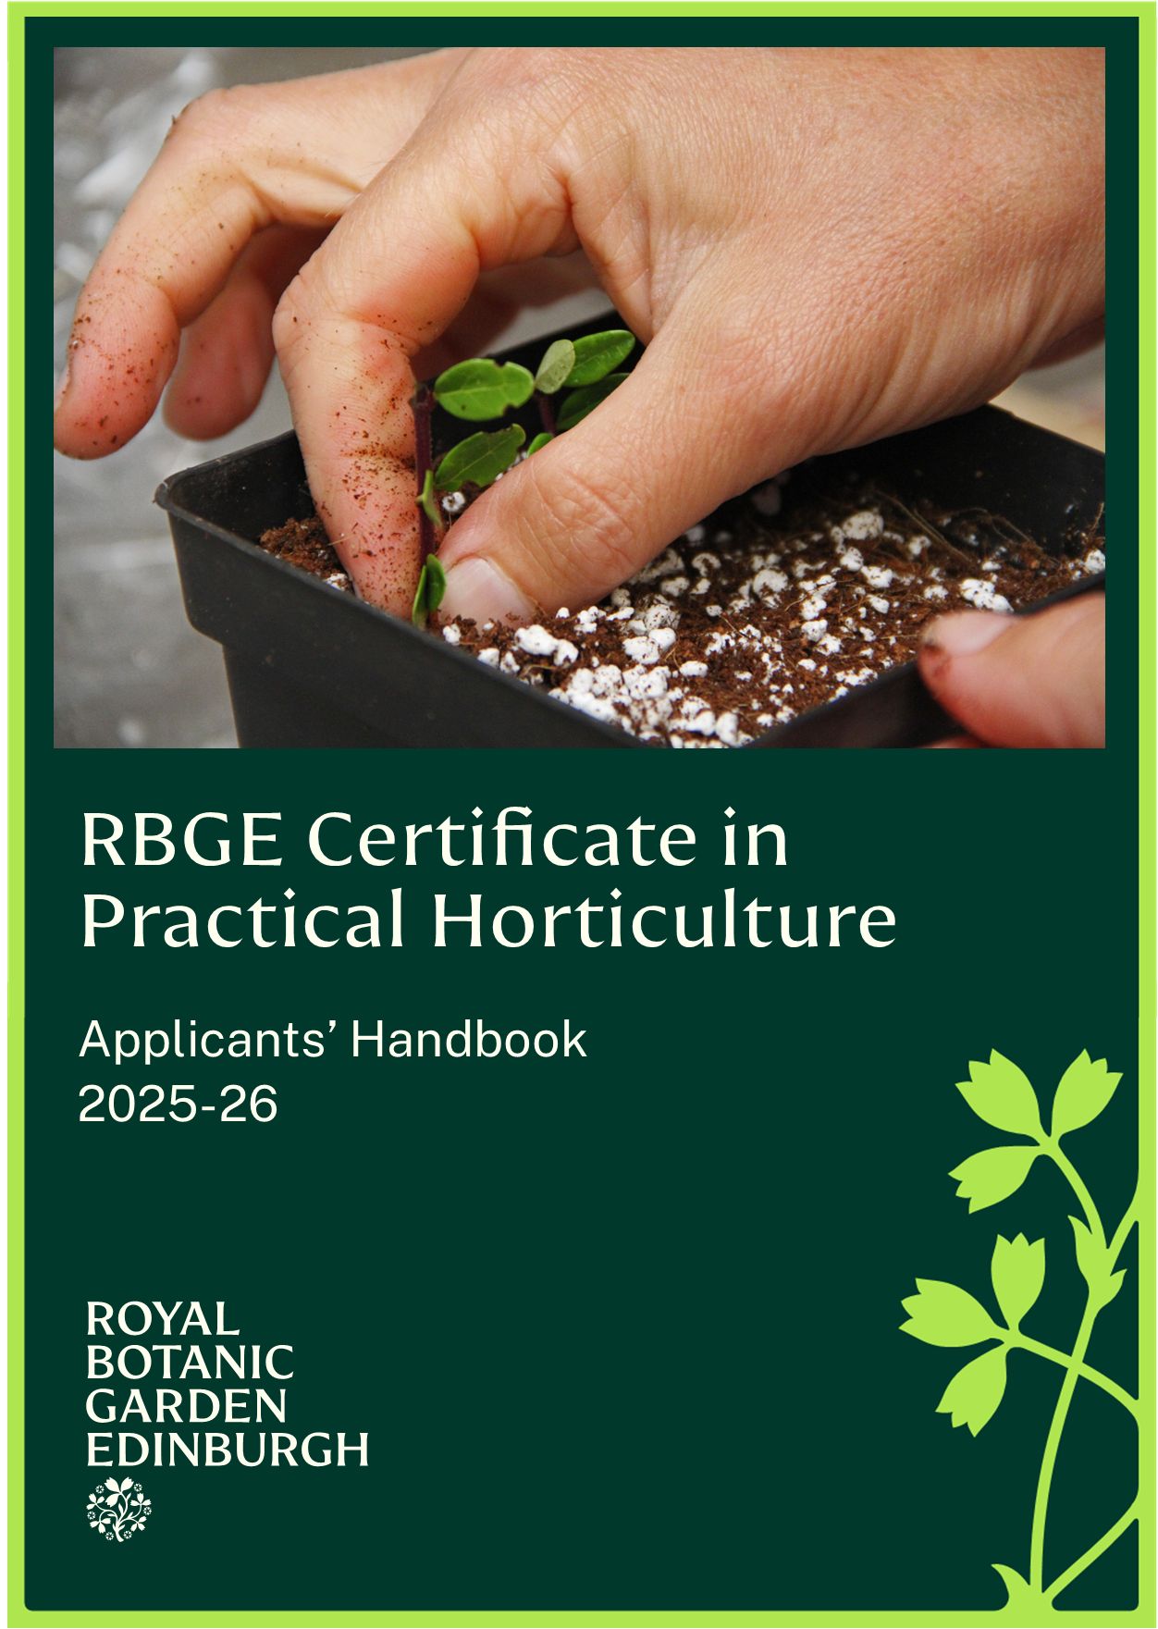
RBGE Certificate in Practical Horticulture

Applicants’ Handbook 2025-2026

Welcome
Welcome to the Royal Botanic Garden Edinburgh (RBGE). This document gives you information on the RBGE Certificate in Practical Horticulture.

We hope it answers all your questions, but please don’t hesitate to contact us as below if you have any further queries.

 | Learning Department  20a Inverleith Row  Edinburgh  EH3 5LR,  0131 248 2937  rbge.org.uk/certph

The Royal Botanic Garden Edinburgh is a charity (registration number SC007983)

Table of Contents
Welcome 2
1. Course Overview 4
2. Course Structure and Dates 5
3. Unit Descriptors 6
CPH-01 - Looking at Plants 7
CPH-02 - Soil Care 8
CPH-03 - Feeding & Watering 9
CPH-04 - Seed Propagation 10
CPH-05 - Vegetative Propagation 11
CPH-06 - Growing Media & Potting 12
CPH-07 - Planting 13
CPH-08 - Pruning & Training 14
4. Assessment Methods 15
5. PropaGate Learning 16
6. Equipment Required 17
7. Entry Requirements and Accessibility 17
8. Attendance Procedure 18
9. Course Fees 18
10. Application Procedure 18
11. Terms and Conditions 19

1. Course Overview
The RBGE Certificate in Practical Horticulture (CPH) is for anyone who wants to acquire the fundamental practical skills of a horticulturist. There are many courses that teach horticultural theory, but this formal 10-day course (eight full-day taught units plus assessment), structured within a standard framework, focuses on the practical skills, taught by experienced and enthusiastic horticulturists. Students who attend all eight units and successfully complete the assessments are awarded the RBGE Certificate in Practical Horticulture.

There is some theory provided to aid your understanding (in the form of short, highly visual presentations), but the course is designed to be delivered and assessed using a predominantly practical approach. Therefore, for the majority of your time in the classes you will be “doing stuff” and will be getting “dirty hands!”

The CPH is a formal qualification and students must therefore pass the assessment to achieve the award. Two practical exams during the course form the bulk of the assessment marks, but students are also required to show they understand the key points. This is done either as a notebook which is a record of their classes, or as worksheets with questions or as quizzes on PropaGate, RBGE’s Virtual Learning Environment. Students are also expected to practice their practical skills in their own time in addition to the formal classes, in order to prepare for the practical exam.

The CPH is endorsed by Botanic Gardens Conservation International (BGCI - the global organisation for botanic gardens).

As well as in Edinburgh, the CPH is also delivered by partner centres supported and validated by RBGE. These include the Nezahat Gökyiğit Botanic Garden in Istanbul, Turkey, Glasgow Botanic Gardens, Bute Produce on Bute, B.E.S.T. in Horticulture, and Norfolk School of Gardening. RBGE also delivers the CPH in countries as diverse as Oman and Laos, as part of global capacity building and conservation programmes.

2. Course Structure and Dates

Option 1 - Summer School July 2025
This option is a ten-day practical course over a two-week block, with the assessment on the final Saturday. The days run from 9.30am to 4.30pm.

Unit Number | Unit Title | Date
CPH-01 | Looking at Plants | Mon 7th July 2025
CPH-02 | Soil Care | Tue 8th July 2025
CPH-03 | Feeding & Watering | Wed 9th July 2025
No class | Study Time | Thurs 10th July 2025
CPH-04 | Seed Propagation | Fri 11th July 2025
CPH-05 | Vegetative Propagation | Sat 12th July 2025
CPH-06 | Growing Media & Potting | Sun 13th July 2025
No class | Study Time | Mon 14th July 2025
CPH-07 | Planting | Tue 15th July 2025
CPH-08 | Pruning & Training | Wed 16th July 2025
CPH-R | Revision Day | Thurs 17th July 2025
No class | Study Time | Fri 18th July 2025
CPH-A | Assessment Day | Sat 19th July 2025

Option 2 – Saturday or Sunday Course, August 2025 to June 2026
This option is spread out from August 2025 – June 2026. The individual units take place on Saturday or Sunday from 9.30am – 4.30pm, it will not be possible swap between the two courses.

Unit Number | Unit Title | Saturday Sessions | Sunday Sessions
CPH-01 | Looking at Plants | 30th August 2025 | 31st August 2025
CPH-02 | Soil Care | 20th September 2025 | 21st September 2025
CPH-07 | Planting | 25th October 2025 | 26th October 2025
CPH-03 | Feeding & Watering | 15th November 2025 | 16th November 2025
CPH-A1 | Assessment Part 1 | 13th December 2025 | 14th December 2025
CPH-08 | Pruning & Training | 7th February 2026 | 8th February 2026
CPH-04 | Seed Propagation | 21st March 2026 | 22nd March 2026
CPH-06 | Growing Media & Potting | 25th April 2026 | 26th April 2026
CPH-05 | Vegetative Propagation | 16th May 2026 | 17th May 2026
CPH-A2 | Assessment Part 2 | 6th June 2026 | 7th June 2026

Option 3 - Friday Course, February 2026 – May 2026
This option is delivered at RBGE in two 5-week blocks. The first block will take place before Easter with the second block taking place after the Easter break. The individual units take place on Fridays from 9.30am – 4.30pm.

Unit Number | Unit Title | Friday Dates
CPH-01 | Looking at Plants | 27th February 2026
CPH-02 | Soil Care | 6th March 2026
CPH-03 | Feeding & Watering | 13th March 2026
CPH-04 | Seed Propagation | 20th March 2026
CPH-A1 | Assessment Part 1 | 17th March 2026
CPH-06 | Growing Media & Potting | 24th April 2026
CPH-07 | Planting | 1st May 2026
CPH-08 | Pruning & Training | 8th May 2026
CPH-05 | Vegetative Propagation | 15th May 2026
CPH-A2 | Assessment Part 2 | 22nd May 2026

All course timetables are subject to change.

3. Unit Descriptors
Descriptors for all units are on the following pages. Each descriptor states the:
- Learning Aim
- Learning Outcomes
- Assessment guidelines

The following themes will be considered throughout all the units:
- Health and safety
- Environmental and sustainability issues
- Tools and equipment, maintenance and use
- Plant identification
- Plant pests and diseases
- Sourcing information
- Record keeping

CPH-01 - Looking at Plants

Learning Aim:
Gain an overview of plants and how they are named.

Learning Outcomes:
After completing this unit, the students will be able to:
- State the basics of plant lifecycles (i.e. annual, biennial and perennial).
- Use botanical plant names.
- Name plant structures.

Assessment:
- Plant identification: 10 plants from the list of 20 provided to students.
- Completed online quiz or worksheets.

CPH-02 - Soil Care

Learning Aim:
Gain an understanding of the principles and practices of looking after the soil.

Learning Outcomes:
After completing this unit, the students will be able to:
- Evaluate soil structure & texture.
- Determine soil pH.
- Cultivate soil by digging and forking
- Apply and/or incorporate organic matter to the soil.
- Remove weeds and prevent weed re-growth.
- Select the correct tools for cultivating soil.
- Maintenance of tools (including sharpening & cleaning).

Assessment:
- Digging and/or forking of an area of soil, including weed removal.
- Maintenance of tools.
- Completed online quiz or worksheets.

CPH-03 - Feeding & Watering

Learning Aim:
Gain an understanding of the principles and practices of feeding & watering plants.

Learning Outcomes:
After completing this unit, the students will be able to:
- State fertilizer types and application methods.
- Identify a range of irrigation equipment.
- Calculate fertilizer application rates, using step-by-step worksheets.
- Apply both liquid and granular fertilizer.
- Assess the irrigation needs of plants using appropriate irrigation terminology.
- Irrigate plants using a watering can and a hosepipe.

Assessment:
- Assess the irrigation requirements of a batch of plants, irrigate as appropriate.
- Completed online quiz or worksheets.

CPH-04 - Seed Propagation

Learning Aim:
Gain an understanding of the principles and practices of seed propagation.

Learning Outcomes:
After completing this unit, the students will be able to:
- State the advantages and disadvantages of seed propagation.
- List the key environmental storage factors that affect seed viability.
- Clean seed prior to sowing.
- Prepare an outdoor soil seedbed.
- Flat drill & v-drill and direct drill sow seeds in the prepared soil bed.
- Correctly fill & prepare containers with seed sowing media.
- Broadcast & space sow seeds in the filled containers.
- Label & water all sown seeds.

Assessment:
- Prepare an outdoor seedbed.
- Sow seeds both by space sowing and broadcast methods in either containers or outdoor seedbed.
- Seeds must be covered, labelled and watered if appropriate.
- Completed online quiz or worksheets.

CPH-05 - Vegetative Propagation

Learning Aim:
Gain an understanding of the principles and practices of vegetative propagation.

Learning Outcomes:
After completing this unit, the students will be able to:
- State the advantages and disadvantages of vegetative propagation.
- State the different methods of vegetative propagation.
- Select appropriate vegetative propagation material.
- Collect, prepare & insert a range of cuttings.
- State the factors important in the propagation environment (inc. media).
- Carry out the aftercare of propagated material (inc. labelling and watering).
- Divide herbaceous plants.

Assessment:
- Propagate two different plants. At least one of these must be by cuttings.
- Collect, prepare and insert the vegetative material. Labelling must be carried out correctly.
- Completed online quiz or worksheets.

CPH-06 - Growing Media & Potting

Learning Aim:
Gain an understanding of the principles and practices of growing plants in pots and different growing media.

Learning Outcomes:
After completing this unit, the students will be able to:
- State the reasons for growing plants in containers.
- Select appropriate pots for a range of different plants.
- Identify the properties of a range of different growing media ingredients.
- State how to mix a batch of growing media.
- Prick-out seedlings into small pots.
- Pot-on plants into a larger pot size.
- Demonstrate potting correctly in relation to depth of plant, level of growing media, positioning of plant in centre of pot and firmness of media.
- Carry out the immediate aftercare of plants that have been potted e.g. standing down and irrigating.

Assessment:
- Decide if plants need to be potted and choose appropriate containers for them.
- ‘Prick-out’ and/or ‘pot-on’ a batch of plants.
- Irrigate the batch of plants using a watering can or hosepipe.
- Completed online quiz or worksheets.

CPH-07 - Planting

Learning Aim:
Gain an understanding of the principles and methods of planting plants in soil.

Learning Outcomes:
After completing this unit, the students will be able to:
- State planting techniques for a range of different types and sizes of plants.
- State a range of tree support mechanisms and when to use them.
- State the reasons for using mulches & a range of materials that can be used.
- Prepare & mark out an area for planting.
- Plant out the area with small plants following a given plan.
- Demonstrate the planting and support of a standard sized tree
- Water & mulch post-planting.
- Select & maintain tools.

Assessment:
- Plant an individual specimen tree or large shrub, or plant out a number of small plants following a given plan.
- Completed online quiz or worksheets.

CPH-08 - Pruning & Training

Learning Aim:
Gain an understanding of the principles of pruning and training plants

Learning Outcomes:
After completing this unit, the students will be able to:
- List the reasons for pruning and training plants.
- Describe alternate methods for pruning and training plants.
- Clean and sharpen bypass secateurs.
- Use secateurs to prune plants correctly.
- Use a hand saw to carry out 3-point pruning to remove thicker branches.
- Select correct tools and materials for pruning and training.
- Tie plants to canes or other support structures.

Assessment:
- Carry out the appropriate training and pruning of a given plant(s).
- Completed online quiz or worksheets.

4. Assessment Methods
This is a predominantly practical course, designed to assess a practical level of understanding and competence. Candidates will be assessed in two ways:

4.1 Practical Exam (80% of assessment marks)
Students are required to undertake 2 practical exams as part of the course, the first exam will take place halfway through the course and cover 4 units, the second will be at the end of the course and will cover the remaining 4 units so that all eight units studied within the programme are properly assessed. The practical assessment will include an identification test, but the bulk of the assessment will be tasks requiring the application of the practical horticultural skills developed during the course.

You are expected to show a significant level of competence in the practical assessments and are therefore recommended to spend some time outside the course practicing all the skills learnt, prior to the final assessment. You must pass the practical exam to be awarded the certificate.

4.2 Online Quizzes (20% of assessment marks)
There is a small theory element to the assessment, to show you have understood the key points. This will be in the form of quizzes on our online Learning Environment or worksheets if you don’t have access to a computer. The worksheets should be completed and handed in to the course tutor on the day of the practical exam, before the practical exam begins. The worksheets will be marked and returned to you when you get your results. The online quizzes will be available after each class and need to be completed before the practical exam.

You are encouraged to take photographs, notes and make sketches during the class as this will help you to complete the worksheets and help you to revise for the practical exam.

4.3 Certification & Grading
Successful candidates will be awarded the ‘RBGE Certificate in Practical Horticulture’, which will be graded as follows:

- Pass: 60%
- Merit: 75%
- Distinction: 85%

If you receive a mark of 50% or less in any unit, this will be considered a “hard fail”, and you will need to re-sit the unit. Students who receive a “soft fail” (mark of 51-59%) on any unit, will have their final overall grade adjusted down. To gain a Distinction you must Pass (60%) every unit.

Students who receive more than 3 soft fails will receive will be required to resit the units they have failed.

Please note this is the RBGE Certificate in Practical Horticulture, completion of this course does not count towards the Royal Horticultural Society (RHS) qualifications.

5. PropaGate Learning
PropaGate Learning is the virtual learning environment that you log into in order to access your course. It is a place for learning and for discussing topics and progress with your tutors and other students. PropaGate Learning allows you to study from home, whilst becoming part of a thriving and enthusiastic learning community.

As a student on the CPH, you will have access to this resource, which contains a wide range of learning materials to support your study, including links to useful websites, a discussion forum and videos. The teaching resources will be made available to you before each class and you will be able to complete the online assessments after the class, at your leisure.

6. Equipment Required
This is a practical course so each module will involve indoor and outdoor work. Each week you will need to bring:
- Appropriate outdoor clothes (even indoor workstations can be cold).
- Steel toe-capped work boots.
- Bypass Secateurs.
- Packed lunch - Tea and Coffee facilities will not be available during the class, please come prepared with a flask should you wish to have a hot drink.

Once you are accepted on the course, we can advise you about what to buy and where to buy these items.

7. Entry Requirements and Accessibility
Although there are no formal entry requirements, it is important to note that this course will be delivered fully in English.

There is a lot of reading, and you must be able to write in English when communicating with your tutor and completing the online quizzes. A good understanding of the English language is required to get the most from the course and to enable you to succeed in your studies.

Some of the units require a certain amount of physical activity. Please contact us if you have any concerns about this so that we can make any arrangements if necessary. Having spoken to you we may unfortunately suggest the course is not suitable for you.

Courses at RBGE are taught in the RBGE Nursery and the main garden. The RBGE Nursery is on Inverleith Avenue South (off Inverleith Place). There are accessible toilets in all locations.

8. Attendance Procedure
As this is a practical course, all students who wish to sit the exams must attend ALL of the classes to be eligible. If you miss a class or are unable to attend, you need to tell us as soon as possible. It may be possible to arrange for a catch-up day, though there would be a fee of £150* for this.

If you are unable to attend a class or miss a class, please contact the Education Office in the first instance via email: education@rbge.org.uk

*If more than one student is attending the catch-up day this fee will be reduced accordingly.

9. Course Fees
The cost for the course is £895. Full payment for the course is required on acceptance of a place.

10. Application Procedure
Spaces on this course are limited. Candidates will be selected on the basis of the answers given to the questions on the application form. If all applications are of a high standard, applications may be allocated based in the order they were received.

To apply for the course, you must complete our online application form.

Course | Applications Open | Applications Close
Summer 2025 Intake | Tuesday 22nd April 2025 | Monday 26th May 2025
Monthly 2025-26 Intake | Wednesday 28th May 2025 | Sunday 20st July 2025
Weekly 2025-26 Intake | Tuesday 22nd July 2025 | Sunday 7th December 2025

Applications will open at 9.00am on the first day and close at 11.00pm on the last day. These times are UK times, please take this into account if applying from outside the UK.

Applicants will be notified if their application has been successful or not within 2 weeks of the application deadline date.

11. Terms and Conditions
- RBGE reserves the right to cancel this course
- RBGE cannot be liable for additional costs incurred in the event of cancellation
- If the course does not go ahead, any money paid to the RBGE would be refunded in full
- Fees will not be refundable should you not complete or pass the course.

What if I change my mind? (Refunds)
You will receive a refund minus a £50 administration fee if you withdraw from the course prior to more than two weeks before the course begins.

If you wish to withdraw from the course, you must inform us of your decision by email. Cancellation by email is effective from the date on which you send us your message.
Attended Courses: We will be unable to offer a refund after the start of the course.

Privacy Notice
RBGE will process your personal data for the administration of your course, to create your account on PropaGate Learning and to take payment (where relevant). RBGE will also process your personal data to inform you of any updates to the course, the admissions procedure, course dates, as well as any special offers. For more information see our privacy notice.

