Access Guide

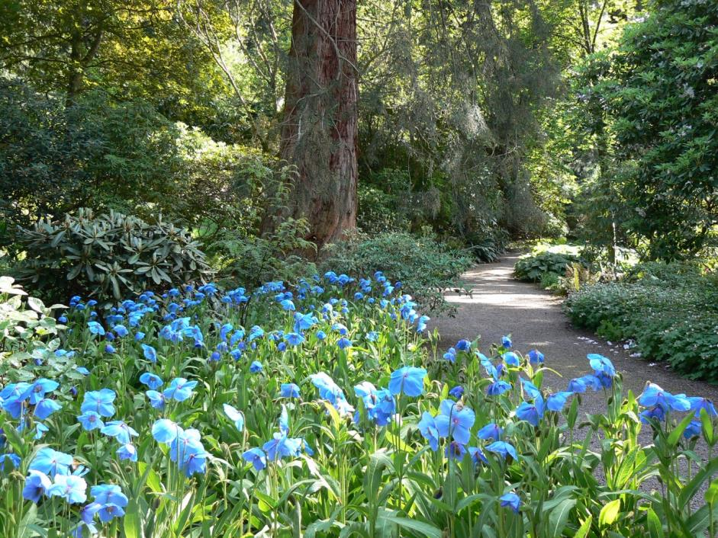

Dawyck Botanic Garden
Stobo
Scottish Borders
EH45 9JU

+44 (0) 1721 760254

www.rbge.org.uk/dawyck

Contents
Access Guide 1
1.0 Our Accessibility Promise to You 3
2.0 A Map of Dawyck Botanic Garden 4
2.1 A word about the weather 4
3.0 How To Reach Us 5
3.1 By Road 5
3.2 Parking 6
3.3 By Bus 6
3.4 By Rail 6
3.5 Taxis 7
3.6 Bicycle 7
4.0 Garden Entrance & Visitor Centre 8
5.0 The Garden 11
6.0 Restaurant 13
7.0 Shop 15
8.0 Hearing Loops 16
9.0 Mobile Reception and Wi-Fi 16
10.0 Accessible Toilets 17
10.1 Changing Places WCs 18
10.2 Accessible Toilets in Peebles 18
11.0 Evacuation 18
12.0 Assistance Animals 18
13.0 Future Plans 19

This Access Guide aims to accurately describe the facilities and services that we offer all our visitors and guests and does not contain personal opinions as to our suitability for those with access requirements.

1.0 Our Accessibility Promise to You

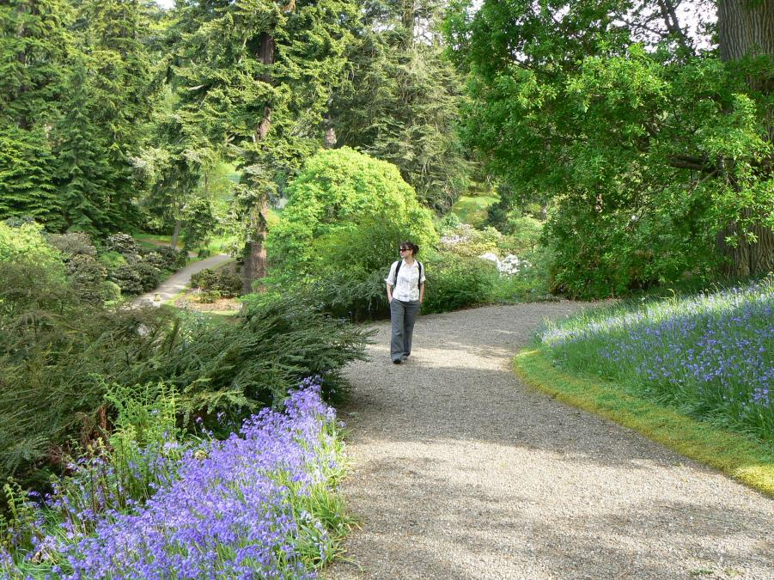
Dawyck Botanic Garden welcomes all visitors and aims to provide best possible access to everyone in order that they enjoy their visit to our Garden. We provide:
- Accessible toilets in our visitor centre.
- Two wheelchairs for our visitors to use.
- Seating at regular intervals throughout the Garden.
- Water for assistance animals, which must be trained.
- Pen, paper and magnifying glass at our Visitor Welcome desk.

If you require any further information about specific access or need advice about planning your visit please contact us on: +44 (0) 1721 760254 or email us at dawyck@rbge.org.uk.
If we have not covered your access needs in this document, please contact us and we will discuss your needs and offer assistance where we can.

2.0 A Map of Dawyck Botanic Garden

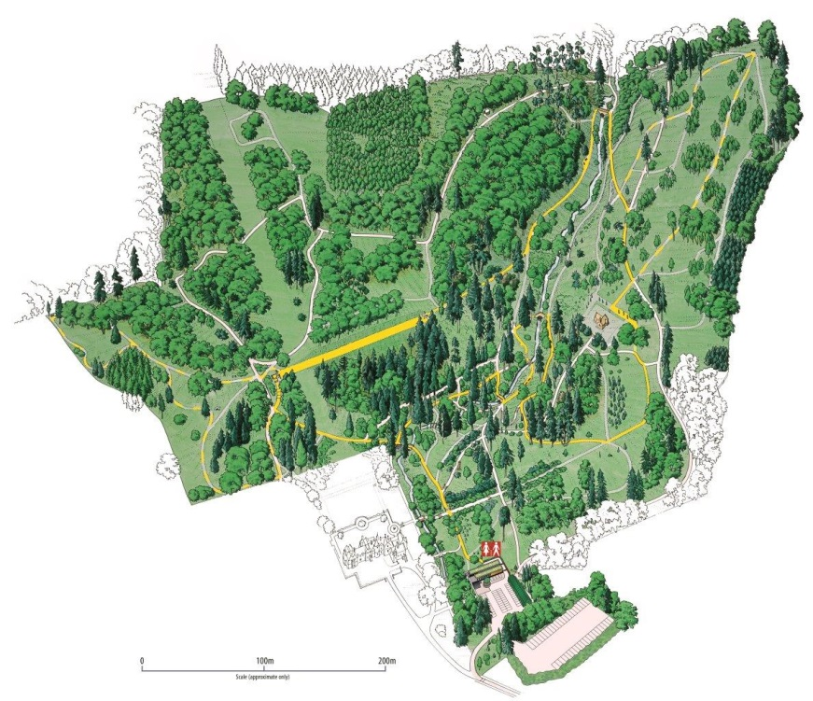

Above: This map shows the layout of Dawyck which is 65 acre Garden offering woodland and burnside walks. Much of the Garden is hillside. There is a designated route for wheelchair users and a map is available on arrival with the route clearly marked. For more detail about the Garden and accessible paths, turn to page 11.

2.1 A word about the weather

Please note that in severe weather conditions the Garden closes for safety reasons but our visitor centre and café remain open as usual. You are welcome to call us to check that the Garden is open on 01721 760254. Visitors are recommended to take extra care outside when exposed to weather conditions such as wind and rain.

3.0 How To Reach Us

Dawyck Botanic Garden is 28 miles south of Edinburgh on the B712, eight miles southwest of Peebles just outside Stobo village in the Scottish Borders. Plan your journey by using www.transportdirect.info.

3.1 By Road

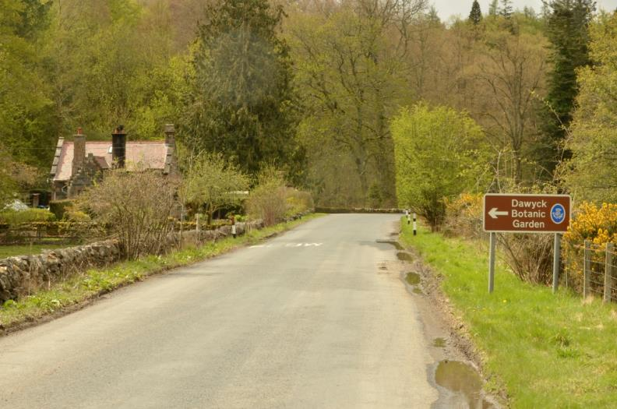

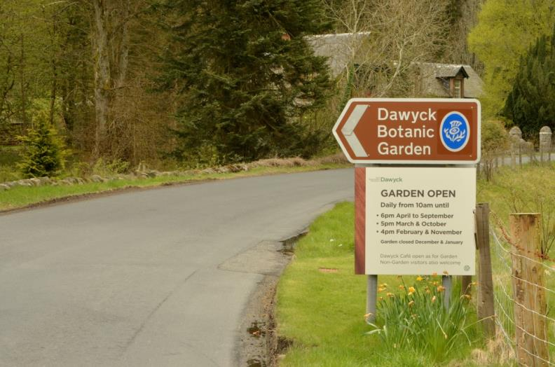

Above: The Garden entrance is sign-posted.

3.2 Parking

There is a large car park at Dawyck Botanic Garden with four 3.6m wide designated parking bays for blue badge holders in front of the visitor centre and within 45 metres of its ramped entrance. Parking is free. There is parking available for coaches and minibuses.

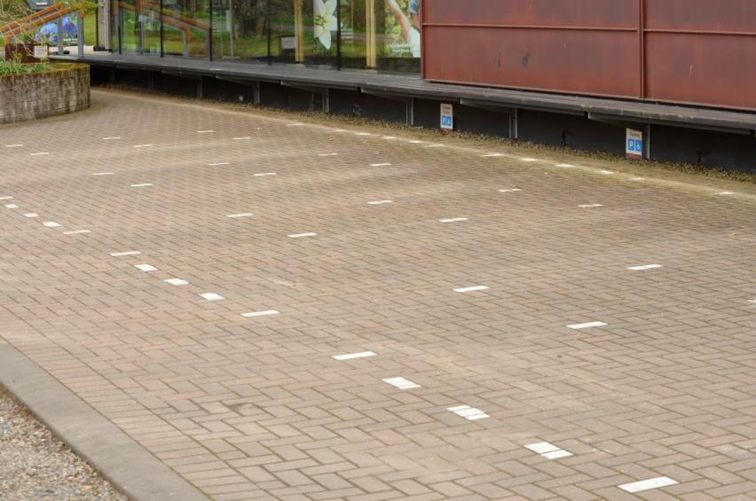

Above: Designated spaces for blue badge holders in front of the visitor centre.

3.3 By Bus

The region’s bus service is operated by First Bus which links the major towns within the Borders. Bus numbers 62, x62 and x70 bus services run between Edinburgh and Peebles, a journey that takes approximately 1.5 hours. For more information, visit www.firstgroup.com
Barc bus service number 91 runs between Peebles, Stobo and Biggar. The bus stops outside the Garden on request. For more information, visit www.travellinescotland.com. Please check that services are running during this uncertain time by visiting the relevant websites.

3.4 By Rail

Visiting by rail is difficult. The nearest station is in Galashiels which served by the new Scottish Borders Railway www.bordersrailway.co.uk. A bus journey would be required from Galashiels to Peebles on bus numbers 62 and x62 to Edinburgh. A direct bus journey from Edinburgh might be preferable. Please check available services during this uncertain time.

3.5 Taxis

There is taxi rank at Eastgate, Peebles outside the Post Office and close to the bus stop served by the main buses from Edinburgh. Check availability of taxis and bus services during this uncertain time.

3.6 Bicycle

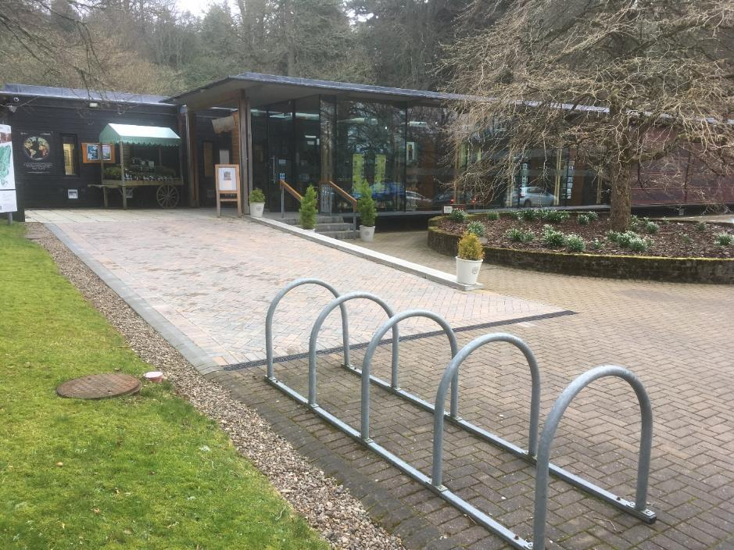

Above: Bicycle stands are available in the car park outside the visitor centre.

4.0 Garden Entrance & Visitor Centre

The main entrance to the Garden is through the visitor centre and this can be reached by either a 10 metre long ramp with 1.5 gradient or three steps.

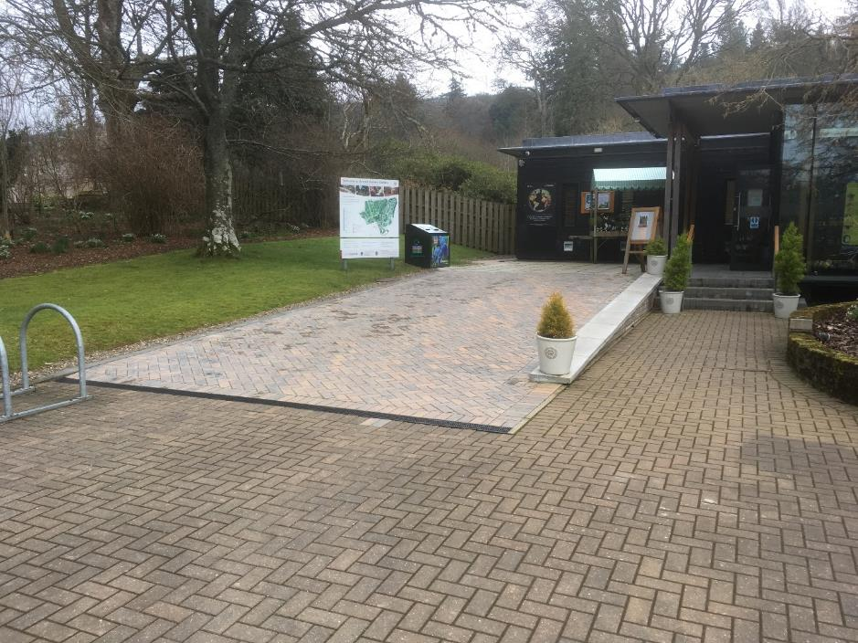
Above: The visitor centre entrance

Dawyck’s award-winning visitor centre is accessible to wheelchair and mobility scooter users. There are push pad controls to operate the automatic doors both inside and out. Inside, you will find an Information Desk, our shop which has spacious aisles, accessible toilets, a café and our exhibition space– all on ground level.

Maps and trails are available at the Information Desk.

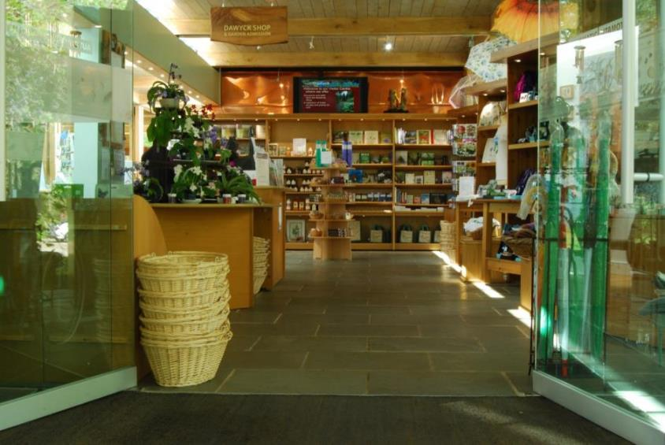
Above: The entrance is accessed through two automatic doors with push pad controls.

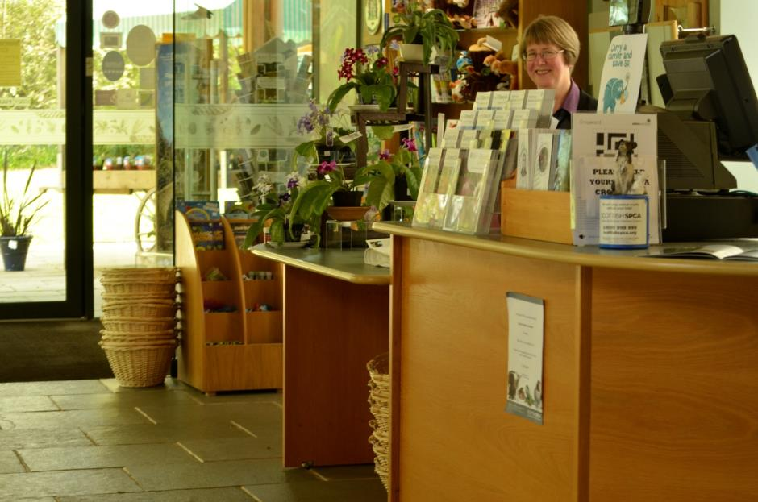

Above: The information desk, where you will receive a warm welcome, has a lowered section at the till point and a hearing loop.
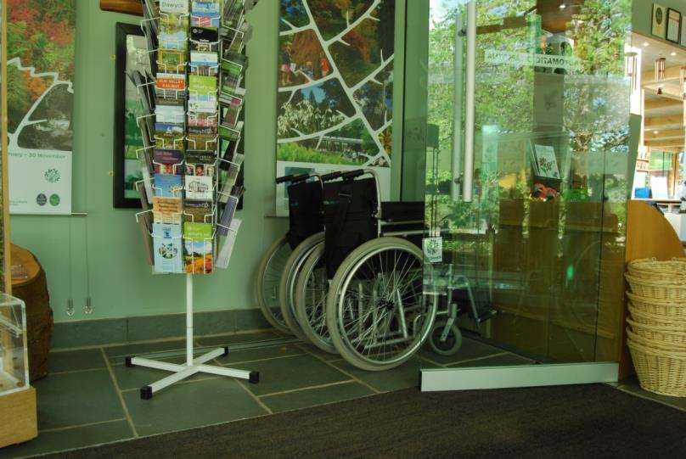

Above: The visitor centre has two wheelchairs for visitors to use. If possible, please book in advance by calling 01721 760254.

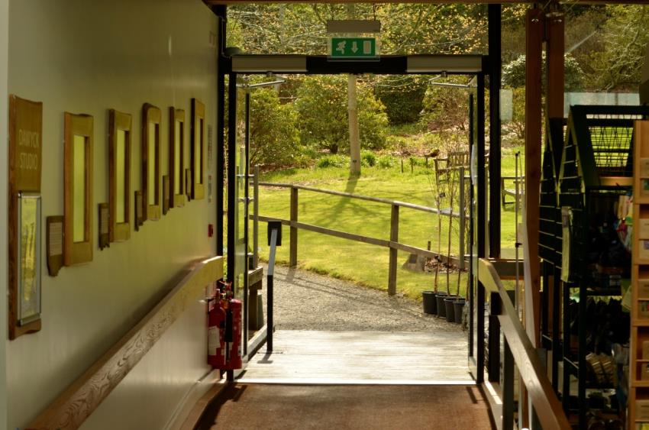
Above: The Garden itself is accessed from the visitor centre, through automatic doors with push pad controls. Please note, there is a foot mat before the entrance to the Garden which protects the plants from external plant diseases.

5.0 The Garden

Dawyck Botanic Garden is set upon a hill-side. As a result, some of the Garden’s paths are steep with inclines of up to 1:6 and there are a number of steps across bridges and terraces. Handrails at various steep sections have recently been added. This does make some paths difficult or impossible to access for users of wheelchairs and mobility scooters.

However, there is an accessible route of gravel paths on the lower level of the Garden, which is way marked. This route avoids several sets of steps to access the central part of the Garden. Manual wheelchair users may still require some assistance to negotiate path gradients and the closing of two sets of gates on the designed wheelchair accessible route. The gates are a minimum of 1360mm when open.

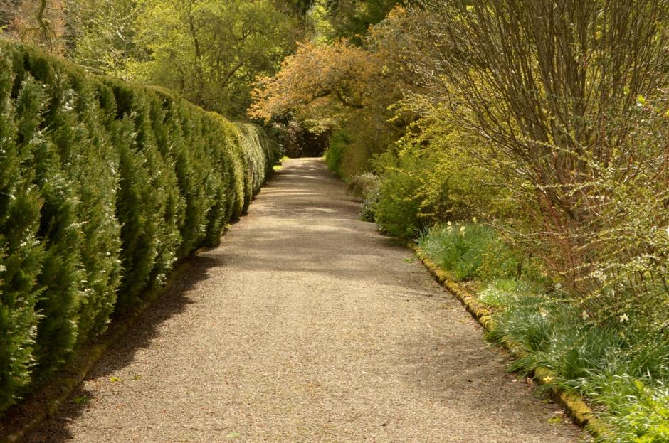
Above: Typical paths on the accessible route are gravel

Watch out for occasional tree roots breaking the surface of some paths, which may require careful negotiation.

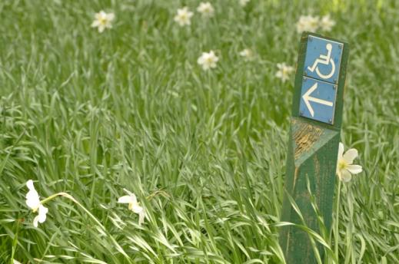
Above: Signage at ground or low level indicates wheelchair accessible paths.

A range of bench seating, with and without arm rests, is provided at intervals around the Garden in all locations. These provide visitors with an opportunity to take a break and rests with their companions.

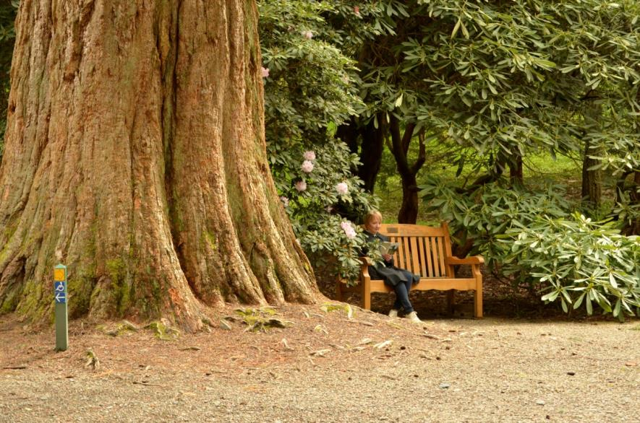
Above: Benches are positioned in many locations around the Garden.

6.0 Restaurant

There is one café/restaurant in the visitor centre, with wonderful views out to the Garden and woodland beyond. It caters for most dietary requirements as indicated on the menu.

Above: A warm welcome is assured from the catering team.

- The tables are accessible for wheelchair users and mobility scooters and seating can be moved to accommodate our visitors’ requirements.
- There are accessible toilets on the same floor as the restaurant.
- The restaurant can also be accessed by mobility scooters and wheelchairs from the Garden and from the entrance point.
- Tables and furniture can be moved as required.
- There are large print menus available and our staff are happy to read out the menu

Please note that the visitor centre will remain open to visitors if the Garden closes because of severe weather.
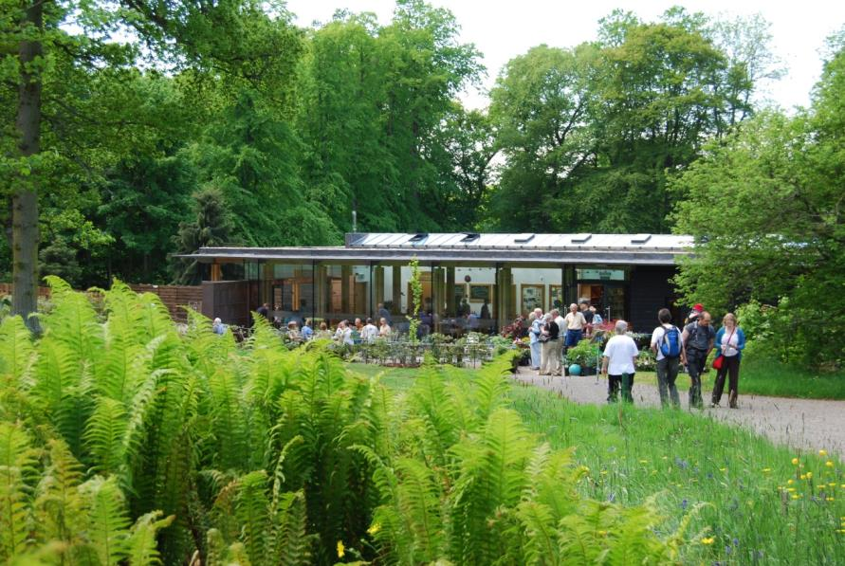
Above: The restaurant’s outside seating area.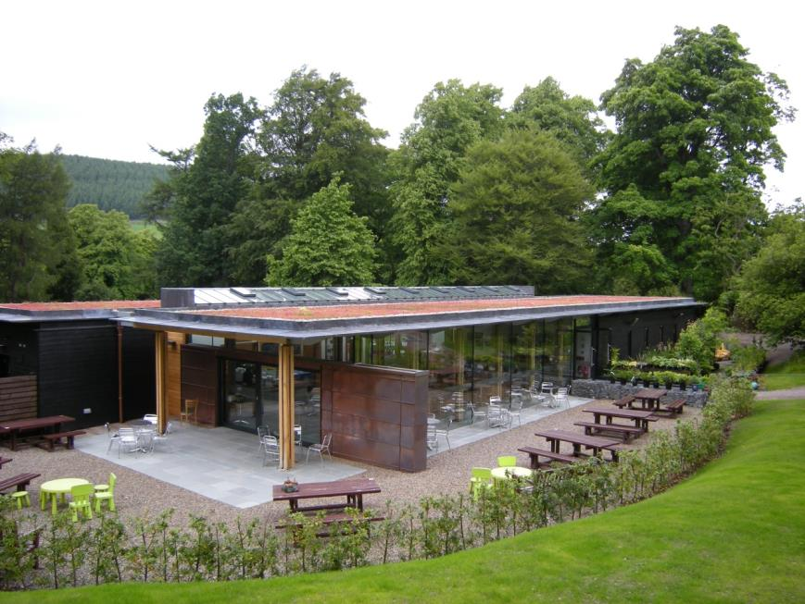
Above: Tables and picnic benches outside the restaurant. Please ask for assistance if you require help with seating.

7.0 Shop

There is a shop in the visitor centre which is easily accessed directly from the entrance foyer, and offers a wide range of quality gifts, souvenirs, books and plants.

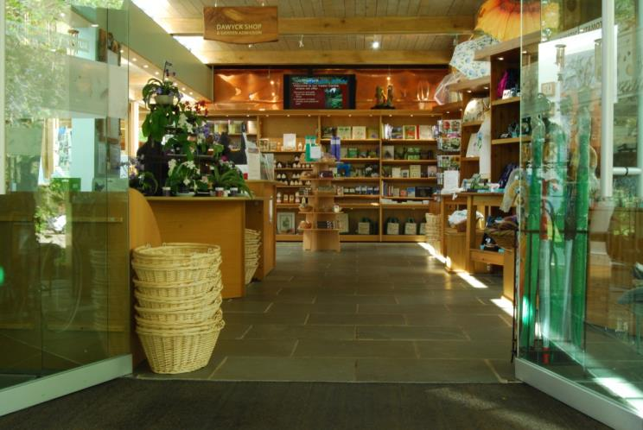
Above: Wide aisles in the shop.

Features of the shop:

- Step free access and spacious placement of shop fixtures to allow ease of movement for wheelchairs and motorised scooters.
- The outdoor plant area is accessed through automatic doors to the rear of the Visitor Centre.
- The shop is evenly and well lit.
- There is a hearing loop at the till point, a magnifying glass, pen and paper.
- Shop staff are always on hand to offer assistance.

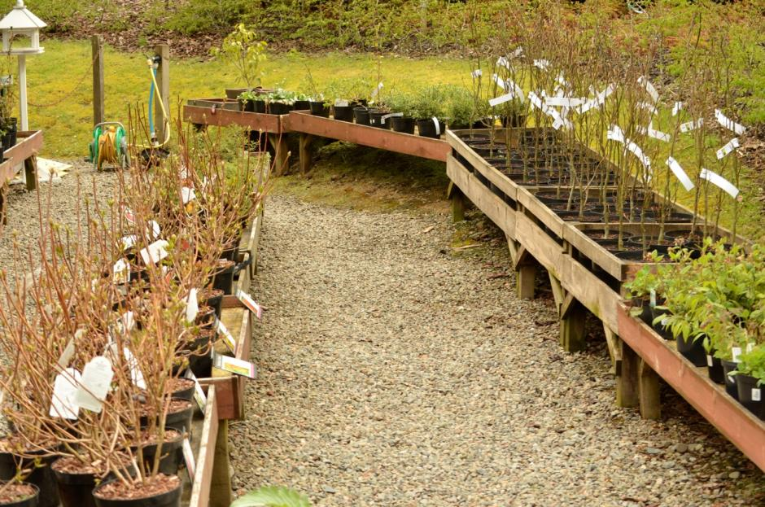
Above: The plant sales area to the rear of the Dawyck visitor centre has wide gravel paths.

8.0 Hearing Loops

A permanent Induction Loop is fitted at the Visitor Centre Information Desk. Please ask for assistance if you require it.

9.0 Mobile Reception and Wi-Fi

Visitors with medical conditions should be aware that mobile signal is limited within Dawyck’s visitor centre but there is some signal in the Garden itself. Dawyck does offer public access to Wi-Fi. If you require assistance, please ask at the Information Desk.

10.0 Accessible Toilets

There is an accessible toilet in the visitor centre, accessed in the restaurant:

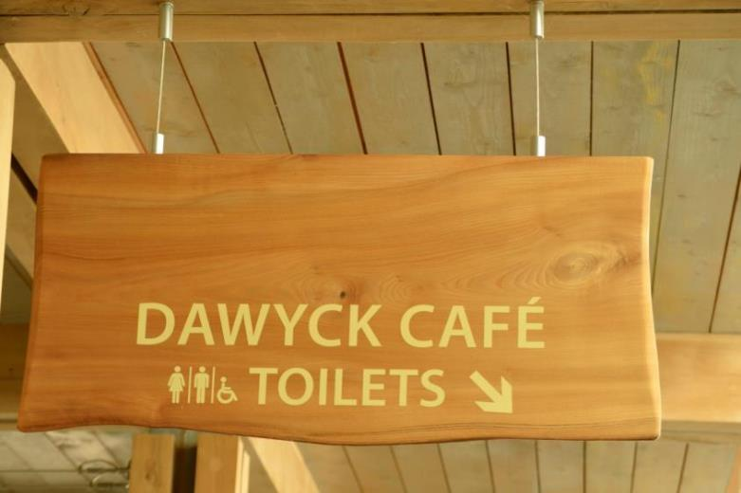

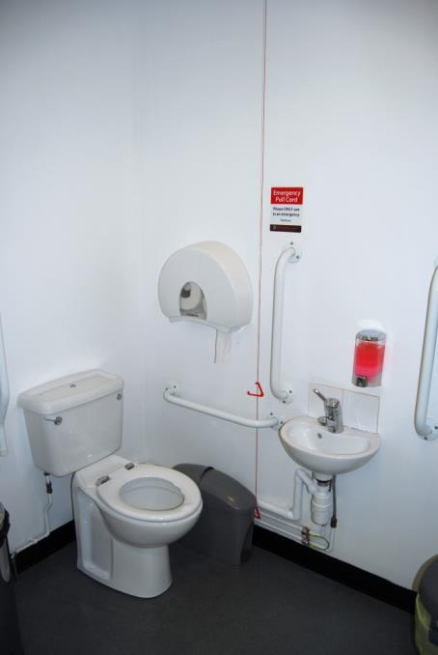
Above: The accessible toilet at Dawyck Botanic Garden

10.1 Changing Places WCs

The nearest Changing Places WC is in Lanark. For further information and to check current status on opening during this time, please visit www.changing-places.org:

25 miles from Dawyck Botanic Garden:
The Harry Smith Complex
Thomas Taylor Avenue
Lanark
Tel: 01555 664419
Monday to Friday 8.45am – 3.45pm

This day-support service provides a toilet located on the ground floor and the key is available from the reception. The toilet is centrally places with room either side for carers, and has a height adjustable, adult sized, free standing changing bench with a ceiling track hoist.

10.2 Accessible Toilets in Peebles

There are a number of other accessible toilets in Peebles, eight miles away from Dawyck Botanic Garden, in the following locations:
Eastgate Car Park
Kingsmeadow Car Park
School Brae, Off High Street
Haylodge Park
Please check directly that they are open during this uncertain time.

11.0 Evacuation

Should a fire alarm sound and an evacuation take place, the Visitor Centre and Garden staff will assist those with specific needs to evacuate. They will assist those who require help until the fire services arrive. Accessible toilets in the Visitor Centre will be physically searched in the event of an emergency evacuation.

12.0 Assistance Animals

Dawyck Botanic Garden welcomes assistance animals. Bowls of water are available on request. The Garden has a world-leading collection of plants that it has a duty to protect and a responsibility of care for all visitors. Therefore, it is our policy only to allow access to assistance animals that are registered or highly trained. We ask that they are kept on a lead during their visit to the Garden.

Above: Guide dog Huxley with toddler Francesca

13.0 Future Plans

Dawyck Botanic Garden is committed to enhancing its offering to those with specific requirements. Our future plans include:
- To be a participant in Disabled Access Day, run in association with Euan’s Guide.
- To providing disability awareness training to our staff.
- To offer a sensory tour of the Garden in future.

If you would like to provide any feedback on this Access Guide, we would welcome your comments. We would be interested to hear if there is any information we may have missed, or things you think might help us to improve accessibility in terms of services and facilities. Please contact us at marketing@rbge.org.uk

