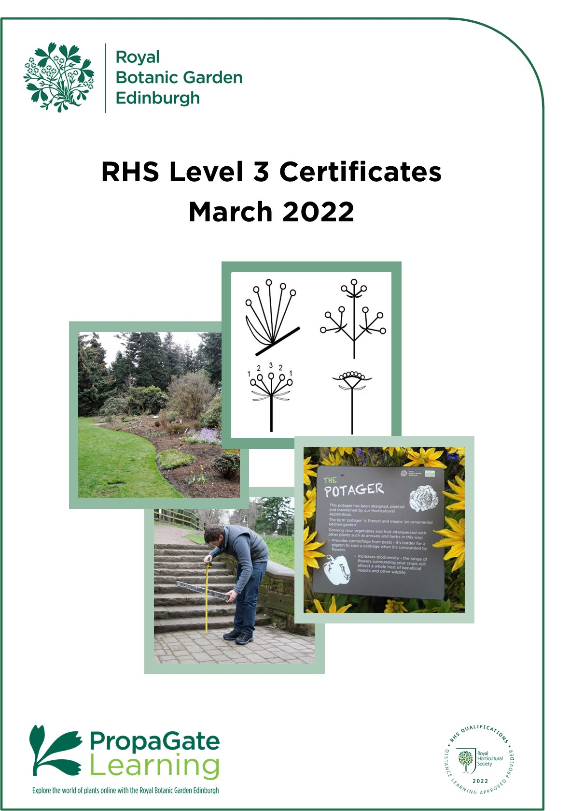

Introduction to the course

Welcome

We are delighted that you are considering joining an RHS Level 3 Certificate course here at RBGE.

The RHS Level 3 Certificate in the Principles of Horticulture comprises of two parts: the Certificate in the Principles of Plant Growth, Health and Applied Propagation (Certificate 1) and the Certificate in the Principles of Garden Planning, Construction and Planting (Certificate 2). Both certificates together can be combined with a practical certificate to make the RHS Level 3 Diploma in the Principles and Practices of Horticulture. We do not offer the practical certificate, which is required to be awarded the Diploma.

The RHS Level 3 Certificate 1 and 2 courses are stand-alone qualifications and can be applied for separately. Many people choose which certificate to take according to their interests or depending on what they intend to do after gaining the certificate. These certificates are ideal if you have a real passion for plants and gardens.

This handbook introduces you to the RHS Level 3 course content and structure. We hope it answers all your questions, but please don’t hesitate to contact us via the details below if you have any further queries.

Education Department
rhslevel3@rbge.org.uk

All information is correct at the time of publication and is subject to change.

Contents

1. Course structure and format 4
2. Course completion deadline 4
3. Cert 1: Plant Growth, Health and Applied Propagation 5
3.1 Introduction to certificate 5
3.2 Learning hours and QCF credits 5
3.3 Unit Descriptors 6
4. Cert 2: Garden Planning, Construction and Planting 7
4.1 Introduction to certificate 7
4.2 Learning hours and QCF credits 7
4.3 Unit Descriptors 8
5. Examinations 9
5.1 Sitting the exams at RBGE 9
5.2 Sitting the exams elsewhere 9
5.3 Sitting exams outside of the UK 10
5.4 Exam fees 10
5.5 Examination dates in 2022 10
5.6 Examination dates and enrolment periods 10
6. How does it work? 11
6.1 Learning Online 11
6.2 How can I prepare for studying online? 11
6.3 What hardware or software will I need? 12
6.4 What support is available? 12
7. Study options and course costs 13
8. Entry requirements 13
9. How to apply 14
10. The future of RHS Level 3 at RBGE 14

1. Course structure and format

Due to the revision of the RHS Qualifications, the planned RHS launch of the updated Level 3 course in September 2023 and the current course completion deadline, RBGE will no longer be offering the existing theory qualification to new learners.

The RHS Level 3 certificates are aimed towards the examinations that are organised by the RHS, they have now announced that the date for the final set of examinations will be February 2024. As a result, we are only going to be offering people who have already completed one part of the theory course the opportunity to complete their second certificate in order to gain the existing RHS Level 3 Certificate in the Principles of Horticulture theory qualification.

If you have not already started studying for an RHS Level 3 Qualification, you should hold off and begin the updated qualification when it launches in September 2023.

- Course completion deadline

This is the last opportunity to complete the current version of the RHS Level 3 Certificate in the Principles of Horticulture Course.

You can start the course any time before 31st March 2022 and will have until June 2023 to complete the exams before your access to the materials runs out. There will be exams in February 2024, but these should be a back up if you need to resit.

By signing up for this course you are acknowledging that you must complete the exams by this time in order to gain the qualification.

RBGE will continue to keep the resources up to date and offer support for the current version of the qualification through to the last set of exams. There will be no need for students to register and pay for the new qualification when it launches unless they have not completed by February 2024.

RHS Registration Deadlines
The following deadlines have been set by the RHS and will apply to all centres. For RBGE deadline dates please see section 9. If you wish to complete either of these individual certificates you must register by the following dates:

- RHS Level 3 Certificate in the Principles of Plant Growth, Health and Applied Propagation (Certificate 1) 31st March 2022
- RHS Level 3 Certificate in the Principles of Garden Planning, Construction and Planting (Certificate 2) 31st March 2023*

*Please note RBGE will not be accepting registrations for these certificates after 28th March 2022.

3. Certificate 1: Principles of Plant Growth, Health and Applied Propagation

3.1 Introduction to certificate

The RHS Level 3 Certificate in the Principles of Plant Growth, Health and Applied Propagation builds on the current RHS Level 2 certificate and delivers a broad-based understanding of horticultural techniques and plant biology. If you are based in Scotland, it is equivalent to something between a higher and an advanced higher or to an English A-Level.

It provides students with a qualification that is recognised internationally by the horticulture industry. This broad base makes it ideal for those wishing to pursue a career in any branch of horticulture. It is also perfect for leisure gardeners who would like to expand their horticultural knowledge, and to have it formally assessed.

3.2 Learning hours and QCF credits

The RHS Level 3 Certificate 1 course is structured around the examinations set by the RHS, so the content is predominantly theory. It is a part of the wider Qualifications and Credit Framework (QCF).

The course is organised into four units and the learning hours recommended by the RHS and the QCF credits for each unit are as shown below.

Unit | Guided learning hours | Additional  Self-directed studies in hours | Total Qualification Time* | QCF Credits^
R3101: Plant taxonomy, structure and function | 32 | 23 | 55 | 5
R3102: The root environment, plant nutrition and growing systems | 28 | 22 | 50 | 5
R3103: The management of plant health. | 24 | 16 | 40 | 3
R3104: Understanding applied plant propagation | 21 | 14 | 35 | 2

*The RHS have estimated that the Total Qualification Time required for students to study this certificate is 180 hours. We have apportioned the number of hours required for each unit based on the guided learning hours.
^The total number of QCF credits for this Certificate is 15 Credits.

3.3 Unit Descriptors

R3101: Plant taxonomy, structure and function

This is the botany section and really helps you to get to grips with plants, their diversity and how they work. There are 7 major learning areas in this part of the course, including plant taxonomy, tissues, reproduction, photosynthesis and respiration, transport, and regulation of growth. Understanding this helps you make sense of many of the processes later in the course.

R3102: The root environment, plant nutrition and growing systems

This unit begins with a look at soil classification and formation and the underlying rocks and their properties. The focus shifts to a detailed look at the properties of the mineral and biological components of soils and growing media. We also look at nutrient cycles in soil and plants as well as causes and symptoms of deficiencies. Finally, this unit introduces the principles of organic growing and the ways in which soils and plant health can be managed in organic systems.

R3103: The management of plant health

This unit covers three major learning areas. Firstly you will be expected to identify a wide range of pests, diseases and weeds and know how to manage and control them by different methods, including integrated pest management. Secondly, to understand how and when chemical controls can be used and stored to minimise damage to non-target organisms. Thirdly there is a focus on biosecurity and reducing the spread of pests and diseases.

R3104: Understanding applied plant propagation

This unit looks at how the germinating seed works, the requirements for seed storage and conservation, breaking dormancy and ensuring successful germination. Vegetative propagation will cover different methods of propagation, including grafting, bulb propagation and micro-propagation and a look at a range of facilities used for vegetative propagation.

4. Certificate 2: Principles of Garden Planning, Construction and Planting

4.1 Introduction to certificate

The RHS Level 3 Certificate in the Principles of Garden Planning, Construction and Planting builds on the current RHS Level 2 certificate and delivers a broad-based understanding of garden design, construction and planting. If you are based in Scotland, it is equivalent to something between a higher and an advanced higher, or to an English A-Level.

It provides students with a qualification that is recognised internationally by the horticulture industry. This broad base makes it ideal for those wishing to pursue a career in any branch of horticulture or garden design. It is also perfect for leisure gardeners who would like to expand their horticultural knowledge, and to have it formally assessed. It is an ideal precursor to relevant diploma and degree programmes here at RBGE.

4.2 Learning hours and QCF credits

The RHS Level 3 Part 2 course is structured around the examinations set by the RHS, so the content is predominantly theory. It is a part of the wider Qualifications, Credit Framework (QCF), a system that is designed to allow you to study a huge range of subjects to tailor your learning.

The course is organised into four units and the learning hours recommended by the RHS and the QCF credits for each unit are as shown below.

Unit | Guided learning hours | Additional  Self-directed studies in hours | Total Qualification Time* | QCF Credits
R3111: Understanding garden survey techniques and design principles | 28 | 32 | 60 | 4
R3112: Understanding the selection and use of landscaping elements in the garden | 28 | 22 | 50 | 4
R3113: Understanding the setting out and construction of landscaping elements in the garden | 27 | 33 | 60 | 4
R3114: Understanding a range of specialist elements in the establishment of garden and urban plantings | 24 | 6 | 30 | 3
*The RHS have estimated that the Total Qualification Time required for students to study this certificate is 202 hours.
^The total number of QCF credits for this Certificate is 15 Credits.

4.3 Unit Descriptors

R3111: Understanding garden survey techniques and design principles

This unit is concerned with garden survey techniques and design principles. It explains the historical development of garden design styles which still have an influence on the gardens of today. Any good garden design needs to reflect the needs of the garden users and the capabilities of the site so the crucial information gathering and recording stages of the process are discussed before dealing with the application of design principles.

R3112: Understanding the selection and use of landscaping elements in the garden

This unit puts physical form to the design by exploring how soft and hard landscaping features and materials are selected and used in the garden. Important safety issues are dealt with and we look at the topical subject of using sustainable materials.

R3113: Understanding the setting out and construction of landscaping elements in the garden

This unit moves on to the construction phase. The plans discussed in unit 1 are translated into physical features and the methods used to construct those features are explained.

R3114: Understanding a range of specialist elements in the establishment of garden and urban plantings

This unit covers aspects of planting and maintenance which are specific to amenity, woodland, wildlife, sensory, prairie, potager and urban gardens. We also look at how water sustainability can be incorporated into garden design and explain a number of specialist pruning techniques.

5. Examinations

Each unit will be assessed by a separate written examination covering the learning outcomes specified in that unit. The dates and times of the exams are set by the RHS and are usually offered twice a year, in February and June.

The exams are a good challenge, and the qualification is one of the reasons many people join the course. However, the course is designed to be great fun and a valuable learning experience even if you do not do the exams, so there is no obligation to sit them.

Exam spaces are limited across the country and RBGE cannot be held responsible if you are unable to secure a space to sit exams.

5.1 Sitting the exams at RBGE

If you have visited the Garden recently you will have seen that building work for the Edinburgh Biomes Project has begun. Due to the disruptive nature and noise expected from the works and their close proximity to the exam rooms, we may no longer be able to offer exams at RBGE.

In the event RBGE are unable to offer exams, students will be able to apply to other centres as an external candidate or apply to sit the exams online, an option that has recently become available.

If we are able to run exams at RBGE we are only able to accept exam registrations from students in Scotland, Northern Ireland and UK based applicants in and north of Newcastle. However please note that this will not guarantee you a space for the exams. Registrations are usually processed on a first come first served basis.

If you live in the RBGE catchment area and can sit the exams elsewhere or online, please consider this option to give those without other options the chance to sit the exams locally.

5.2 Sitting the exams elsewhere

It is possible to study with RBGE and sit the exams elsewhere, however we advise ensuring you will be able to sit the exams at a local centre before signing up for the course.

You should contact your local centre to find out how and when to register for the exams, each centre will have their own system in place.

If you need to find an exam centre near you please check the RHS External Candidate Centre List.

5.3 Sitting exams outside of the UK

It is possible to sit the exams online. Students should enquire about the possibility directly with the RHS: qualifications@rhs.org.uk

5.4 Exam fees

The RHS registration fee for the exams is £29 per unit, the total cost to sit all 4 units in a single certificate is £116. These fees are not included in the course fee.

- If you are absent on the day of the exam, you lose your fee. You will have to
re-register and pay again to sit the exam(s) you have missed.
- If you need to re-sit any exams you must re-register and will have to pay again to sit the exam(s).
- Some centres may charge external candidates an administration fee on top of the RHS registration fee.

5.5 Examination dates in 2022

June 2022

Certificate 1
Wednesday 22nd June 2022
- R3101 9:00 – 10:40
- R3102 13:30 – 15:10
- R3103 11:45 – 12:50
- R3104 15:55 – 16:45

Certificate 2
Thursday 23rd June 2022
- R3111 9:00 – 10:25
- R3112 11:25 – 12:50
- R3113 13:30 – 14:55
- R3114 15:35 – 16:40

*Exams R3102 and R3103 run out of sequence

Exam dates for 2023 have not been released by the RHS, although it is anticipated they will run in February and June as normal.

5.6 Examination dates and enrolment periods

It is possible to sit exams outside of your enrolment period, it just means you will no longer have access to the course materials on PropaGate. However, it is possible to extend your online support period should you wish to retain access until you have completed the exams.

- How does it work?

6.1 Learning Online

Your online learning environment is PropaGate Learning which uses the Moodle learning platform.

PropaGate Learning is a website that you log into in order to access your course. It’s a place for learning and for discussing topics and progress with your tutors and other students. PropaGate Learning allows you to study from home, whilst becoming part of a thriving and enthusiastic learning community.

Your course will consist of a number of elements which include e-books, PDFs, presentations, videos, interactive lessons, quizzes, discussion forums and links to useful websites.

We continually review and update the course and we are in the final stages of updating the course with more videos and interactive lessons. We are also updating the course to ensure it is more accessible.

6.2 How can I prepare for studying online?

You should be a competent computer user with a basic understanding of standard computer applications such as using an internet browser, email and word processing. Experience of participating in online forums would also be a benefit, but not essential.

Our ‘Digital Skills Check’ will help you to identify any areas of IT you may need to brush up on.

When you are first given access to PropaGate Learning, please take time to complete the Orientation Activity. This will give you an essential introduction to the tutors on your course, finding your way around, advice on learning independently and the best ways to communicate with tutors and other students.

Online courses require a much more self-motivated learning style than traditional attended classes. You should plan to set aside a certain amount of time each week to log into the course lessons and carry out activities. The amount of time required depends on the number of units you are studying at a time, however we suggest 2-3 hours per week for 6 months if you want to take 2 exams at the end of that 6 months. Participation in online discussions is also a key part of the course – online learning is much more sociable than you might think!

6.3 What hardware or software will I need?

You will need access to a desktop or laptop computer. Most of the course will be accessible via a tablet, but we recommend using a laptop or desktop computer. You may find some aspects of the course will be easier to use on a computer.

Regarding software, you will need an up-to-date browser (We recommend Firefox, Chrome or Safari). You will also need software that will open PDFs (e.g. Adobe Acrobat Reader).

Most importantly you will need a reliable strong internet connection.

PropaGate Learning is available 24/7 with the exception of any maintenance work which we will inform you about in plenty of time.

6.4 What support is available?

We encourage everyone to make the most of the forums on the course. These provide a way for students to talk to one another and to tutors and ask each other questions. They are also used by us to share information about exam registration and other course-related news.

Tutors check the forums at regular intervals and will usually reply to forum queries within 2 working days.

Our PropaGate Learning team are always available so if you ever feel you are stuck with a course-related technical problem, they can be contacted via the forums or by emailing: propagatelearning@rbge.org.uk

Your online support period will start from the date your PropaGate Learning account is activated and will last until 30th June 2023.

It is possible to extend your online support period for an additional fee.

- Study options and course costs

The fee is £270 for an individual certificate and your enrolment will last until 30th June 2023. The fee is payable on application and includes:

- Access to course materials via PropaGate Learning
- Online support for horticultural study questions

It is possible to extend your online support period for an additional fee:

- 1 month extension £10
- 3 month extension £25
- 6 month extension £50

- Entry requirements

Although the RHS Level 3 Certificates do not require any prior qualifications we strongly recommend completing the RHS Level 2 Certificate in the Principles of Horticulture first, as there will be some assumed knowledge.

Fundamentally, however, all you need is an interest in the subject and a willingness to set aside time for home study. We are looking for keen, enthusiastic ‘plants people’ of all ages, who would value the opportunity to develop their knowledge in a structured and supported learning environment and will contribute to the programme.

To help you make the decision about which course is best for you we would suggest that rather than comparing the levels of the courses, take a careful look at the content in the qualification specifications which are available on the RHS website, look at the individual learning outcomes and pick the course which appeals to you most/is most relevant for your goals.

We also advise that you should have some basic confidence with computers, as the course makes use of PropaGate learning, our online learning environment. You must be self-motivated, have access to an internet-ready computer and e-mail account for the course.

Students wishing to study with RBGE must have completed or be registered with another centre for at least one certificate of the theory qualification. This course is not open for registrations to new students, new students should wait to register for the updated qualification launching in September 2023.

- How to apply

Applications for the course will close on Monday 28th March 2022.

Payment must be received by 31st March 2022 for Certificate 1 which is the RHS deadline for registering for this version of the qualification. We will not be able to add anyone to this part of the course after this date.

To apply all you have to do is complete the course application form: Online Application Form

Your application will be processed within 5 working days of receipt. Once your payment has been received your PropaGate Learning account will be activated and course joining instructions will be sent by email. Please only apply when you are ready to start studying.

Please contact by email at rhslevel3@rbge.org.uk if you have any questions.

- The future of RHS Level 3 at RBGE

RBGE has no immediate plans to run the revised RHS Level 3 course when it launches in September 2023. If this changes we will of course let you know, however it may be some time before this qualification is part of our offer.

