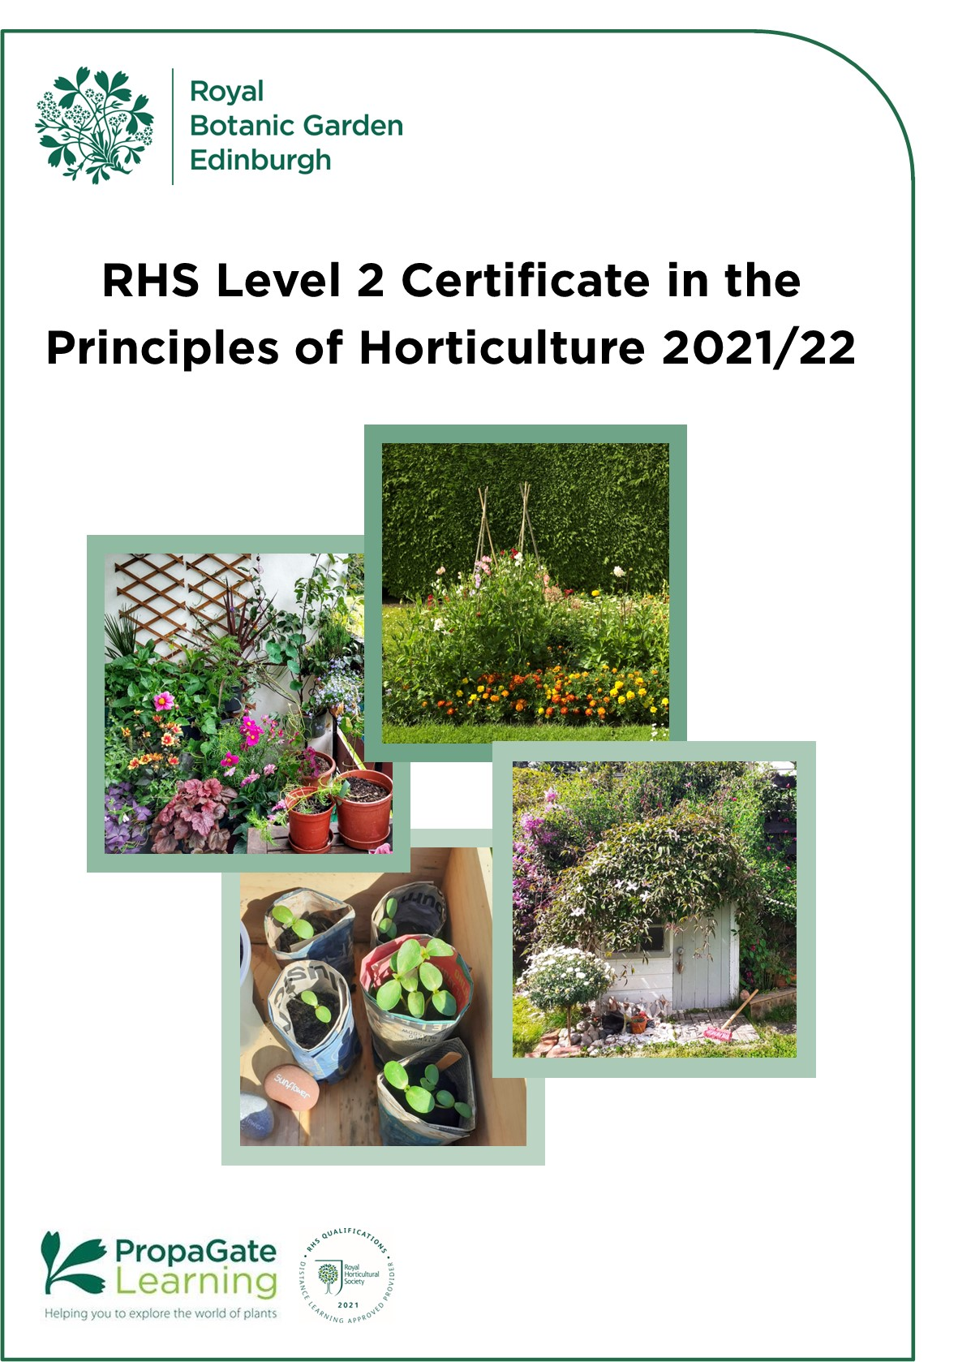

Introduction to the course

Welcome

We are delighted that you are considering joining the RHS Level 2 Certificate in the Principles of Horticulture course here at RBGE.

The RHS Level 2 Certificate in the Principles of Horticulture is the most widely regarded entry-level horticulture course. It is suitable for anyone with a passion for plants and gardens who wants to develop their knowledge. The certificate delivers a broad-based understanding of horticultural techniques and plant biology and provides you with a qualification that is recognised internationally by the horticulture industry. This broad base makes it the ideal starting point or first qualification for those wishing to pursue a career or business in any branch of horticulture or garden design. It is also perfect for leisure gardeners who would like to expand their horticultural knowledge, and to have it formally assessed.

The award of the Certificate is based on written examinations. These are externally set and marked by the RHS. The certificate is accredited by OFQUAL (The Office of Qualifications and Examinations Regulation) in England and Wales.

When you complete the course, you may be able to look at developing your skills to the highest level through RBGE’s HND or BSc in Horticulture with Plantsmanship.

This handbook introduces you to the RHS Level 2 course content and structure. We hope it answers all your questions, but please don’t hesitate to contact us via the details below if you have any further queries.

Education Department
rhslevel2@rbge.org.uk

All information is correct at the time of publication and is subject to change.
Contents

1. Course structure and format 4
2. Course Timetable and Completion Deadline 4
3. Cert 1: Principles of Plant Growth, Propagation and Development 6
4. Cert 2: Principles of Garden Planning, Establishment and Maintenance 8
5. Examinations 11
6. What is Online Learning? 13
7. Study options and course costs 15
8. Entry requirements 15
9. How to apply 16
Terms and Conditions 17

1. Course structure and format

The RHS Level 2 course is aimed towards the examinations set by the RHS, so the content is predominantly theory. We provide you with a complete set of information and learning support to help you pass the exams.

The course is broken down into two separate certificates that are designed to stand alone. When combined, they make up the RHS Level 2 Certificate in the Principles of Horticulture.

A third practical certificate is also available and when combined with the theory certificates makes up the RHS Level 2 Diploma in the Principles and Practices of Horticulture. RBGE does not offer the practical certificate, if you wish to find your nearest centre please use the Find a Centre tool on the RHS website. Due to an update of RHS Qualifications in 2022, there is now a deadline for those looking to complete the Diploma.

- Course Timetable and Completion Deadline

Due to planned updates to the RHS qualifications, this is the last opportunity to complete the current version of the RHS Level 2 Certificate in the Principles of Horticulture Course. For details of the changes please see the RHS website.

You can start the course in October 2021 or January 2022 and will have until June 2023 to complete the exams before your access to the materials runs out. There will be exams in February 2024, but these should be a back up if you need to resit.

Your enrolment will last until 30th June 2023. To help you plan your studies, we’ve provided a timetable that can be used as a guide to help keep you on track. We’ve based this on students spending approximately 5-6 hours per week studying, however it would be possible to do the course faster if you are able to dedicate more time to your studies.
If you’d prefer to make your own timetable, look at the breakdown of learner hours and set a schedule that will work for you. If you do this please bear in mind you should be aiming to complete the course by June 2023.

Timetable
October Start |  |  |  | January Start
Week starting (Monday) | Unit | Exam Sittings |  | Week starting (Monday) | Unit | Exam Sittings
11/10/2021 |  |  |  | The enrolment for students starting in January 2022 will also end in June 2023. This should be more than enough time to complete the course, however it will require more intensive study than the October start.
18/10/2021 | Unit 1
20/12/2021 | Unit 2
07/02/2022 | EXAMS | Units 1 & 2
14/02/2022 | Study Break
21/02/2022 | Unit 3 |  |  | 17/01/2022 | Unit 1
11/04/2022 | Unit 4 |  |  | 04/04/2022 | Unit 2
30/05/2022 | Revision |  |  | 23/05/2022 | Revision
20/06/2022 | EXAMS | Units 3 & 4 |  | 20/06/2022 | Exam week | Units 1 & 2
27/06/2022 | Summer Break |  |  | 27/06/2022 | Unit 3
05/09/2022 | Unit 5 |  |  | 15/08/2022 | Unit 4
21/11/2022 | Unit 6 |  |  | 03/10/2022 | Unit 5
09/01/2023 | Revision |  |  | 19/12/2022 | Unit 6
06/02/2023 | EXAMS | Units 5 & 6 |  | 06/02/2023 | Exam week | Units 3, 4, 5 & 6
13/02/2023 | Study Break |  |  | 13/02/2023 | Study Break
20/02/2023 | Unit 7 |  |  | 20/02/2023 | Unit 7
10/04/2023 | Unit 8 |  |  | 10/04/2023 | Unit 8
29/05/2023 | Revision |  |  | 29/05/2023 | Revision
26/06/2023 | EXAMS | Units 7 & 8 |  | 26/06/2023 | Exam week | Units 7 & 8
Feb 2024 | EXAMS | Resits |  | Feb 2024 | Exam week | Resits

The RHS transition arrangements are aimed at those who have already completed part of the existing RHS qualification and not at those who have yet to start. If you sign up to the current version of the course, you will be able to complete in time without having to mix the two versions of the qualification.

There will be no option for students to transfer to the new version of the qualification. RBGE will continue to keep the resources up to date and offer support for the current version of the qualification through to the last set of exams. There will be no need for students to register and pay for the new qualification when it launches unless they have not completed by February 2024.
By signing up for this course you are acknowledging that you must complete the exams by June 2023 in order to gain the qualification. Due to the qualification change, you will be unable to significantly extend your course. If you have any doubts about your ability to complete by this date, we’d suggest waiting until 2022 to apply for the new version of the course so that you don’t have the time constraints that you would experience with the current version.

3. Certificate 1: Principles of Plant Growth, Propagation and Development

3.1 Introduction to the certificate
This certificate focuses on many of the processes that go on 'behind the scenes' in a plant. These are the fundamentals that help everything else make sense in plants when you are working with them in the garden.

3.2 Learning hours and QCF credits

Unit | Guided learning hours | Additional  Self-directed studies in hours | Total Qualification Time* | QCF Credits^
R2101: Plant classification, structure and function | 31 | 24 | 55 | 5
R2102: Plant nutrition and the root environment | 23 | 12 | 35 | 3
R2103: Maintaining plant health | 22 | 12 | 34 | 3
R2104: Understanding plant propagation | 23 | 12 | 35 | 3

*The RHS have estimated that the Total Qualification Time required for students to study this certificate is 159 hours. We have apportioned the number of hours required for each unit based on the guided learning hours.
^The total number of QCF credits for this Certificate is 14 Credits.

3.3 Unit Descriptors

R2101: Plant classification, structure and function
This unit provides a solid grounding in basic botany. Considerable time is devoted to understanding the structures and processes that allow plants to survive – from the cellular level right through to the myriad variety of leaves, flowers and fruits that make horticultural plants so interesting. Whilst there is a considerable amount of technical botanical information in this unit, it is geared towards real-life situations, making it easy to understand and apply in gardening and wider horticultural contexts.

R2102: Plant nutrition and the root environment
One of the keys to maintaining healthy plants is, of course, an understanding of plant nutrition. This unit works through plant nutrition from first principles. We cover soil structure and properties – both mineral and organic, as well as looking at the fauna and microflora that the soil harbours and the ways in which these organisms interact with each other, the soil, and the plants growing there. Soil management is an important part of this unit, so we also look at how to use the right compost, fertilizer or mulch for the job.

R2103: Maintaining plant health
This unit discusses weeds, pests and diseases and their control. As well as this, we cover plant physiological problems – such as the effects of nutrient deficiencies, drought, overwatering and excessive sun and shade.

R2104: Understanding plant propagation
Successful, safe propagation is one of the fundamental skills for the horticulturist and gardener. This unit covers propagation, both from seed and using vegetative methods. We discuss the relative merits and disadvantages of each type of propagation and which is the most appropriate for each plant or group of plants. Vegetative propagation includes learning about techniques such as cuttings, layering and grafting, as well as care and safe use of the tools and equipment needed to do the job.

4. Certificate 2: Principles of Garden Planning, Establishment and Maintenance

4.1 Introduction to the certificate
This certificate focuses on gardens and the huge diversity of plants and other materials available to the gardener. Emphasis is placed on the selection and maintenance of plants, with a great deal of information from the first certificate feeding in to support this one.

4.2 Learning hours and QCF credits

Unit | Guided learning hours | Additional  Self-directed studies in hours | Total Qualification Time* | QCF Credits^
R2111: Understanding garden features, plant selection and planning | 29 | 26 | 55 | 5
R2112: Understanding the choice, establishment and maintenance of gardens plants and lawns | 22 | 11 | 33 | 3
R2113: Understanding the production of outdoor vegetables and fruit | 23 | 11 | 34 | 3
R2114: Understanding protected environments and their use in plant cultivation | 23 | 11 | 34 | 3

*The RHS have estimated that the Total Qualification Time required for students to study this certificate is 156 hours. We have apportioned the number of hours required for each unit based on the guided learning hours.
^The total number of QCF credits for this Certificate is 14 Credits.

4.3 Unit Descriptors

R2111: Understanding garden features, plant selection and maintenance
This unit is an introduction to the principles of garden design, from site analysis and identification of purpose and potential, through surveying, to putting together the actual designs. Garden styles, materials and the initial processes of bed layouts are discussed. Soft landscaping and the selection of plants is then introduced with an opportunity to learn about a huge range of horticulturally significant plants – something for every situation - and this theme continues into the next unit.

R2112: Understanding the choice, establishment and maintenance of garden plants and lawns
Continuing on from the previous unit we look at how to select plants for whatever job you have in mind. Everyone will be able to bring some of their own knowledge to this unit as we cover the following topics:
- Annuals and herbaceous perennials appropriate for bedding, borders and baskets. We also look at the different ways in which to organise these planting schemes for any garden situation.
- Woody plants are a very large group, encompassing ornamental trees, shrubs, climbers, hedging plants and ground cover.
- Lawns and turfing, including choice of plants, establishment of lawns, and annual care.
- Alpine and rock garden plants and choosing and growing these specialised plants.
- Planting and maintaining a garden pool.

R2113: Understanding the production of outdoor vegetables and fruit
Whether you are cultivating fruit, vegetables, or both, food crops are one of the most rewarding groups of plants to grow. This unit provides an overview of the most common food garden and smallholding plants grown in the UK and similar climates. Groups include tree, bush and cane fruits such as apples, currants and raspberries, soft fruits (e.g. strawberries) and a wide range of vegetables such as peas, brassicas, lettuces and carrots. Cultivation strategies and timing, as well as pest control are important elements of this unit. We also discuss the broader theory behind site selection, crop rotation, making beds and soil cultivation.

R2114: Understanding protected environments and their use in plant cultivation
Protected cultivation covers a diverse range of techniques used to cultivate plants in a protected environment. This unit covers the whole spectrum, from simple container grown plants through to cultivation of plants in glasshouses, conservatories and indoors. We look at the ways in which these forms of protected cultivation differ from each other and from the outdoor environment.

5. Examinations

Each unit will be assessed by a separate written examination covering the learning outcomes specified in that unit. The dates and times of the exams are set by the RHS and are usually offered twice a year, in February and June.

The exams are a good challenge, and the qualification is one of the reasons many people join the course. However, the course is designed to be great fun and a valuable learning experience even if you do not do the exams, so there is no obligation to sit them.

Exam spaces are limited across the country and RBGE cannot be held responsible if you are unable to secure a space to sit exams.

5.1 Sitting the exams at RBGE
Due to capacity limits RBGE are only able to accept exam registrations from students in Scotland, Northern Ireland and UK based applicants in and north of Newcastle. However please note that this will not guarantee you a space for the exams. Registrations are usually processed on a first come first served basis.

If you live in the RBGE catchment area and can sit the exams elsewhere, please consider this option to give those without other options the chance to sit the exams locally.

5.2 Sitting the exams elsewhere
It is possible to study with RBGE and sit the exams elsewhere, however we advise ensuring you will be able to sit the exams at a local centre before signing up for the course. You should contact your local centre to find out how and when to register for the exams, each centre will have their own system in place.

If you need to find an exam centre near you please check the RHS External Candidate Centre List.

5.3 Sitting exams online
It may be possible to arrange to sit the exams online if you are not able to find a centre at which to sit them. Online exam registration will be managed by the RHS, please contact them directly to discuss this option: qualifications@rhs.org.uk

5.4 Exam fees
The RHS registration fee for the exams is £19 per unit, the total cost to sit all 8 units is £152. These fees are not included in the course fee.

- If you are absent on the day of the exam, you lose your fee. You will have to
re-register and pay again to sit the exam(s) you have missed.
- If you need to re-sit any exams you must re-register and will have to pay again to sit the exam(s).
- Some centres may charge external candidates an administration fee on top of the RHS registration fee.

5.5 Examination dates in 2022

February 2022

Certificate 1
Monday 7th February 2022
- R2101 9:00 – 10:20
- R2102 11:20 – 12:10
- R2103 13:30 – 14:20
- R2104 15:20 – 16:10

Certificate 2
Tuesday 8th February 2022
- R2111 9:00 – 10:20
- R2112 11:20 – 12:10
- R2113 13:30 – 14:20
- R2114 15:20 – 16:10

June 2022

Certificate 1
Monday 20th June 2022
- R2101 9:00 – 10:20
- R2102 11:20 – 12:10
- R2103 13:30 – 14:20
- R2104 15:20 – 16:10

Certificate 2
Tuesday 21st June 2022
- R2111 9:00 – 10:20
- R2112 11:20 – 12:10
- R2113 13:30 – 14:20
- R2114 15:20 – 16:10
These dates and times are dependent on lockdown restrictions lifting and will be subject to change. Dates for 2023 have not been released by the RHS at time of publication.

What is Online Learning?

6.1 Learning Online
Your online learning environment is PropaGate Learning which uses the Moodle learning platform.

PropaGate Learning is a website that you log into in order to access your course. It’s a place for learning and for discussing topics and progress with your tutors and other students. PropaGate Learning allows you to study from home, whilst becoming part of a thriving and enthusiastic learning community.

Your course will consist of a number of elements which include e-books, PDFs, presentations, videos, online activities, quizzes, discussion forums and links to useful websites.

We continually review and update the course and we are in the final stages of updating the course with more videos and interactive lessons. We are also updating the course to ensure it is more accessible.

6.2 How can I prepare for studying online?
You should be a competent computer user with a basic understanding of standard computer applications such as using an internet browser, email and word processing. Experience of participating in online forums would also be a benefit, but not essential.

Our ‘Digital Skills Check’ will help you to identify any areas of IT you may need to brush up on.

When you are first given access to PropaGate Learning, please take time to complete the Orientation Activity. This will give you an essential introduction to the tutors on your course, finding your way around, advice on learning independently and the best ways to communicate with tutors and other students.
Online courses require a much more self-motivated learning style than traditional attended classes. You should plan to set aside a certain amount of time each week to log into the course lessons and carry out activities.

6.3 What hardware or software will I need?
You will need access to a desktop or laptop computer. Most of the course will be accessible via a tablet, but we recommend using a laptop or desktop computer. You may find some aspects of the course will be easier to use on a computer.

Regarding software, you will need an up-to-date browser (We recommend Firefox, Chrome or Safari). You will also need software that will open PDFs (e.g. Adobe Acrobat Reader). Most importantly you will need a reliable strong internet connection.

PropaGate Learning is available 24/7 with the exception of any maintenance work which we will inform you about in plenty of time.

6.4 What support is available?
We encourage everyone to make the most of the forums on the course. These provide a way for students to talk to one another and to tutors and ask each other questions. They are also used by us to share information about exam registration and other course-related news.

Tutors check the forums at regular intervals and will usually reply to forum queries within 3 working days.

Our PropaGate Learning team are always available so if you ever feel you are stuck with a course-related technical problem, they can be contacted via the forums or by emailing: propagatelearning@rbge.org.uk

Study options and course costs

You can choose to start in October 2021 or January 2022.

If you have already completed one of the theory certificates, you can sign up to complete the remaining certificate to complete the full theory qualification. We will not be accepting registrations for single certificates from people who have not already started the qualification, this is due to the updated qualification which will be launching in September 2022.

The fee for the full course is £400 or £250 for an individual certificate. This is payable on application and includes:

- Access to course materials via PropaGate Learning through to June 2023
- Online support for horticultural study questions

Entry requirements

The RHS Level 2 Certificate does not require any existing qualifications or experience. All you need is an interest in the subject and a willingness to set aside several hours a week for study. Overall we are looking for keen, enthusiastic ‘plants people’ of all ages, who would value the opportunity to study at RBGE and will contribute to the programme.

We do advise that you should have some basic confidence with computers, as the course makes use of PropaGate learning, our online learning environment. You must be self-motivated, have access to an internet-ready computer and e-mail account for the course. There is further information on this earlier in the handbook (section 6).

How to apply

Applications for the October intake will open on Monday 18th October at 10.00am and will close on Friday 12th November 2021.

To apply all you have to do is complete the course application form:
Online Application Form.
*Please note the electronic form will not be available until 10.00am on Monday 18th October 2021, clicking on the link before this time will result in a page not found error message.

Your application will be processed within 5 working days of receipt. Once your payment has been received your PropaGate Learning account will be activated and course joining instructions will be sent by email.

Students will be added to the course on Tuesdays and Thursdays from Tuesday 19th October through to 15th November depending on when the application and payment are received. After this date students will be required to wait for the January 2022 intake.

Applications for the January Intake will open on Wednesday 17th November 2021 and will close on Friday 7th January 2022. Students starting in January will start the course on Monday 17th January 2022.

We will not be accepting applications outside of these times for this course.

Please contact us by email at rhslevel2@rbge.org.uk if you have any questions.

Terms and Conditions
- There is a time limit to complete the course in order to achieve the qualification. By signing up for this course you are acknowledging that you must complete the exams by June 2023 for the full course and February 2023 for an individual certificate in order to gain the qualification. If you have any doubts about your ability to complete by this date, we’d suggest waiting until 2022 to apply for the new version of the course so that you don’t have the time constraints that you would experience with the current version.

What if I change my mind?
You will receive a full refund within the 14 day cooling off period, but if you have started the course within this time, the following conditions apply:

RHS Courses and Short Courses where all resources are accessible immediately with no time constraint
You will not be eligible to a refund if any of the learning materials have been accessed within the 14 day cooling off period (this does not include introductory resources, but does include any e-books). If you have access to 2 certificates, however you have only accessed one, a 50% refund will be given.

Any exceptions to the refund policy outlined above will be considered on a case by case basis and will be at the discretion of the Education Department and may be subject to a £50 administration fee.

Refunds after 14 days
We do not offer refunds after 14 days of payment except in exceptional circumstances and this would be at the discretion of the Education Department. If you wish to exercise your right to cancel within the 14 days, you must inform us of your decision within the cooling off period. Cancellation by email or by post is effective from the date on which you send us your message.

Fees will not be refundable if you do not complete or pass the course.

Privacy Notice
RBGE will process your personal data for the administration of your course, to create your account on PropaGate Learning and to take payment (where relevant). RBGE will also process your personal data to inform you of any updates to the course, the admissions procedure, course dates, as well as any special offers. For more information see our privacy notice.

