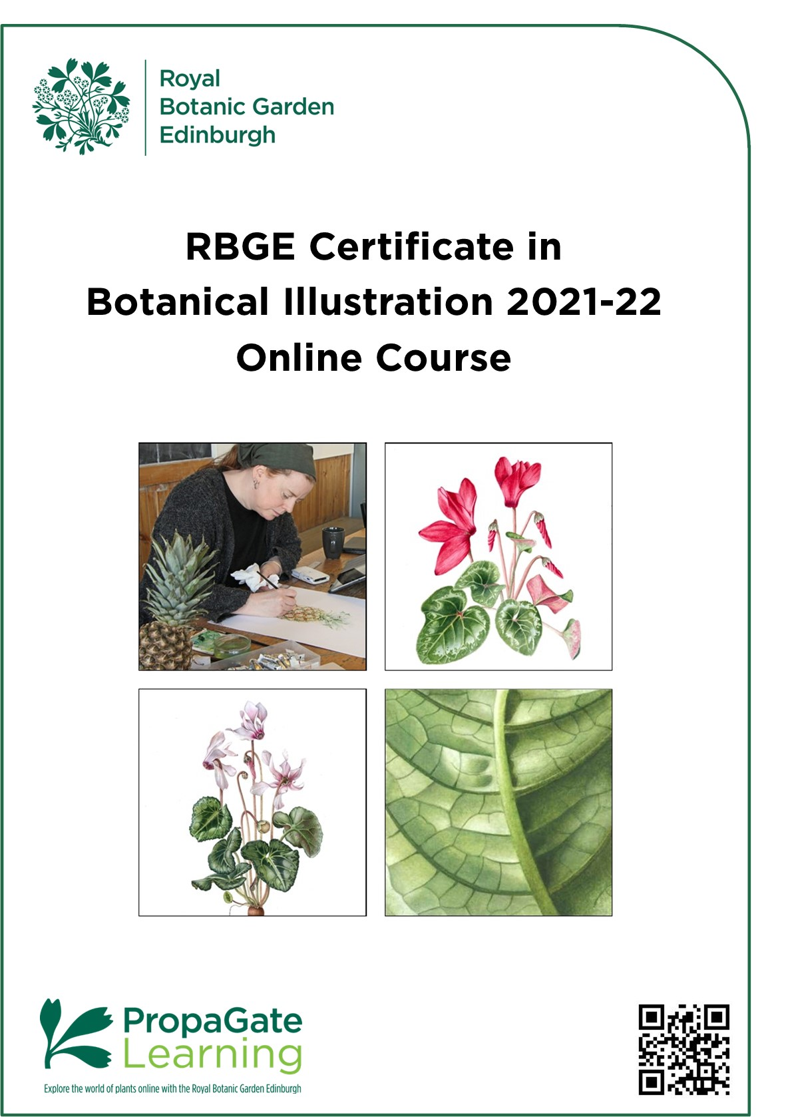

Contents

1. Course Overview 3
2. Course Structure and Dates for 2021-22 4
3. Course Content 5
Unit: CBI-01 6
Unit: CBI-02 7
Unit: CBI-03 8
Unit: CBI-04 9
Unit: CBI-05 10
Unit: CBI-06 11
Unit: CBI-07 12
Unit: CBI-08 13
Unit: CBI-09 14
Unit: CBI-10 15
4. Assessment Methods 16
5. Online Learning 18
6. Equipment Required 20
7. Course Fees 21
8. Entry Requirements 21
9. Application Procedure 22

Cover images: Top left photo by Brenda White
Top right painting by C. Love
Bottom left painting by Agita Keiri
Bottom right painting by Agita Keiri

1. Course Overview
The RBGE Certificate in Botanical Illustration (CBI) is a great way to learn the fundamental techniques of paint and pencil. Using plants as our core subject this course is an ideal starting certificate if you want to become a botanical illustrator. The techniques you learn are valuable across all areas of illustration and seldom taught in art colleges or university art departments, so although it is aimed at beginners it is also useful for developing artists.

This course consists of ten units with ongoing assessment built into the programme. The focus is on the fundamental skills and is taught by experienced and enthusiastic tutors.

There is some theory provided to aid your understanding, but the course is designed to be delivered and assessed using videos, galleries, and text which is focused on predominantly practical skills.

The RBGE Certificate in Botanical Illustration is a formally assessed course and therefore requires students to successfully pass all units and assignments in order to achieve the award. Students are required to build up a course portfolio containing notes, visuals and exercises and to upload this to PropaGate Learning (RBGE’s online learning environment) throughout. This body of work will show progression and help develop skills leading to a final painted composition. Both the portfolio and the final piece will be assessed, and the marks combined to provide the final grade. There is also an element of continuing self-assessment and evaluation within the programme.

RBGE Diploma in Botanical Illustration
This course gives you all the skills required to join the RBGE Diploma in Botanical Illustration if you wish to take your studies to a professional level. Further details on the diploma can be found by visiting our website.

All information in this handbook is correct at the time of publication and is subject to change.

2. Course Structure and Dates for 2021-22
The online CBI programme will be delivered through PropaGate Learning as a ten-unit course. Students who complete all ten units and the assessments are awarded the RBGE Certificate in Botanical Illustration. The timetables below are included to demonstrate the pace of the course. The course can be very absorbing, and some activities may take longer than you expect! We advise that students need to put aside 7-8 hours per week for study.

It is extremely important that you keep to the study timetable to get the most out of this course. It means you will receive feedback at the appropriate times to enable you to continue smoothly with the course and successfully complete it. In the event you do find you are falling behind you must contact your tutor to discuss the options.

If you are unable to complete a module in the specified timeframe, there will be an additional charge for marking and feedback. This fee will vary depending on the module and the level of marking and feedback required. These fees may be waived in the event of extenuating circumstances.

Option 1: Starting September 2021
Unit | Title | Release
Start | Welcome and introductions | 09/09/21
CBI-01 | Context of Botanical Illustration and Drawing Exploration | 13/09/21
CBI-02 | Drawing – Texture & Tone | 27/09/21
CBI-03 | Modelling in 3D with paint | 11/10/21
CBI-04 | Colour and Mixing Paint | 25/10/21
CBI-05 | Botany | 08/11/21
CBI-06 | Practice - Flowers and Leaves | 22/11/21
CBI-07 | Introduction to Composition | 06/12/21
CBI-08 | Working on final Composition – Flowers and buds | 10/01/22
CBI-09 | Working on final Composition - Leaves | 24/01/22
CBI-10 | Working on final Composition – roots, sections, final hand-in | 07/02/22
End | Final Submission | 6 weeks later

Option 2: Starting January 2022
Unit | Title | Release
Start | Welcome and introductions | 06/01/22
CBI-01 | Context of Botanical Illustration and Drawing Exploration | 10/01/22
CBI-02 | Drawing – Texture & Tone | 24/01/22
CBI-03 | Modelling in 3D with paint | 07/02/22
CBI-04 | Colour and Mixing Paint | 21/02/22
CBI-05 | Botany | 07/03/22
CBI-06 | Practice - Flowers and Leaves | 21/03/22
CBI-07 | Introduction to Composition | 04/04/22
CBI-08 | Working on final Composition – Flowers and buds | 18/04/22
CBI-09 | Working on final Composition - Leaves | 02/05/22
CBI-10 | Working on final Composition – roots, sections, final hand-in | 16/05/22
End | Final Submission | 6 weeks later

Option 3: Starting March 2022
Unit | Title | Release
Start | Welcome and introductions | 24/03/22
CBI-01 | Context of Botanical Illustration and Drawing Exploration | 28/03/22
CBI-02 | Drawing – Texture & Tone | 11/04/22
CBI-03 | Modelling in 3D with paint | 25/04/22
CBI-04 | Colour and Mixing Paint | 09/05/22
CBI-05 | Botany | 23/05/22
CBI-06 | Practice - Flowers and Leaves | 06/06/22
CBI-07 | Introduction to Composition | 20/06/22
CBI-08 | Working on final Composition – Flowers and buds | 04/07/22
CBI-09 | Working on final Composition - Leaves | 18/07/22
CBI-10 | Working on final Composition – roots, sections, final hand-in | 01/08/22
End | Final Submission | 6 weeks later

3. Course Content
Descriptors for all units are on the following pages. Each descriptor states the:
- Learning Objectives
- Key Knowledge and Practical Activities to be covered during the unit
- Assessment Guidelines

Unit: CBI-01
Context for Botanical Illustration & Drawing – Line and Measuring

Learning Objectives:
At the end of this Unit students will be able to:
- Understand to the discipline of Botanical Illustration.
- Be familiar the materials of the Botanical Illustrator
- Understand the key structures of the subject through investigation and simple line drawings.
- Understand the basic principles for accurate measured drawing

Key Knowledge:
- Use the drawing materials of the Botanical Illustrator.
- Understand the basic principles for accurate measured drawing.
- Demonstrate how to measure the correct size of the plant parts with correct scale and proportions.
- Understanding of the key structures of the subject through investigation, and simple line drawings

Key Practical Activities:
- Exploration of pencil line techniques
- Practicing key measuring skills
- An accurate measured observational drawing of a fruit and a leaf

Assessment:
- Student self-assessment
- Annotations of materials and methods used
- Upload of coursework

Unit: CBI-02
Drawing – Texture & Tone

Learning Objectives:
At the end of this Unit students will be able to:
- Carry out a range of different techniques in pencil
- Understand the use of tone for 3D rendering
- Understand the techniques for rendering appropriate texture

Key Knowledge:
- Getting to know different pencil strengths appropriate for task
- How to create three dimensional illustrations
- Learn exactly what type of drawing is appropriate for the purpose (sketching, accurate line or tone)
- Reinforcement of measuring skills

Key Practical Activities:
- Exercises in tonal pencil
- Carry out a 3D pencil drawing of a fruit
- Explore various aspects of a leaf, front and back

Assessment:
- Student self-assessment
- Annotations of materials and methods used
- Upload of coursework

Unit: CBI-03
3D Modelling with Paint

Learning Objectives:
At the end of this Unit students will be able to:
- Mix a variety of tertiary colours
- Build up depth of tone appropriate to the subject
- Use different methods to create detail

Key Knowledge:
- How to mix good tertiary colours
- Building up depth of tone in a controlled way
- Different methods to create detail
- Render the subjects in 3 Dimensions

Key Practical Activities:
- Tertiary colour mixing
- Creation of 3D shapes
- Transfer of drawing
- Application of paint

Assessment:
- Student self-assessment
- Annotations of materials and methods
- Upload of coursework

Unit: CBI-04
Painting in True Colour

Learning Objectives:
At the end of this Unit students will be able to:
- Understand the principles of primary colour mixing
- Apply paint with the appropriate technique
- Understand how to bring a subject to a conclusion

Key Knowledge:
- Proportions of paint to water
- To learn control of paint
- Creating 3D form

Key Practical Activities:
- Colour Charts
- Primary Colour Wheel
- Further dry brush technique
- Colour matching fruit and foliage

Assessment:
- Student self-assessment
- Annotations of materials and methods
- Upload of coursework

Unit: CBI-05
Botany

Learning Objectives:
At the end of this Unit students will be able to:
- Identify basic floral parts and their functions, in order to record the plants correctly
- Create and draw a cross section of a flower
- Understand how to convey scale
- Utilise a camera for recording accurately all the plant details

Key Knowledge:
- Appreciation of structure of flower head and its function
- Understanding of section depictions and scale conventions
- Identification of important and relevant parts of the plant
- Appreciation of the work of other botanical artists

Key Practical Activities:
- Becoming familiar with the final project brief
- Learning the basic botany of the plant subject
- Learn to dissect the flower and create a drawing
- Looking critically at botanical art from the context of your studies

** Introduction to Final Composition Brief will be given **

Assessment:
- Student self-assessment
- Annotations of materials and methods
- Upload of coursework

Unit: CBI-06
Exploring Composition – Leaves and Flowers

Learning Objectives:
At the end of this Unit students will be able to:
- Identify basic structure and parts of leaves and flowers
- Draw and paint subject to a life-like standard
- Accurately match the colours of all plant parts
- Create a storyboard to plan a composition

Key Knowledge:
- Building on the skills of the previous units
- Practising colour matching
- Practising painting techniques
- Assembling work produced by different approaches
- Organising one’s time with reference to the life of the plant

Key Practical Activities:
- To colour test and mix relevant colours
- Investigate the subject through drawing and painting
- Learn the importance and use of Story boards

Assessment:
- Student self-assessment
- Annotations of materials and methods
- Upload of coursework

Unit: CBI-07
Composition

Learning Objectives:
At the end of this Unit students will be able to:
- Arrange elements aesthetically
- Use sketches to help create a balanced composition
- Create a measured drawing of each part and combine into a convincing whole
- Transfer a drawing onto watercolour paper

Key Knowledge:
- View scientific and contemporary painting styles and consider how they differ
- Explore and understand how to create an interesting composition
- Create a measured drawing of the composition
- Transfer the drawing to watercolour paper

Key Practical Activities:
- Use of an appropriate method to transfer the drawing to watercolour paper
- Develop composition to conclusion

Assessment:
- Student self-assessment
- Annotations of materials and methods
- Upload of coursework

Unit: CBI-08
Working on the Final Composition – Flowers and Buds

Learning Objectives:
At the end of this Unit students will be able to:
- Understand colour weight and balance, and the relationships between the elements of a composition
- Depict the flowers and buds to a high standard of finish
- Understand how to create depth of field in a painting

Key Knowledge:
- Importance of refining the composition
- Gain confidence with colour mixing and matching
- Continue exploration of paint application
- Control and use of materials

Key Practical Activities:
- Identifying correct colour balance for flowering parts
- Continue to work on the painting of the three elements
- Exploring details and challenging areas

Assessment:
- Student self-assessment
- Annotations of materials and methods
- Upload of coursework

Unit: CBI-09
Work on Final Composition - Leaves

Learning Objectives:
At the end of this Unit students will be able to:
- To assess areas requiring more work
- Adjust work to increase depth of field
- Depict surface pattern
- Render overlaps convincingly

Key Knowledge:
- Balancing the composition
- Creating convincing spatial relationships between elements
- Understanding atmospheric depth

Key Practical Activities:
- Reinforcement of colour mixing techniques
- Exploring depth and overlapping subjects

Assessment:
- Student self-assessment
- Annotations of materials and methods
- Upload of coursework

Unit: CBI-10
Finalising and hand in of all course work - Roots, sections and hand in

Learning Objectives:
At the end of this Unit students will be able to:
- Application of finishing techniques
- Know when your painting is finished
- Be able to depict roots
- Transfer knowledge and skills gained to other pieces of work

Key Knowledge:
- Assessment of coursework so far and completion of any outstanding work
- Investigation of areas for future work and development
- Awareness of when to add additional elements

Key Practical Activities:
- Complete final composition and any outstanding course work
- Drawing roots
- Decide on the inclusion of additional elements

Assessment:
- Student self-assessment
- Annotations of materials and methods
- Upload of coursework

4. Assessment Methods
This is a predominantly practical course, designed to teach a foundation level of skills, understanding and competence. This will be delivered through a series of videos, written tasks and galleries for reference. Candidates will be assessed in three ways:

4.1 Course Portfolio for Units 1-4
(35% of assessment marks)
You will be asked to upload work regularly for feedback and/or assessment.

You will need to include notes, self-analysis, diagrams, and photographs. These will need to be uploaded along with your work. This is a practical course, and you will be engaged for the most part in ‘hands on’ drawing and painting.

As you progress through the course you will to create a collection of work that will be a valuable resource to refer back to in the future.

You will be given tutor feedback at key points during the course, and your work and finished composition will be assessed at the end.

4.2 Botany & Self-Assessment throughout the course
(15% of assessment marks)
Each student is required to fill in the Submission Text area at the end of each unit. This is to enable the tutors to gauge your understanding of your progression through the course.

4.3 Final Composition Project: Units 5-10
(50% of assessment marks)
Working from fresh plant material, students experiment with compositional approaches and, with tutor approval, select the final composition to be used.

Beginning with pencil studies, the proposed image composition is agreed and transferred onto the final watercolour paper and the process of painting from base washes to fully rendered state follows.

Students are required to present their work, demonstrating that they have been able to meet the set criteria, given at the start of the course. A level of skill, in association with the assessment criteria, is required to pass this course.

Grading will consist of:
- An assessment of the course units through your portfolio of work
- An assessment of your final composition
- An assessment of basic botanical knowledge
- Analysis of your Student Self-Assessment
- Written tutor feedback to students.

Your Portfolio of work will count for 35% of the final course mark, Botany and Student Self-Assessment throughout the course 15%, and the Final Composition 50%.

4.4 Certification & Grading
Successful candidates will be awarded the ‘RBGE Certificate in Botanical Illustration’, which will be graded as follows:
- Referral: 49%
- Pass: 50%-59%
- Merit: 60%-69%
- Distinction: 70% and above

NB: Referred candidates may retake the Final Composition Assessment but will only be able to gain a Pass.

4.5. Common Themes
The following themes will be considered throughout all the modules.
- Observation
- Drawing with precision
- Materials and equipment
- Painting techniques
- Composition
- Sourcing information
- Understanding plants
- Keeping a portfolio of work

5. Online Learning
Your online learning environment is PropaGate Learning which uses the Moodle learning platform.

PropaGate Learning is the website that you log into to access your course. It is a place for learning and for discussing topics and progress with your tutors and other students. PropaGate Learning allows you to study from home, whilst becoming part of a thriving and enthusiastic learning community.

Your course consists of a number of elements including: notes, videos, galleries, discussion forums, and an upload area for your drawings and paintings. The resources and activities are designed to help you learn online and to help you to share and learn from each other.

How can I prepare for studying online?
You should be a competent computer user with a basic understanding of standard computer applications such as using an internet browser, email and word processing. Your course involves uploading your drawings and paintings, so experience of scanning images using a scanner, taking photographs with a digital camera and of editing/re-sizing images would be useful. Our ‘Digital Skills Check’ will help you to identify any areas of IT you may need to brush up on.

You will be given access to PropaGate Learning prior to the course starting to help you familiarise yourself with the online environment. Please make use of this time as it will enable you to fully engage with the course itself once it starts, rather than spending your time finding your way around. It is also a chance to meet other learners and the tutors.

Online courses require a much more self-motivated learning style than traditional attended classes. You should plan to set aside a certain amount of time to log into the course classes and carry out tasks. You will need to be proactive about understanding the timetable and submitting your work. Participation in online discussions and the sharing of work is also part of the course – online learning is much more sociable than you might think!

What hardware or software will I need?
You will need access to a desktop or laptop computer with an up-to-date operating system. You will also need a reliable internet connection capable of viewing videos online. Most of the course will be accessible via a tablet, but we recommend using a laptop or desktop computer. You may find some aspects of the course will be easier to use on a computer. You will also need access to a digital camera and/or a scanner. In most instances a good camera image or clear phone camera image is sufficient.

Regarding software, you will need an up-to-date browser (e.g., Firefox, Chrome, Safari). You will also need software that will open PDFs (e.g., Adobe Reader).

The PropaGate Learning website is available 24/7 with the exception of any maintenance work, which we will inform you about in plenty of time.

What support is available?
We encourage everyone to make the most of the forums on the course. These provide a way for students to talk to one another and to tutors and ask each other questions. Tutors usually check the forums at regular intervals (e.g. once or twice a week). There is also a private messaging forum within PropaGate Learning where you can contact your tutor directly and privately.

Our PropaGate Learning team are always available so if you ever feel you are stuck with a course-related technical problem, they can be contacted via the forums or by emailing: propagatelearning@rbge.ac.uk

6. Equipment Required
This is a practical course so you must have basic drawing and painting materials.

Art Materials
- A4 drawing paper pad
- Hot Press Watercolour paper: At least 2 sheets of 300 gsm paper A2 size or local equivalent (such as Saunders Waterford Hot Press (HP) watercolour paper)
- Tracing paper: 1 sheet
- Artists Quality Watercolour Paints (such as Windsor & Newton Professional Quality Watercolour Paints) in the following colours:

- Permanent Rose
- Perylene Maroon
- Transparent Yellow
- Windsor Lemon
- Indanthrene Blue
- Cobalt Blue

- 2B, HB, 2H pencils
- Ceramic palette or white plate for mixing paint
- High quality pointed watercolour brushes size 0, 2 and 4 (these are not required until Unit 03)
- Eraser – Plastic and Putty
- Sharpener / knife
- 30cm clear Ruler and / or dividers
- Magnifying glass
- A “Pocket” microscope is also recommended

Computer Equipment
You will need access to a desktop or laptop computer with an up-to-date operating system and a reliable internet connection capable of viewing videos online. You will also need access to a digital camera and/or a scanner. In most instances a good camera image or clear phone camera image is sufficient.

Software
You will need an up-to-date browser (e.g., Firefox, Chrome, Internet Explorer). You will also need software that will open PDFs (e.g., Adobe Reader).

7. Course Fees
The cost for the course is £720. Full payment for the course is required on acceptance of a place. Fees do not include the cost of any materials required to complete the course.

8. Entry Requirements
Although there are no formal entry requirements, it is important to note that this course will be delivered fully online and in English.

There is a lot of reading, and you must be able to write in English when communicating with your tutor. A good understanding of the English language is required to get the most from the course and to enable you to succeed in your studies.

You should be a competent computer user with a basic understanding of standard computer applications such as using an internet browser, email and word processing. Your course involves uploading your drawings and paintings, so experience of scanning images using a scanner, taking photographs with a digital camera and of editing/re-sizing images would be useful. Our ‘Digital Skills Check’ will help you to identify any areas of IT you may need to brush up on.

9. Application Procedure
Spaces on this course are limited. Candidates will be selected on the basis of the answers given to the questions on the application form at the back of the handbook. If all applications are of a high standard, spaces will be allocated to people based on the date the applications were received.

Applications will only be open for one intake of the course at a time. To apply for the course, you must complete our online application form.

Course | Applications Open | Applications Close
September 2021 Intake | Wednesday 11th August 2021 | Thursday 19th August 2021
January 2022 Intake | Monday 27th September 2021 | Friday 5th November 2021
March 2022 Intake | Monday 17th January 2022 | Friday 3rd February 2022

Applications will open at 9.00am on the first day and close at 5.00pm on the last day. These times are UK times, please take this into account if applying from outside the UK.

Applicants will be notified if their application has been successful or not within 2 weeks of the application deadline date.

