Access Guide

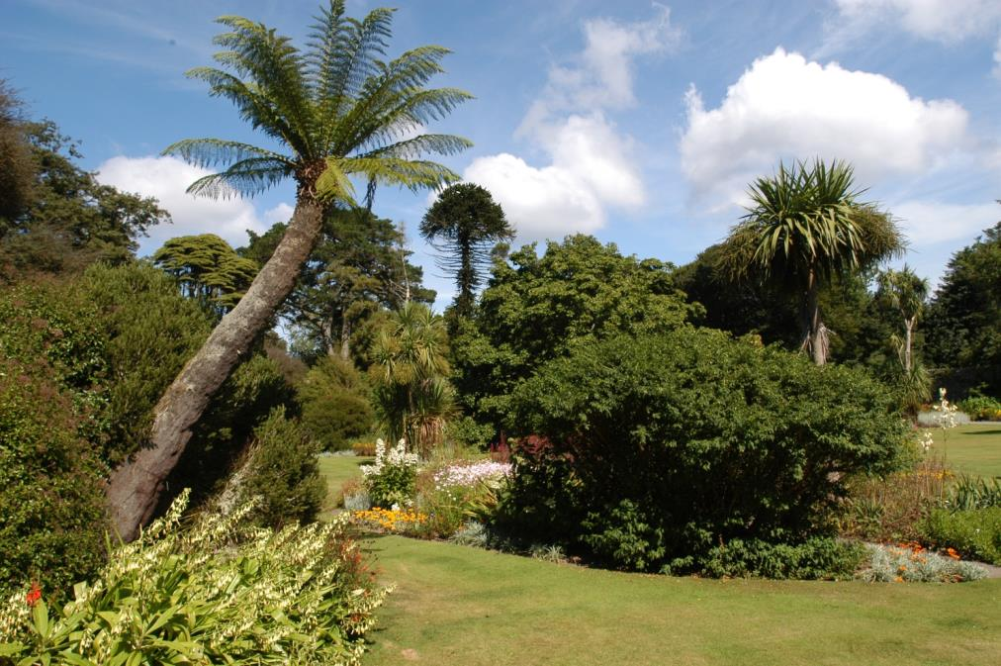

Logan Botanic Garden
Port Logan, Stranraer
Dumfries & Galloway
DG9 9ND

+44 (0) 1776 860231

www.rbge.org.uk/logan

Contents
Access Guide 1
1.0 Our Accessibility Promise to You 3
2.0 A Map of Logan Botanic Garden 4
3.0 How To Reach Us 5
3.1 By Road 5
3.2 Parking 6
3.3 By Bus 6
3.4 By Rail 7
3.5 By Taxi 7
3.6 By Ferry 7
3.5 By Bicycle 7
4.0 Garden Reception 8
4.1 Information and Ticket Desk 8
4.2 Garden Entry 10
5.0 The Garden 10
5.1 The Logan Conservatory 13
5.2 The Discovery Centre and Logan Studio 14
6.0 The Potting Shed Bistro 15
7.0 Shop 16
7.1 Plant Sales 17
8.0 Hearing Loops 17
9.0 Mobile Reception and Wifi 17
10.0 Accessible Toilet 18
10.1 Changing Places WCs 19
10.2 Accessible Toilets in Stranraer 19
11.0 Evacuation 20
12.0 Assistance Dogs 20
13.0 Future Plans 21
14.0 A final word about the weather 21
15.0 Contact Us 21

This Access Guide aims to accurately describe the facilities and services that we offer all our visitors and guests and does not contain personal opinions as to our suitability for those with access requirements.

1.0 Our Accessibility Promise to You

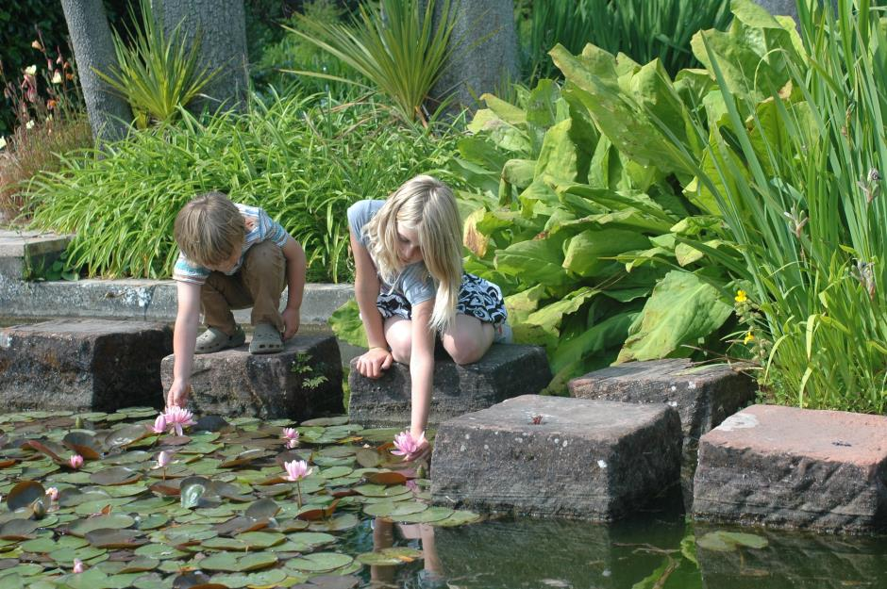

Five-star Logan Botanic Garden, Scotland’s most exotic Garden, welcomes all visitors and aims to provide best possible access to everyone in order that they enjoy their visit to our Garden. New health and safety measures are in place to protect visitors and staff following the Covid-19 outbreak. Some of our facilities and services are restricted.

We provide:
- One accessible toilet near the Garden entrance.
- Two wheelchairs for visitors to use.
- Lots of benches at regular intervals throughout the Garden.
- Water for assistance dogs, which must be highly trained.
- Pen, paper and magnifying glass at our Reception desk.
- An accessible path around the Garden.

If you require any further information about specific access or need advice about planning your visit please contact us on: +44 (0) 1776 860231 or email us at logan@rbge.org.uk.
If we have not covered your access needs in this document, please contact us and we will discuss your needs and offer help where we can.

2.0 A Map of Logan Botanic Garden

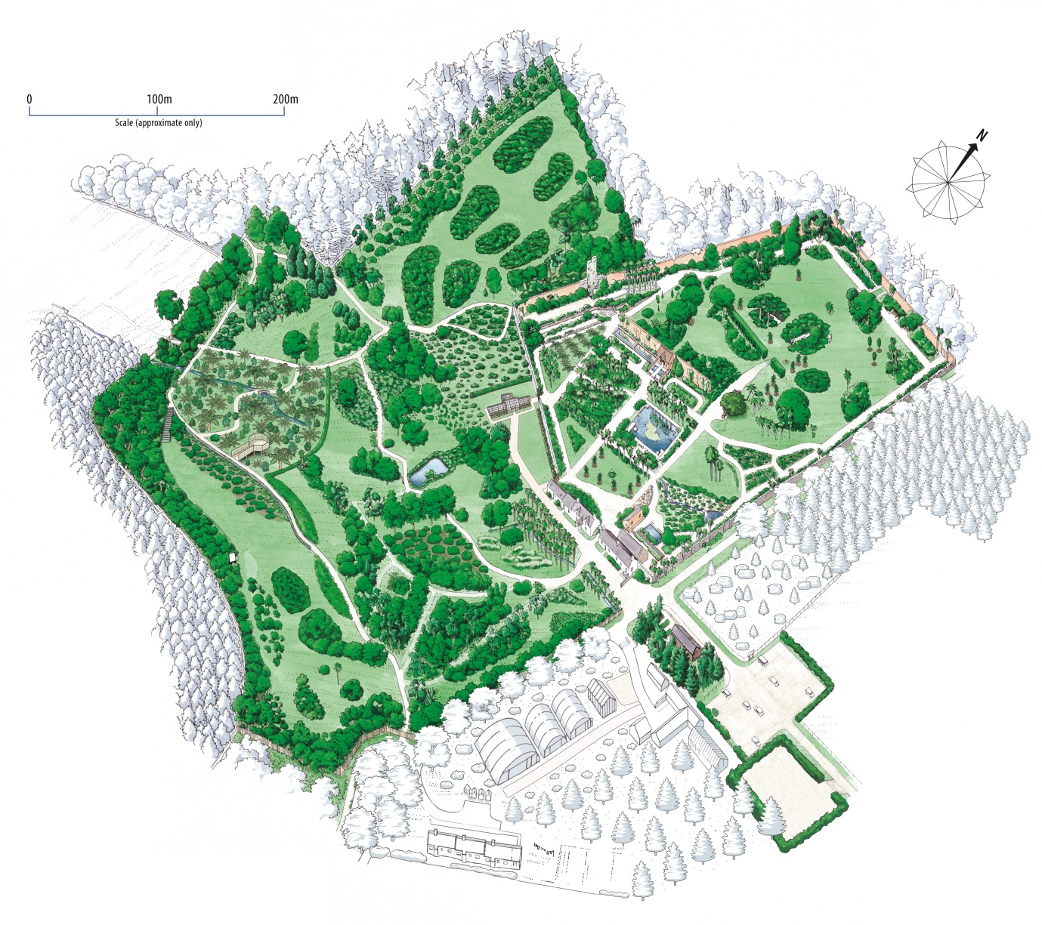

Above: This map shows the layout of Logan Botanic Garden which is a 25 acre exotic Garden, warmed by the Gulf Stream. There is a designated route for wheelchair and mobility scooter users. A map is available on arrival with this route clearly marked. For more details about the Garden and accessible paths, turn to page 10.

There is a welcome panel in the car park outside the entrance which gives further visual information about the Garden. The panel shows the location of the accessible toilet and also confirms that assistance dogs are welcome in the Garden. However, if you have further questions, please just ask at the Reception area beyond.

3.0 How To Reach Us
Logan Botanic Garden is located 14 miles south of Stranraer in the Rhins of Galloway, off the A716 and the B7065. Plan your journey by using www.transportdirect.info.

3.1 By Road

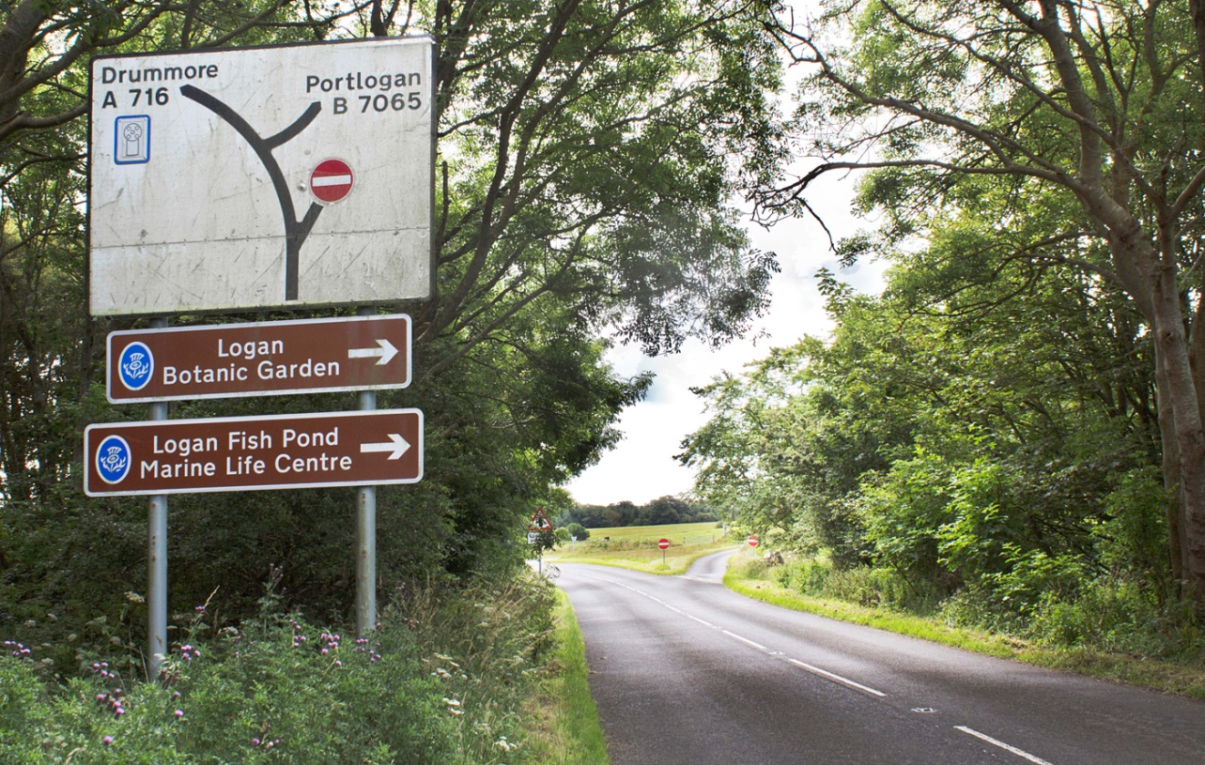

Above and below: The Garden is sign-posted from the A716.

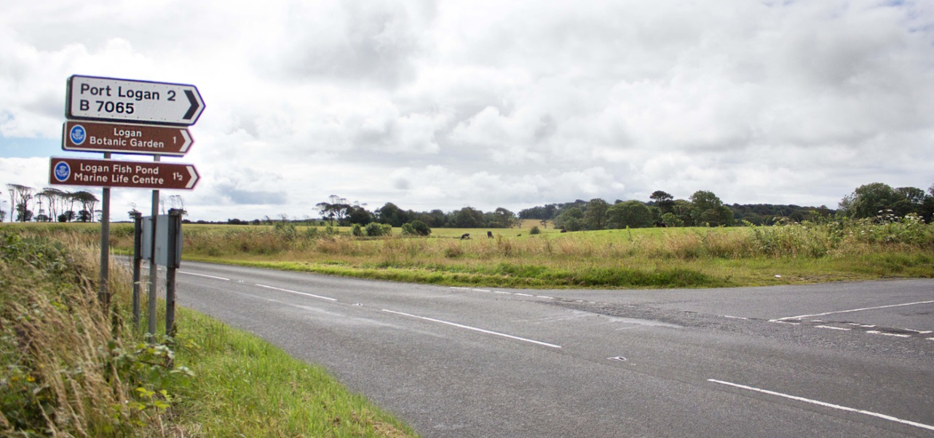

3.2 Parking

There is a large car park at Logan Botanic Garden and enough space is available for coaches and minibuses. Parking is free. There is also an electric charger point.

There is one designated parking bay on the right-hand side for Blue Badge holders approximately 50 metres from the entrance.

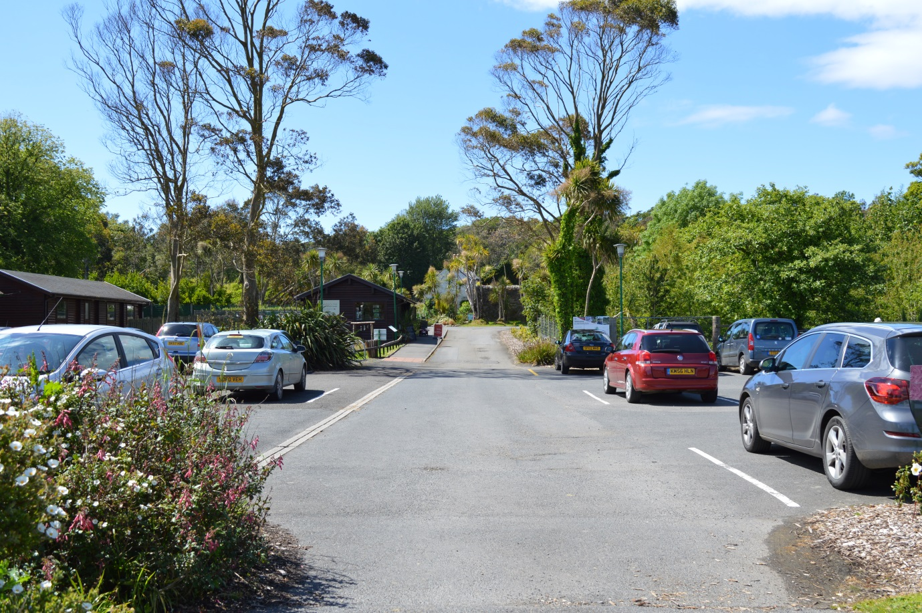
Above: Logan car park offers plenty of space for visitors.

3.3 By Bus

The region’s bus service is operated by Stagecoach West Scotland which links the major towns and villages within South West Scotland. Buses run from Edinburgh, Glasgow and Dumfries to Stranraer where a connection can be made to Port Logan. The bus stops outside the Garden on request. Please note that buses to Port Logan do not operate on Sundays. For more information on bus services in the area, visit www.travellinescotland.com
Please check availability of services during this uncertain time.

3.4 By Rail

The nearest station is Stranraer which is served by www.scotrail.co.uk. Trains run from Ayr and Glasgow. A bus journey would be required from Stranraer to Port Logan on bus number 407. Buses to Port Logan do not operate on Sundays. Please check available services directly with providers during this uncertain time.

3.5 By Taxi

There is taxi rank in Stranraer just down from Tesco, in Charlotte Street, DG9 7EF or taxis can be called. A local firm is McLeans, contactable on 01776 705555. Please check services are operating during this time.

3.6 By Ferry

Ferries travel from Belfast and Larne in Northern Ireland to Cairnryan, just outside Stranraer. For more information, please visit www.stenaline.co.uk and www.poferries.com. Please check available services directly with providers during this uncertain time.

3.5 By Bicycle

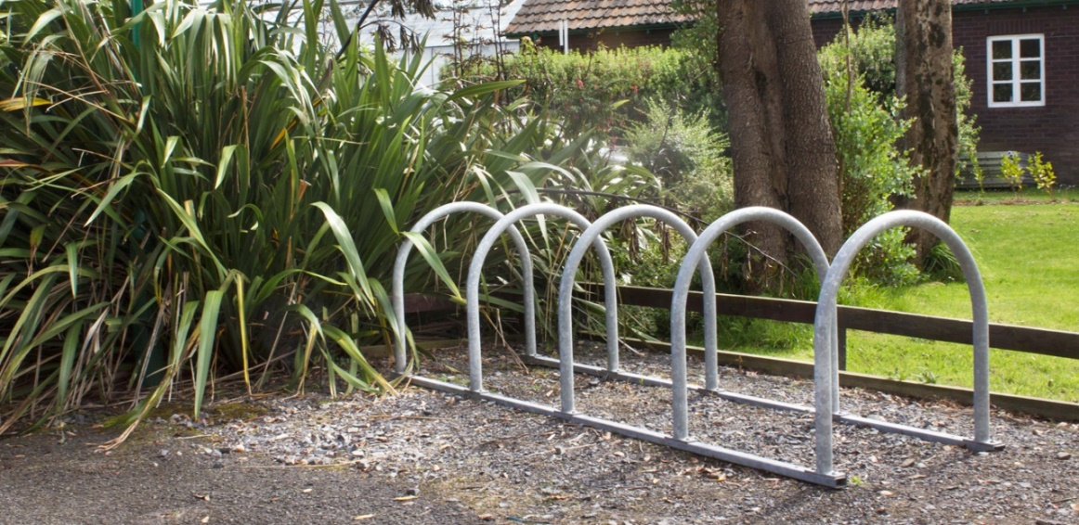

Above: Bicycle stands are available in the car park outside the visitor centre.

4.0 Garden Reception

The Garden’s reception and information desk is located approximately 50 metres from the car park on the left, accessed by a wide route which is mostly level with a slight incline of 1:20. The door to the reception and shop is 1040mm clear opening with a small threshold of about 15mm at the entrance.

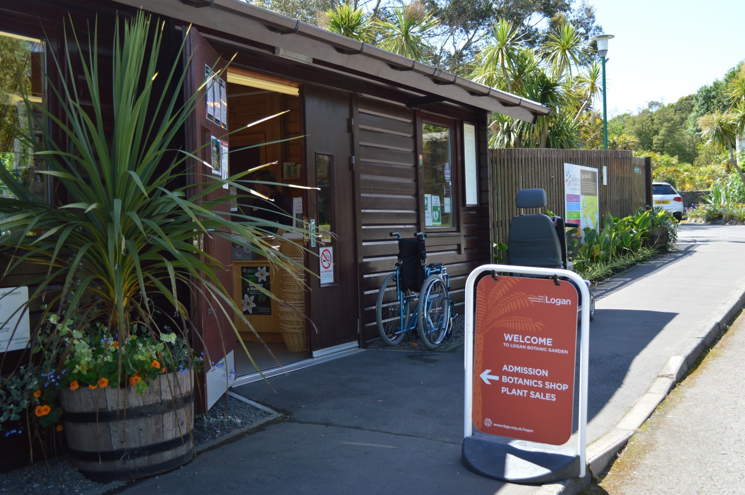
Above: The Garden’s reception and shop, where there are two manual wheelchairs to borrow. To ensure availability, please call us to book these in advance of your visit on +44 (0) 1776 860231 or email logan@rbge.org.uk.

4.1 Information and Ticket Desk

Logan’s reception area is accessible to wheelchair and mobility scooter users, and there is a hearing loop available. A warm welcome is guaranteed at the information desk where you can buy your admission ticket. Access to the reception area is limited for health and safety reasons during this time. Please observe physical distancing guidelines and note that staff are working behind a protective screen.

Ticket concessions are available and carers go free. For the latest prices, please visit our website www.rbge.org.uk/logan. Our staff will be delighted to provide you with a map indicating the accessible pathways at Logan.

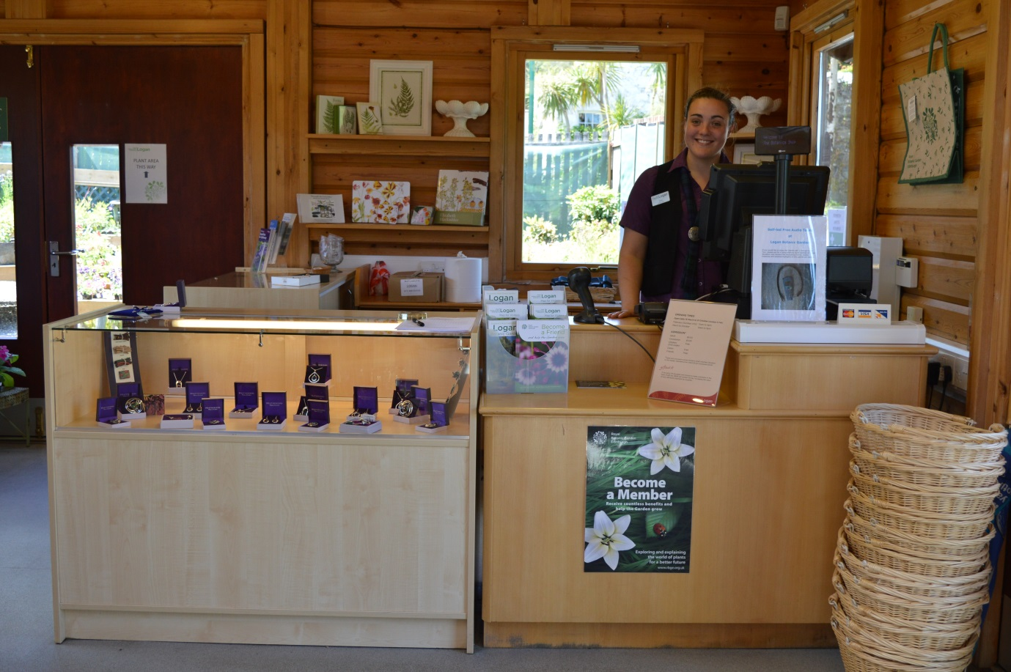

Above: The information desk, where you will receive a warm welcome, has a lowered section at the till point and a hearing loop. Protective screens for staff and visitors are currently in place.

4.2 Garden Entry

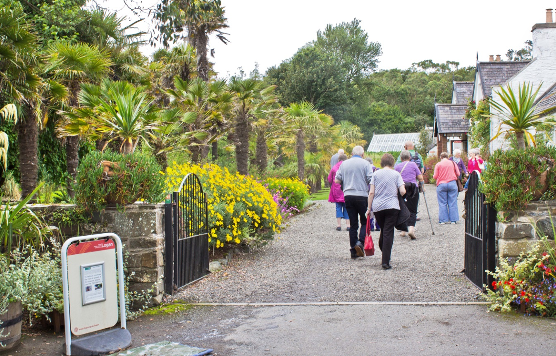

Above: The Garden is accessed from reception through open gates. Please note, there is a foot mat before the entrance to the Garden which helps to protect the plants from external plant diseases. There is a wide and generally level path leading to the Garden.

5.0 The Garden

Logan Botanic Garden is an exotic paradise, home to plant treasures from South and Central America, Southern Africa and Australasia rarely seen in the United Kingdom. Here, visitors can enjoy groves of palm trees and eucalyptus as well as giant rhubarb-like gunnera plants. The Walled Garden is a showcase for exotic plants and the fish pond, adorned with water lilies, adds to the air of tranquillity.

Much of the Garden is flat and level. However, there are some paths at Logan which are steep and inaccessible for disabled visitors. These include the terrain at upper levels, including gradients of 1:5 – 1:7 leading to the Australasian Collection and Chilean Collections, and the stepped route up to the Woodland Garden. Also, assistance may be required for manual wheelchair users to reach the Tasmanian Creek and Viewing Platform.

Much of the Garden is flat and level with footpaths generally comprising of compacted gravel. These paths are mostly wide and level.

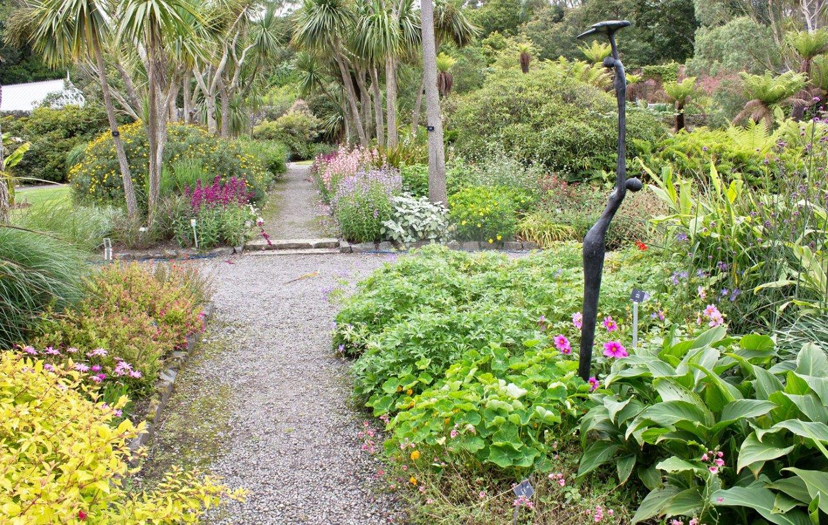
Above and below: Typical paths at Logan are compacted gravel
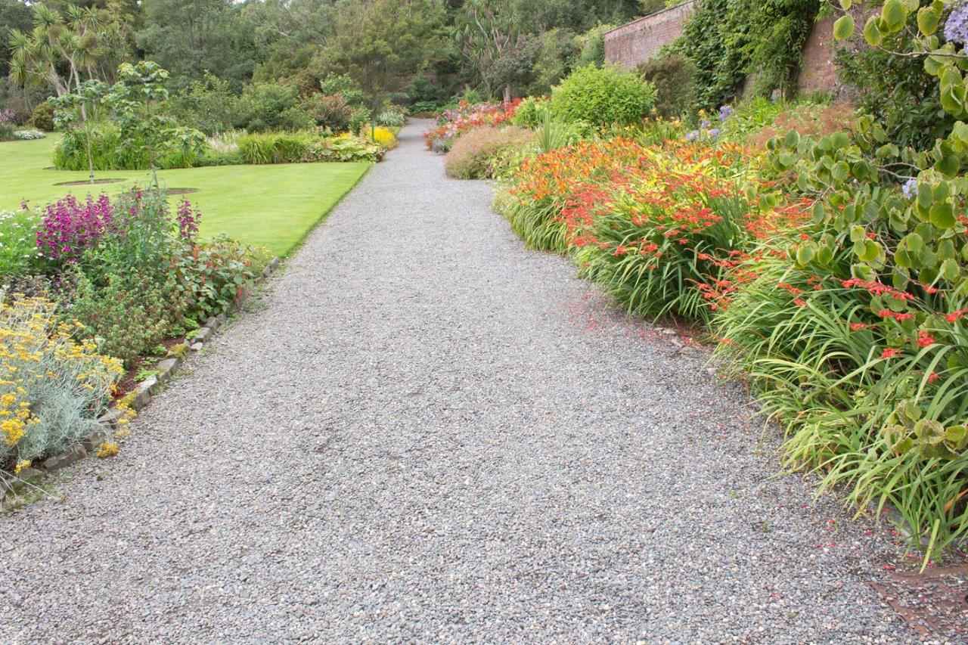
A range of bench seating is provided at regular intervals around the Garden in all locations. These provide visitors with an opportunity to take a break and rest with their companions.

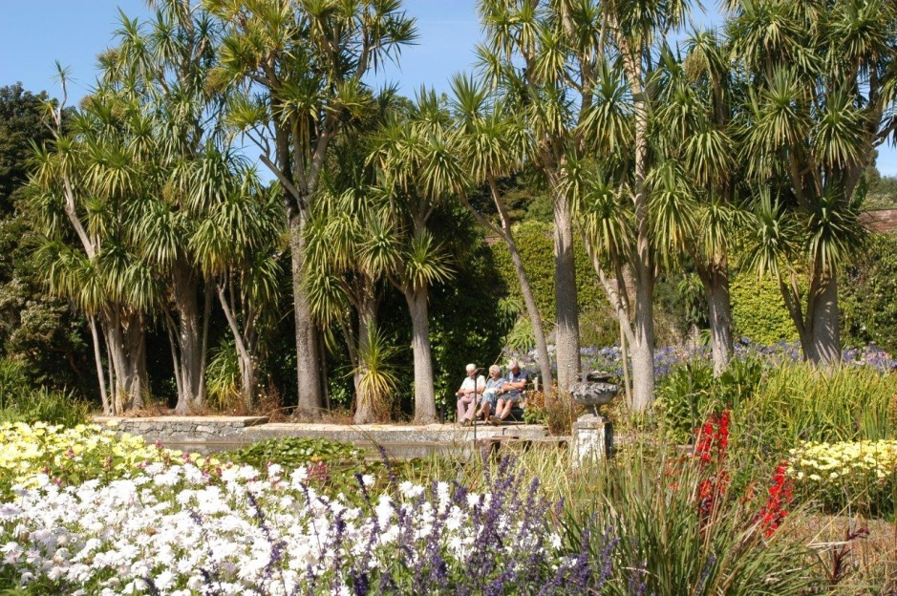
Above and below: Benches are positioned in many locations around the Garden.
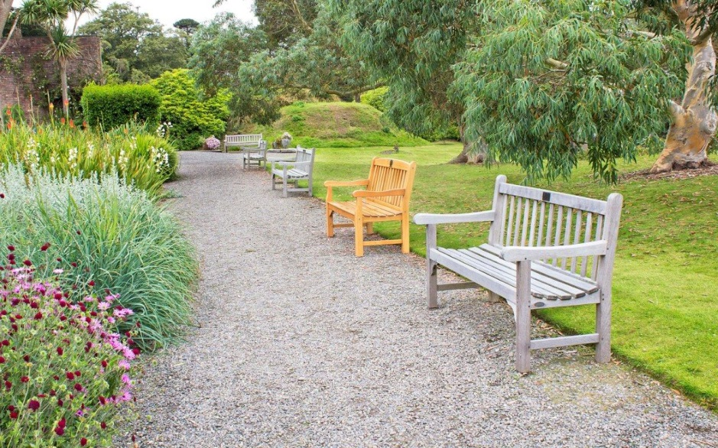

5.1 The Logan Conservatory

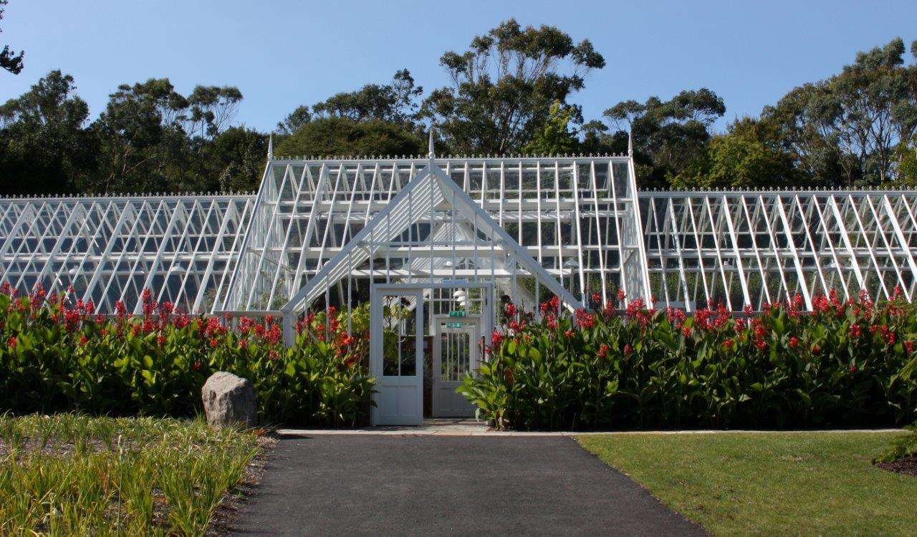

The elegant Logan Conservatory (above) houses a range of especially tender plants from Southern America and Southern Africa.

The Logan Conservatory is accessible to wheelchair and mobility scooter users. Please note that there is a gradient of up to 1:12 leading up to the Conservatory and some manual wheelchair users may require assistance to gain access. Within the Conservatory, doors have a minimum of 875mm clear opening.

Some manual wheelchair users also may need assistance to gain access to the Walled Garden at the set of gates beside the Logan Conservatory.

Please note that there is a one-way system in place in the Logan Conservatory during this period and we ask visitors to observe physical distancing guidelines.

5.2 The Discovery Centre and Logan Studio

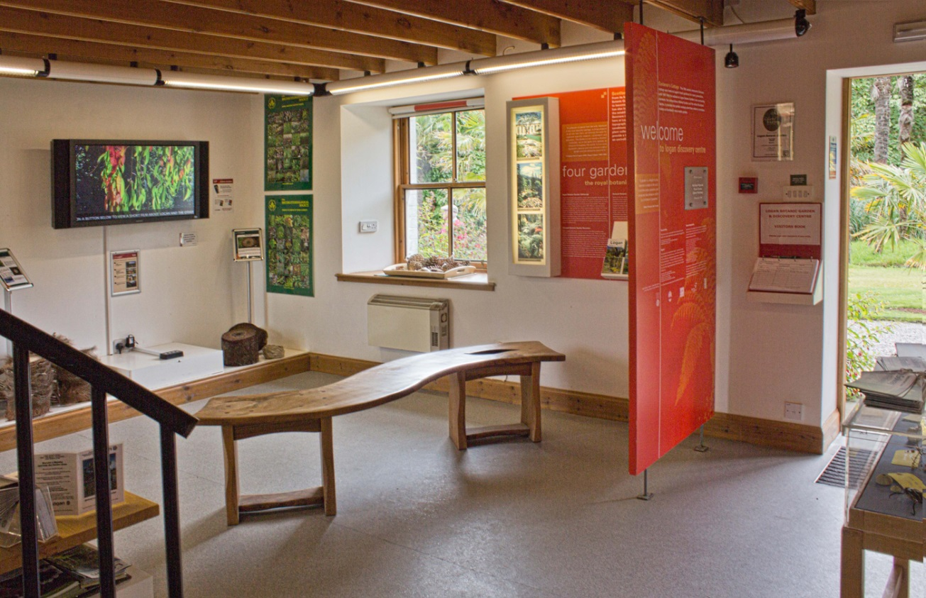

The Discovery Centre and Logan Studio (above) are spaces where Logan Botanic Garden presents videos and exhibitions, often with an environmental theme. There are tactile objects such as flower heads and cones for visitors to touch.

There are external doors, 750mm clear, providing access to both the Discovery Centre and Logan Studio which are both at ground level. There is a slight incline leading into the Discovery Centre. The Discovery Centre and Studio adjoin via a doorway inside where there is a 190mm high step with nosing.

There is also a spiral staircase inside the Discovery Centre which leads to an upper exhibition gallery which is inaccessible to wheelchair and mobility scooter users. Note that upstairs the ceilings are slanted and low so visitors must mind their heads.

The Discover Centre and Logan Studio are operating a one-way system and we ask visitors to observe physical distancing guidelines while inside the area.

6.0 The Potting Shed Bistro

Logan’s Potting Shed Bistro is open for take-away food and drink. There is a one-way system in place and customers are asked to observe physical distancing guidelines. Staff are serving behind a protective screen. Cashless payment is preferred.

The Bistro (pictured below) is accessed through a gate with a 900mm clear opening. The doors to and from the Bistro are 800mm clear opening.

There are large print menus available and our staff are happy to read out the menu.

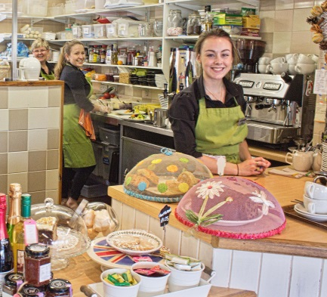

Bistro staff are on hand to provide assistance should visitors have any specific dietary requirements, allergies or food intolerances. A warm welcome is assured.

Logan also now offers wheelchair accessible picnic benches outside the Bistro.

7.0 Shop

There is a shop in the reception area as you enter and exit Logan Garden. It offers a wide range of quality gifts, souvenirs, books and plants. The shop is open with a one- way system in place. Visitors are asked to observe physical distancing guidelines.

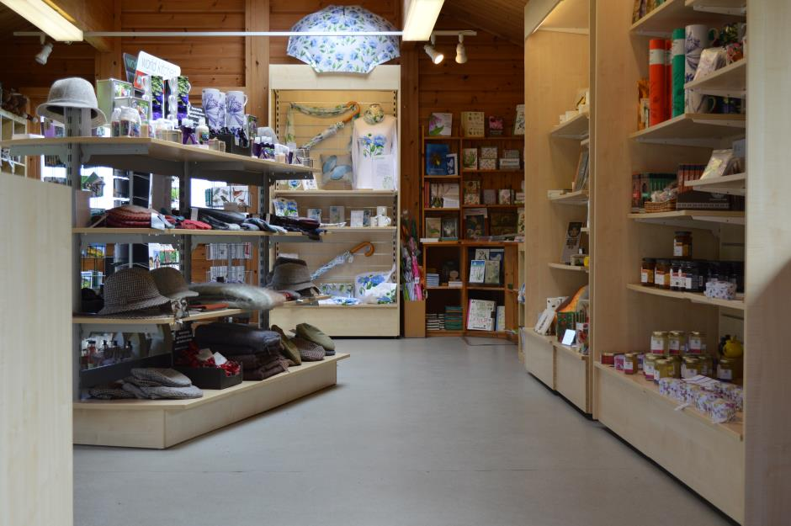
Above: Wide aisles in the shop.

Features of the shop:

- Step free access and spacious placement of shop fixtures to allow ease of movement for wheelchairs and motorised scooters.
- The outdoor plant area is accessed through doors at the rear of the Visitor Centre.
- The shop is evenly and well lit.
- There is a hearing loop at the till point, a magnifying glass, pen and paper.
- Our shop staff are always on hand to offer assistance.

7.1 Plant Sales

Logan provides an outdoor plant sales area, accessed via its shop. Plants are displayed at a height that wheelchair users can see. The door to the plant sales area is 1040mm clear opening and there is a threshold of about 30mm at the doorway. Wheelchair users may require assistance at this doorway. Our shop staff are happy to offer assistance.

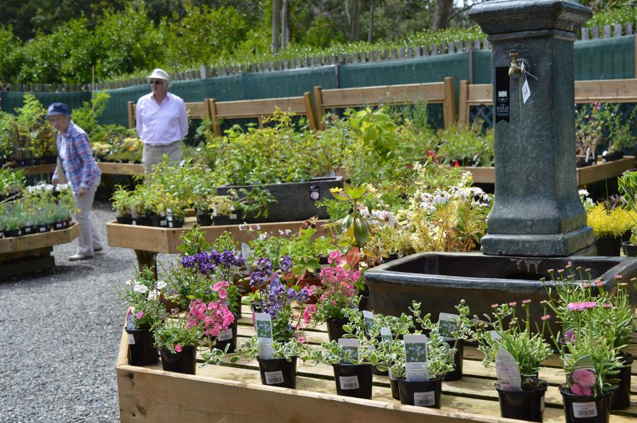
Above: The plant sales area to the side of the reception centre has wide gravel paths.

8.0 Hearing Loops

A permanent Induction Loop is fitted at the reception information desk. Please ask for assistance if you require it.

9.0 Mobile Reception and Wifi

Visitors with medical conditions should be aware that mobile signal is extremely limited at Logan but there is some signal in the Garden itself. Currently there is no public access to Wifi. If you require assistance, please ask at the reception.

10.0 Accessible Toilet

There is an accessible toilet in the public WC building near the Garden entrance. Entry is easiest from the outside of the building. Note that there is a slight incline to the entrance. Doors to the WC are 800mm clear opening with a 1200mm clear space opposite the door.
Three steps leading down to the WCs from the Potting Shed Bistro make access from the restaurant a challenge for disabled visitors. Note that these steps have highlighted nosings and a handrail to one side.

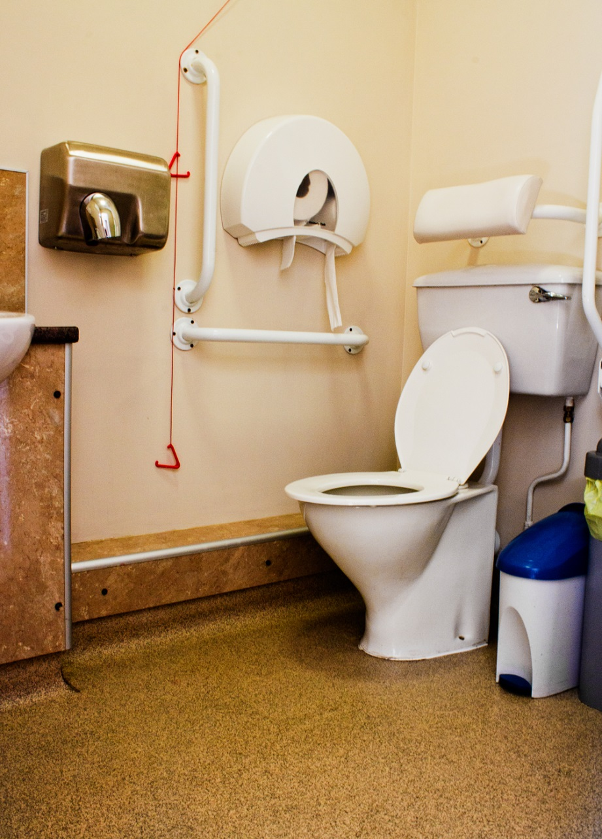
Above: The accessible toilet at Logan Botanic Garden

10.1 Changing Places WCs

The nearest Changing Places WC is in Stranraer. For further information, please visit www.changing-places.org:

13 miles from Logan Botanic Garden:
Stair Park public toilets
London Road
Stranraer
DG9 8B

Normally open daily between 00.00hrs and 23.59 hrs but please double check opening times during these uncertain times.

Owned by Dumfries & Galloway Council, this stand-alone toilet is located within a play park and provides the following:

- Toilet located at ground level
- Bench – height adjustable, adult-sized, wall mounted
- Ceiling hoist with loop
- Peninsular toilet
- Non-slip floor
- Floor space (14 sq m)
- Emergency alarm

10.2 Accessible Toilets in Stranraer

There are a number of other accessible toilets in Stranraer, 14 miles away from Logan Botanic Garden, including a unisex accessible toilet at Stranraer railway station. Please check directly with these facilities that they are open during this uncertain time.

11.0 Evacuation

Should a fire alarm sound and an evacuation take place, the reception and Garden staff will assist those with specific needs to evacuate. They will also assist those who require help until the fire services arrive. The accessible toilet will be physically searched in the event of an emergency evacuation.

12.0 Assistance Dogs

Logan Botanic Garden welcomes assistance dogs. Dog bowls of water are available on request in the restaurant. Logan has a world-leading collection of plants that it has a duty to protect and we also have a responsibility to care for all our visitors. Therefore, it is our policy that only assistance dogs that are registered or highly trained are allowed into the Garden. Assistance dogs should be kept on a lead during their visit.

Above: Guide dog Huxley with toddler Francesca

13.0 Future Plans

Logan Botanic Garden is committed to enhancing its offering to those with specific requirements. Our future plans include:

- To hold more events which highlight our accessibility.
- To providing disability awareness training to our staff.
- To offer more general information about the Garden in large print.

14.0 A final word about the weather

Please note that in severe weather conditions the Garden closes for safety reasons. You are welcome to call us to check that the Garden is open on 01776 860231. Visitors are recommended to take extra care outside when exposed to weather conditions such as wind and rain.

15.0 Contact Us

If you would like to provide any feedback on this Access Guide, we would welcome your comments. We would be interested to hear if there is any information we may have missed, or things you think might help us to improve accessibility in terms of services and facilities. Please contact us at marketing@rbge.org.uk

