Access Guide

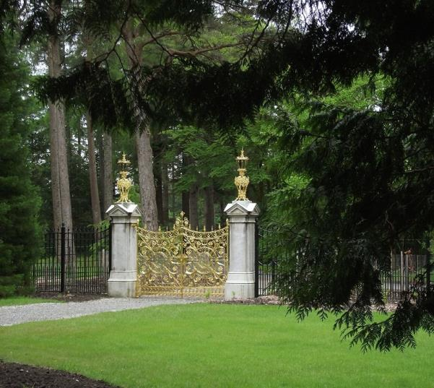

Benmore Botanic Garden,
Dunoon,
Argyll,
PA23 8QU

+44 (0) 1369 706261
www.rbge.org.uk/benmore

Contents
Access Guide 1
1.0 Our Accessibility Promise to You 3
2.0 A Map of Benmore Botanic Garden 4
2.1 A word about the weather 5
3.0 How To Reach Us 5
3.1 By Ferry 5
3.2 By Bus 8
3.3 By Car 8
3.2 Parking 8
3.5 By Taxi 11
3.6 By Rail 11
3.7 By Bicycle 11
4.0 Garden Entrance & Visitor Centre 12
4.1 Maps, trails, guided tours and the Benmore Explorer. 14
4.2 Benmore Café 16
4.3 Entry to the Garden 18
5.0 The Garden 19
5.1 The Redwood Avenue 19
5.2 Garden layout 20
5.3 Benches 22
5.4 The Pond 23
5.5 Golden Gates 24
5.6 Puck’s Hut 24
5.7 The Courtyard Gallery 25
5.8 The Garden’s Higher Levels 26
5.9 The Victorian Fernery 29
6.0 Before You Leave 31
7.1 Accessible WCs 32
7.2 Hearing Loops 34
7.3 Assistance Dogs 34
7.4 Mobile Reception and Wifi 35
7.5 Evacuation 35
7.6 Future Plans 35

This Access Guide aims to describe the facilities and services that we offer to all our visitors and guests. It does not contain personal opinions as to our suitability for those with access requirements. If we have not covered your access needs in this document, please contact us and we will discuss your needs and offer assistance where we can. Plus, if you require any further information about specific access or need advice about planning your visit, please contact us on: +44 (0) 1369 706261 or email us at benmore@rbge.org.uk.

1.0 Our Accessibility Promise to You

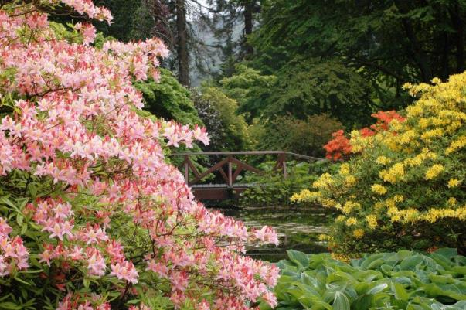

Benmore Botanic Garden welcomes all visitors and aims to provide best possible access to everyone in order that they enjoy their visit to our Garden. Some new health and safety measures are in place to protect our visitors and staff following the Covid-19 outbreak, resulting in some restrictions to our facilities and services.

We provide:
- An Easy Access Route along low level paths in the Garden.
- Accessible toilets at the entrance point and by our Formal Garden.
- Three manual wheelchairs for our visitors to use.
- Benches at regular intervals throughout the Garden.
- Water for assistance dogs.
- Pen, paper and magnifying glass at our Visitor Welcome desk.
- Free entry for carers and children under 16.

2.0 A Map of Benmore Botanic Garden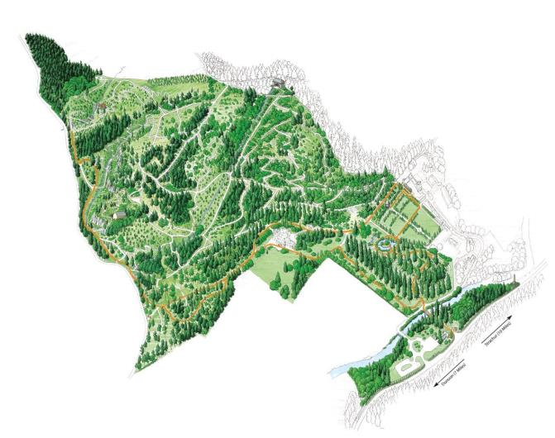

Above: The map shows the layout of Benmore, a Garden of 120 acres set in a magnificent mountainside setting. There is a designated Easy Access Route for wheelchair users, indicated in orange on the map above. This map is available on arrival with the route clearly marked. For more details about the Garden, entry and accessible paths turn to page 17.

2.1 A word about the weather

Please note that in severe weather conditions the Garden closes for safety reasons but our visitor centre and café remain open as usual. You are welcome to call us to check that the Garden is open on 01369 706261. Visitors are recommended to take extra care outside when exposed to weather conditions such as wind and rain.

3.0 How To Reach Us

Benmore Botanic Garden is on the A815 seven miles north of Dunoon on the Cowal Peninsula. Plan your journey by using www.transportdirect.info.

3.1 By Ferry

Argyll Ferries (for passengers) and Western Ferries (for cars and passengers) both sail from Gourock to Dunoon. The journey time is approximately 20 minutes. Visit www.argyllferries.co.uk and www.western-ferries.co.uk for more details about current services and accessibility. Discounts are available when tickets are purchased in advance.

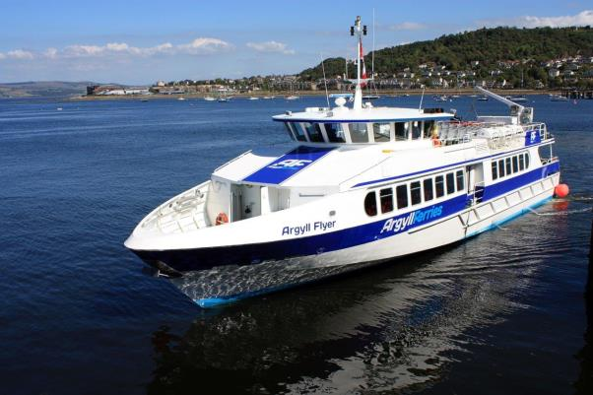

Above: Argyll Ferries’ passenger ferry. Follow the signs for ‘Dunoon Ferry’ to locate the correct departure quay in Gourock. Please check availability of this service directly with the provider by visiting their website. Services may have been altered during this uncertain time.

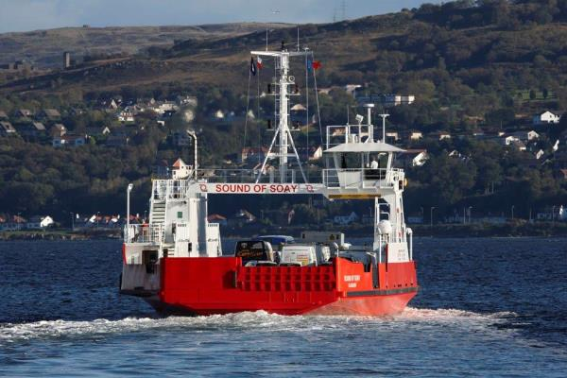

Above: Western Ferries’ car and passenger ferry, which provides two disabled parking spaces at each terminal, ramped access to the ticketing office at Dunoon and an accessible WC on board. To check the current service, please visit their website, and also look for their comprehensive accessibility page at www.western-ferries.co.uk/accessibliity

Western Ferry Terminals

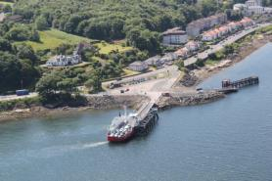

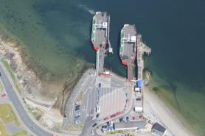
Above: McInroy’s Point, Gourock Above: Hunter’s Quay, Dunoon

3.2 By Bus

West Coast Motors operates a regular bus service to the Garden from Dunoon. Call 01586 559 139 for further details, or visit www.westcoastmotors.co.uk. The 484 and 486 buses drop off visitors by turning into the car park and there is a bus stop for return journeys opposite on the other side of the road.
It is also possible to travel by bus no: 907 from Glasgow’s Buchanan Bus Station to Dunoon and more details are available at www.mcgillsbuses.co.uk. Please check services directly with the provider during this uncertain time.

3.3 By Car

The Garden is clearly sign-posted on the A815 from Hunter’s Quay, where the ferries arrive (see page 6). If approaching from the opposite direction, there is sign posting at the start of the A815 near Strachur after drivers leave the A83 ‘Rest and Be Thankful’ road.
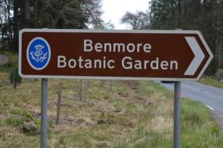

Above: The Garden’s brown tourism sign opposite the entrance.

3.2 Parking

Benmore has a large car park with three 3x3.6m wide designated parking bays for blue badge holders located about 40 metres from the Garden entrance. Signage for this designated parking indicates the position of the bays. There is also designated parking available for coaches and minibuses. Parking is free.
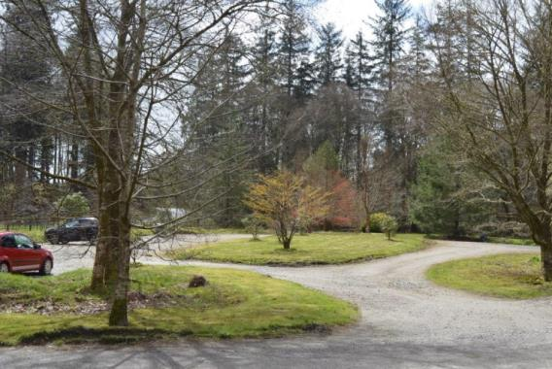
Above and below: The ample car parking facility at Benmore Botanic Garden

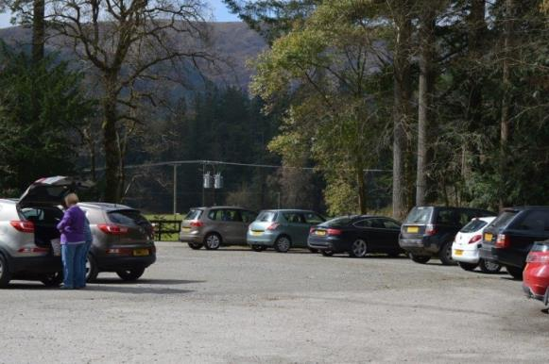

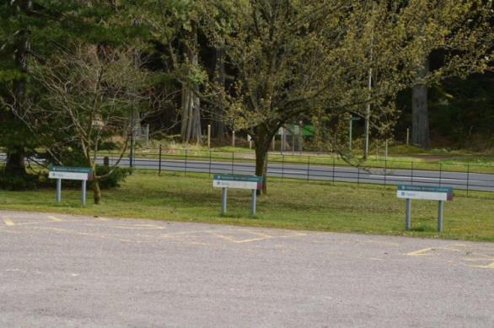Above: Spaces for blue badge holders to the right of the visitor centre, facing the road.

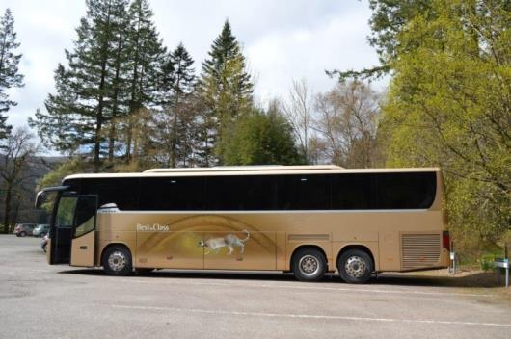
Above: Ample parking provided for coaches.

3.5 By Taxi

A taxi service runs on Sundays service between Dunoon and Benmore Botanic Garden. For more information and to check availability of the service at this time, call 07913 601442.

3.6 By Rail

Visiting by rail is difficult. The best option is to travel to Glasgow Central Station and take a train to Gourock in order to travel by Ferry to Dunoon. During this uncertain time, please check availability of services directly with the train provider.

3.7 By Bicycle

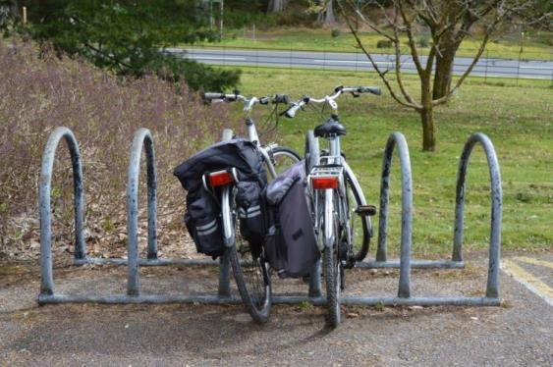

Above: Benmore Botanic Garden provides a bicycle rack in the car park.

4.0 Garden Entrance & Visitor Centre

The main route to the Garden is through the visitor centre and there is level access from the car park to the entrance. A welcome panel outside the entrance way provides information about the Garden including the easy access route. The visitor centre entrance door is 850mm clear opening with 1500mm clear spaces opposite the door.

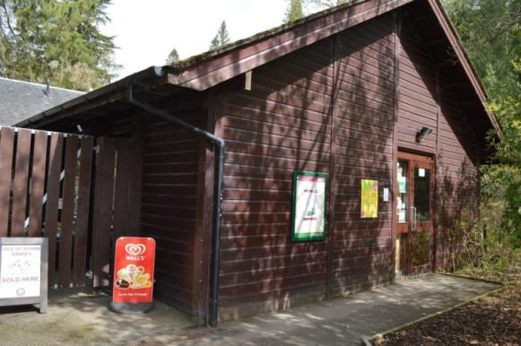
Above: The visitor centre entrance
Benmore’s visitor centre is accessible to wheelchair users. Inside, you will find an Information Desk, our shop and a café – all on ground level. Visitors using mobility scooters are recommended to enter the Garden through the gate to the left of the visitor centre entrance which leads you through the plant sales area.
During this time, you may find safety measures in place including one-way systems, staff wearing protective wear and physical distancing guidance.

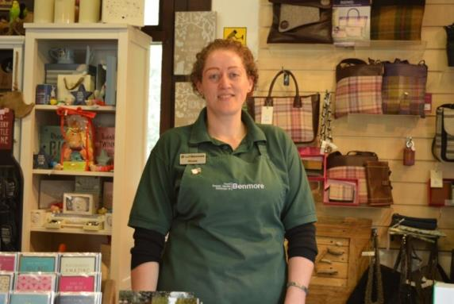

Above: A warm welcome is guaranteed at our Information Desk where your ticket and Garden Map can be purchased.

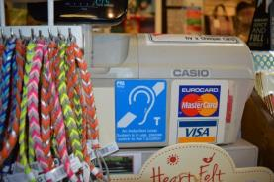

Above: Hearing loop at the counter.

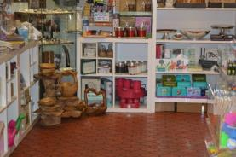

Above: The shop space.

4.1 Maps, trails, guided tours and the Benmore Explorer.

Maps and trails are available at the Information Desk. Unfortunately, during this time, there are no guided tours either by foot or on the Benmore Explorer vehicle.

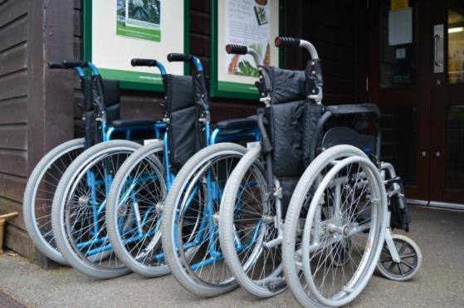
Above: The visitor centre has three wheelchairs for visitors to use. If possible, please book in advance by calling 01369 706261.
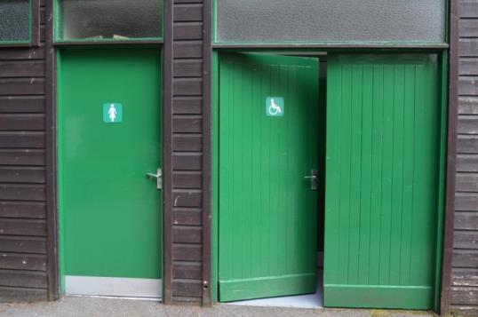
Above: Toilets, including an accessible WC, are located outside the Visitor Centre entrance. For more information about Benmore accessible toilets, please turn to page 33.

4.2 Benmore Café

There is a café located in the visitor centre. It caters for most dietary requirements as indicated on the menu. The café is currently open with limited indoor seating. Outdoor seating is also available.
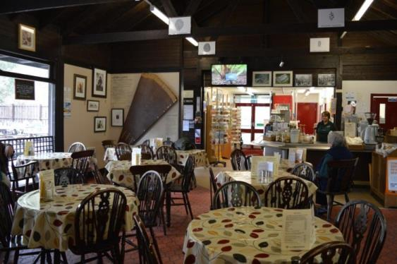
Above: A warm welcome is assured at the restaurant.

Please note that during this uncertain time, some of the facilities below are restricted because of health and safety reasons.
- The café is accessible for wheelchair users.
- There is clear space beneath the tables of 700mm.
- Tables and seating can be moved to accommodate our visitors’ requirements.
- There is seating with and without arm rests.
- There is an accessible toilet in close proximity, outside the café door.
- Assistance dogs are welcome and water can be provided.
- There are large print menus available and our staff are happy to read out the menu
- Wheelchair accessible picnic tables are provided outside the café.
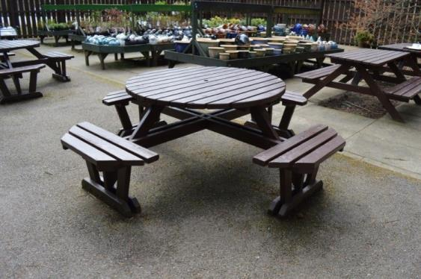
Above: Wheelchair accessible picnic tables outside the café.

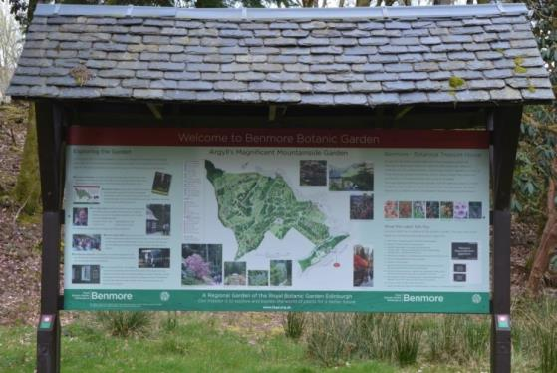
Above: Information panel at the Garden entrance.

4.3 Entry to the Garden

There are two ways to access the Garden. The first option, marked on the map as the Easy Access Route, is to approach the Garden from the visitor centre via its café and outdoor plants area. The path to the Garden leads visitors over a small footbridge and towards a metal gate, where you will see the Redwood Avenue beyond.

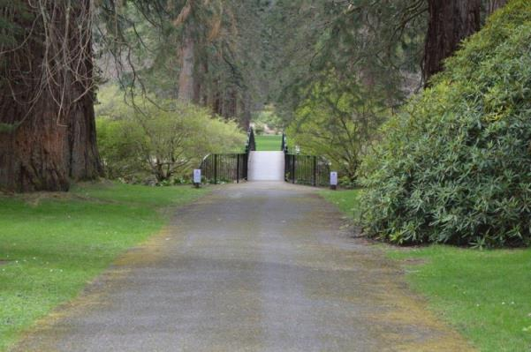

Above: Manual wheelchair users may require assistance to cross the footbridge over the river as it has a gradient of up to 1:6 on either side. They may also require assistance at the metal gate which leads to the Garden.
The second option, which is a slightly longer route, is accessed via the car park and level entry over the vehicle access bridge, turning right to join the main path to the entrance gate.
Please note that there is currently additional health and safety signage in the Garden to help protect our visitors following the Covid-19 outbreak

5.0 The Garden

Benmore is a beautiful Garden in a mountainside setting, steeped in history and surrounded by dramatic scenery. Its 120 acres are home to a world-leading plant collection from regions ranging from the Orient and the Himalaya to North and South America. Highlights include:

- The 150 yr old Redwood Avenue, one of the finest entrances to any botanic garden.
- Exotic plantings which includes over 300 species of rhododendron
- The Pond, a peaceful place to visit
- The beautifully-restored Golden Gates
- The charming Victorian Fernery
- The Bhutanese and Chilean pavilions

5.1 The Redwood Avenue

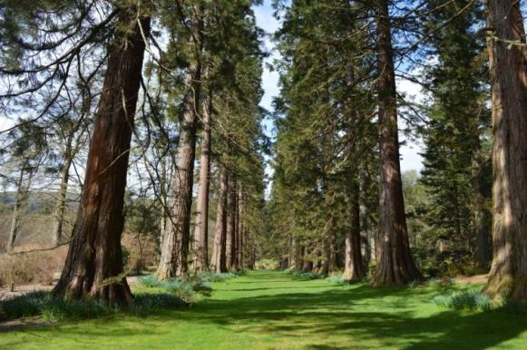
Above: The dramatic Redwood Avenue which is over 150 years old.
It is possible to take a route through or around the Redwood Avenue. Please note that the path through the middle is grass covered and can be slippy in wet weather.

5.2 Garden layout

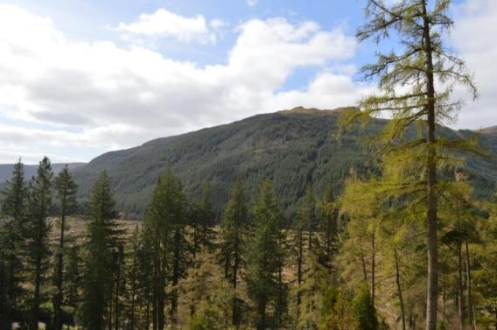

The Garden spreads over two levels – a lower level and up on a mountainside with some particularly steep slopes.
The Easy Access Route, available on the printed map, provides a tour of the lower level of the Garden. This route is way-marked and avoids several slopes. The footpaths are comprised of compacted or loose gravel and are mostly wide and level. A section leading up to Benmore House has a gradient of up to 1:12 and manual wheelchair users may need assistance.
Please note that there are occasional tree roots breaking the surface of some paths, which may require careful negotiation and manual wheelchair users may still require some assistance to negotiate path gradients.
The most challenging aspect for any visitor is likely to be the terrain in order to reach the upper level, with gradients on loose surfaces of up to 1:3 leading to the Chilean and Bhutanese pavilions and Wright Smith Memorial Viewpoint and Shelter.
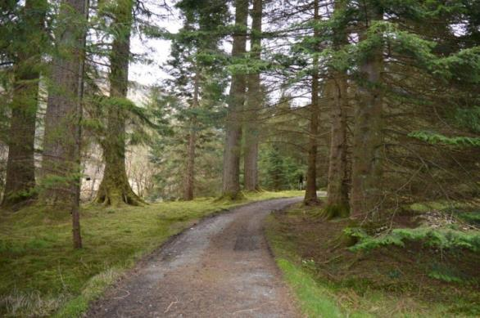
Above and below: Gravel paths on Benmore’s accessible route. Note, that there are several speed bumps along the Easy Access Route. 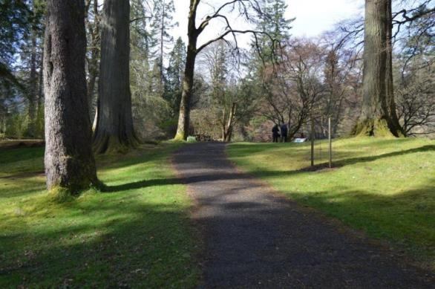

5.3 Benches

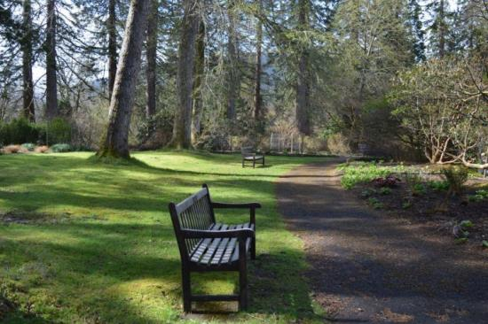
A range of bench seating, with and without arm rests, is provided at intervals around the Garden in all locations, offering visitors the opportunity to take a break.
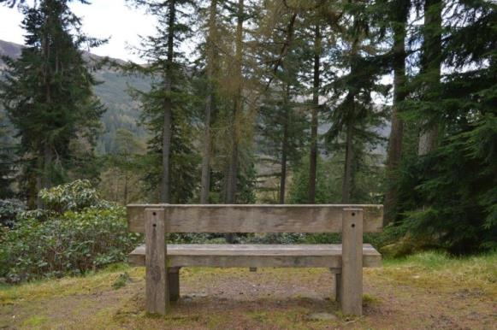

5.4 The Pond

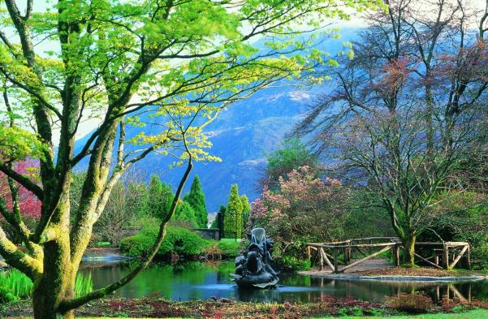
Above: The Pond is set amidst dramatic landscapes and on the Easy Access Route. Manual wheelchair users may need help with thresholds to reach the Pond’s viewing stage. Currently, we are operating a one-way system around The Pond, and the viewing stage below is closed.
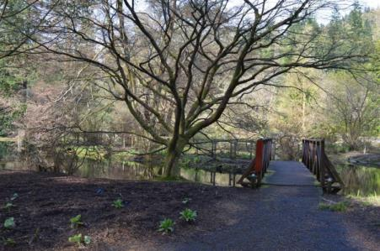
Above: The Pond’s viewing point.

5.5 Golden Gates

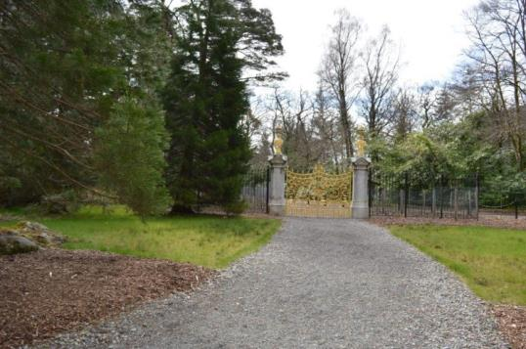
Above: Benmore’s Golden Gates are accessible to view along a wide loose gravel path.

5.6 Puck’s Hut

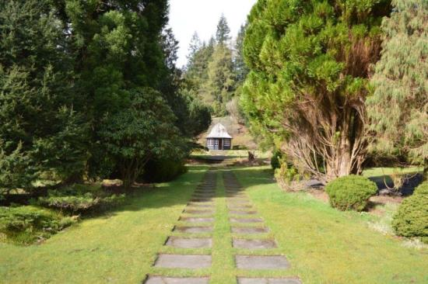
Above: Puck’s Hut in the Formal Garden. Manual wheelchair users may need help to access the entrance which has a ramp gradient of 1:10. There is a 40mm threshold at the door which has a 660mm clear opening so help may be required to open the second door.

5.7 The Courtyard Gallery – is currently closed.
Benmore’s Courtyard Gallery is used for visitor exhibitions and events. Level access is provided into the cobbled courtyard and the Gallery is approached via a gradiant of up to 1:8 across cobbles.
Approaching the Gallery from the Formal Garden, manual wheelchair users may need assistance at a set of metal gates, and from this direction there is a slight incline on route to the Gallery.
There is a platform lift (or five steps) to the upper level of the Benmore Gallery.
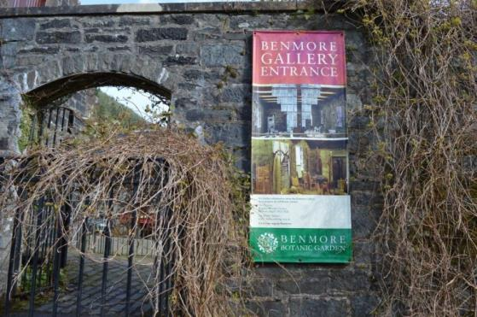
Above: Benmore Gallery Entrance with views to the cobbled Courtyard.

5.8 The Garden’s Higher Levels

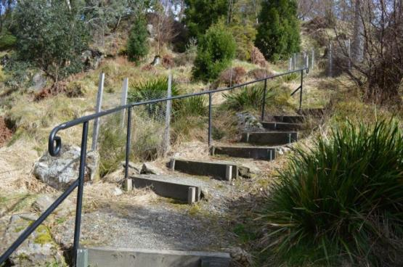
Above: Benmore’s higher levels are not on the Easy Access Route. There are gradients of up to 1:3 on some footpaths with loose surfaces. Many of the steps leading to the higher levels of the Garden feature a handrail to one side.
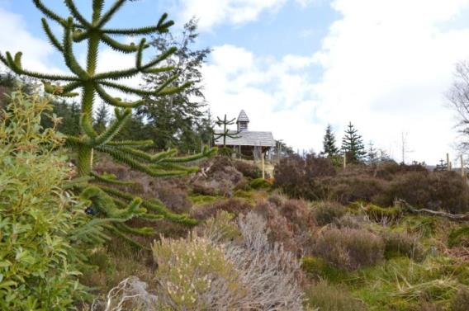
Above: The Chilean Pavilion
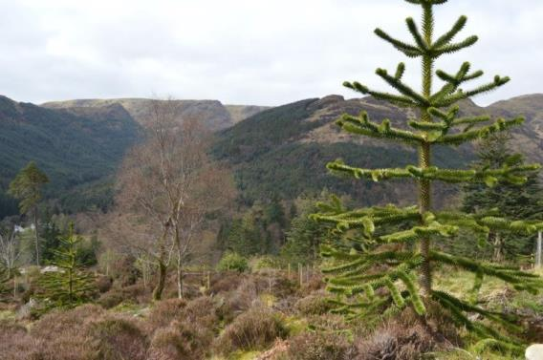
Above: Views from the Chilean Pavilion
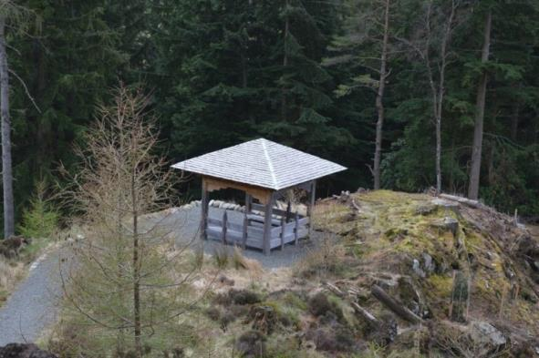
Above: The Bhutanese Pavilion
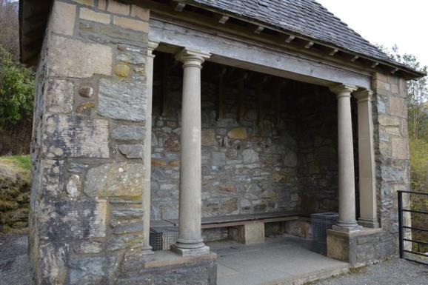
Viewpoint and Shelter (Wright Smith Memorial) 137m (450 ft) above sea level and accessed via a series of paths and steps. From here it is possible to see Holy Loch and the tops of neighbouring mountains.
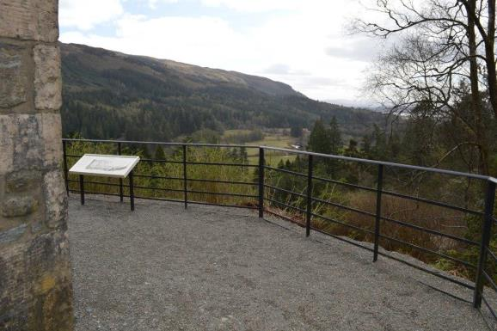
5.9 The Victorian Fernery – is open with a one-way system in place.
The Victorian Fernery is beautifully restored and worth a visit. However, it is not part of the Easy Access Route and there is a gradient of up to 1:4 leading to the entrance steps. There are 44 steps leading to the Fernery with a handrail to one side. There are a further 24 steps within the Fernery. Bench seating is provided inside. Assistance dogs are welcome.

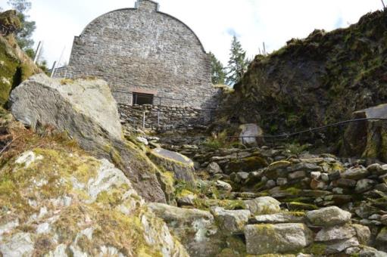
Above: The stepped approach to the Victorian Fernery.
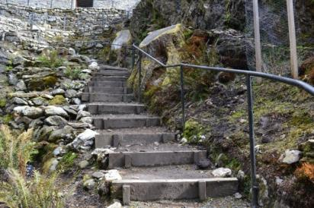
Above: 44 steps lead to the entrance.

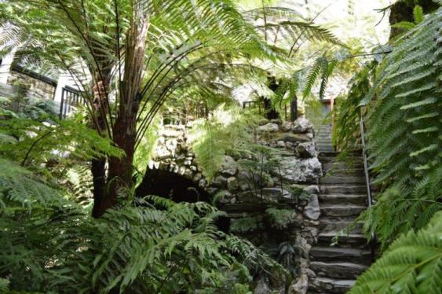
Above and below: Inside the Victorian Fernery where benches are provided.
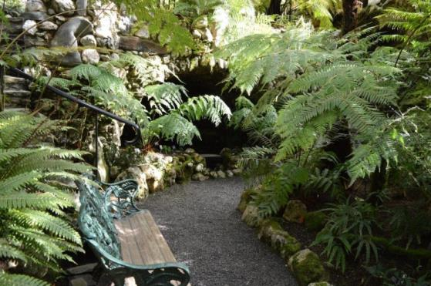

6.0 Before You Leave

After your tour of Benmore Botanic Garden, why not visit our shop or plant sales area to select a souvenir before you depart.
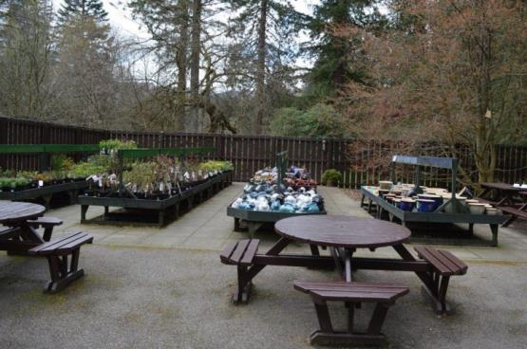
Above: The plant sales area to the rear of the Benmore visitor centre and café offers wide aisles and low level units.
The shop is located inside the visitor centre and sells a range of gifts and souvenirs.
Please see page 12.
- Step free access and placement of shop fixtures allows wheelchair users to manoeuvre in the space.
- The shop is evenly and well lit.
- There is a hearing loop at the till point, a magnifying glass, pen and paper.
- Shop staff are always on hand to offer assistance.

7.1 Accessible WCs

There is an accessible WC located with other toilets just outside the visitor centre. A horizontal door bar on the hinge side aids closure. The doors to the WC are 170mm clear opening with clear space opposite the door. The floor space is 1500mm x 1200mm and there is 1000mm lateral transfer space to the right beside the WC.

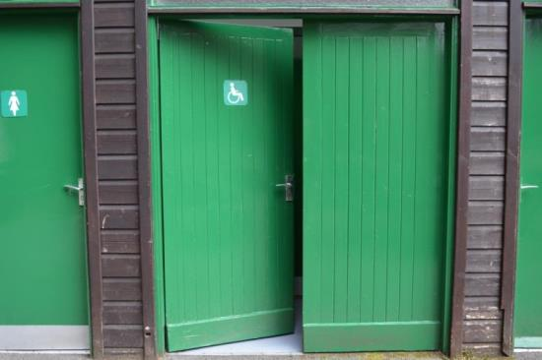
Above: Accessible toilet outside the visitor centre
There is also another accessible WC beside the Benmore Courtyard, which is signposted for convenience (below).
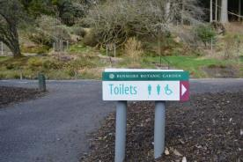
The Accessible WC beside the Courtyard Gallery
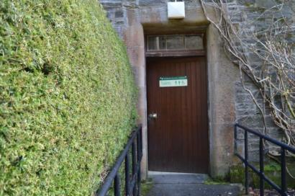
Above: Entrance to the accessible WC by the Courtyard Gallery.
The doors to this WC are 930mm minimum clear opening with clear space opposite the doors. The floor space is 1200 x 1200mm and there is 700mm lateral transfer space to the left of the WC. The height of the WC is 420mm to the top of the seat.

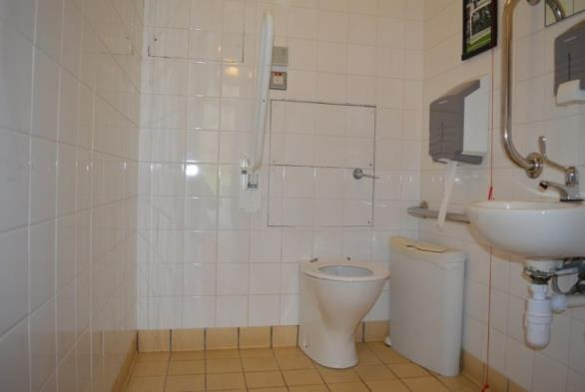
Above: The WC by the Courtyard Gallery.

7.2 Hearing Loops

A permanent Induction Loop is fitted at the Visitor Centre Information Desk. Please ask for assistance if you require it.

7.3 Assistance Dogs

Benmore Botanic Garden welcomes all assistance dogs. Dog bowls of water are available on request. The Garden has a world-leading collection of plants that it has a duty to protect and a responsibility of care for all visitors. Therefore, we ask that assistance dogs are registered or highly trained.

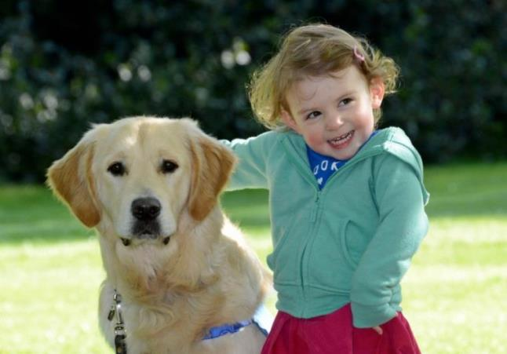
Above: Guide dog Huxley with toddler Francesca

7.4 Mobile Reception and Wifi

Visitors with medical conditions should be aware that mobile signal is extremely limited within Benmore’s visitor centre but there is some signal in the Garden itself. Currently there is public access to Wifi in the café and shop. If you require assistance, please ask at the Information Desk.

7.5 Evacuation

Should a fire alarm sound and an evacuation take place, the Visitor Centre and Garden staff will assist those with specific needs to evacuate. They will assist those who require help until the fire services arrive. Accessible toilets will be physically searched in the event of an emergency evacuation.

7.6 Future Plans

Benmore Botanic Garden is committed to enhancing its offering to those with specific requirements. Our future plans include:

- To hold more events which highlight our accessibility.
- To providing disability awareness training to our staff.
- To offer more general information about the Garden in large print.

If you would like to provide any feedback on this Access Guide, we would welcome your comments. We would be interested to hear if there is any information we may have missed, or things you think might help us to improve accessibility in terms of services and facilities. Please contact us at marketing@rbge.org.uk

