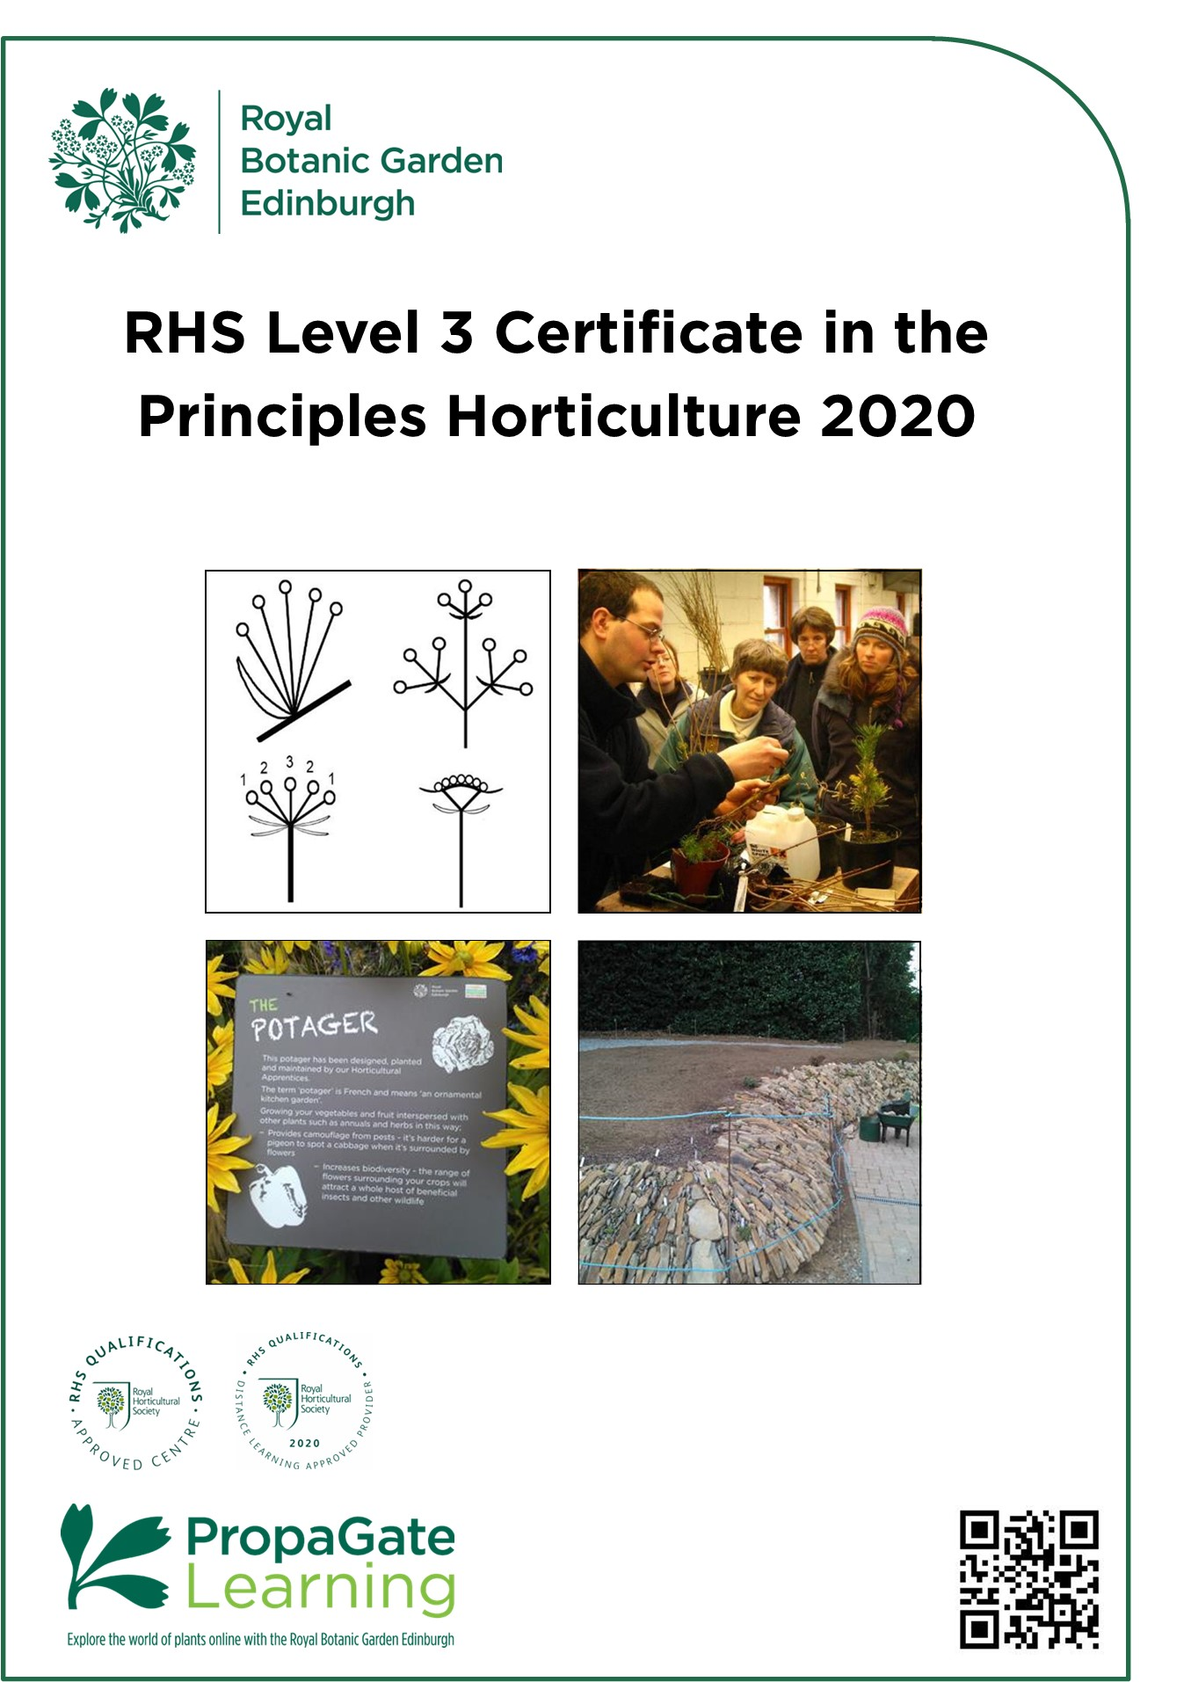
RHS Level 3 Handbook 2020
Introduction to course

Welcome

We are delighted that you are considering joining the RHS Level 3 Certificate course(s) here at RBGE.

The RHS Level 3 Certificate in the Principles of Horticulture comprises of two parts: the Certificate in the Principles of Plant Growth, Health and Applied Propagation (Certificate 1) and the Certificate in the Principles of Garden Planning, Construction and Planting (Certificate 2). Both certificates together can be combined with a practical certificate to make the RHS Level 3 Diploma in the Principles and Practices of Horticulture. We do not offer the practical certificate, which is required to be awarded the Diploma.

The RHS Level 3 Certificate 1 and 2 courses are stand-alone qualifications and can be applied for separately. Many people choose which certificate to take according to their interests or depending on what they intend to do after gaining the certificate. These certificates are ideal if you have a real passion for plants and gardens.

This handbook introduces you to the RHS Level 3 course content and structure. We hope it answers all your questions, but please don’t hesitate to contact us via the details below if you have any further queries.

RBGE Education Department
rhslevel3@rbge.org.uk
0131 248 2937

All information is correct at the time of publication and is subject to change.

Contents

1. Cert 1: Principles of Plant Growth, Health and Applied Propagation 4
1.1 Introduction to certificate 4
1.2 Learning hours and QCF credits 4
1.3 Unit Descriptors 5
2. Certificate 2: Principles of Garden Planning, Construction and Planting 6
2.1 Introduction to certificate 6
2.2 Learning hours and QCF credits 6
2.3 Unit Descriptors 7
3. Examinations 8
3.1 Sitting the exams at RBGE 8
3.2 Sitting the exams elsewhere 8
3.3 Sitting exams outside of the UK 8
3.4 Exam fees 8
3.5 Examination dates 9
4. How does it work? 10
4.1 Learning Online 10
4.2 How can I prepare for studying online? 10
4.3 What hardware or software will I need? 11
4.4 What support is available? 11
5. Course completion deadline 12
6. Study options and course costs 12
7. Entry Requirements 13
8. How to Apply 13

1. Certificate 1: Principles of Plant Growth, Health and Applied Propagation

1.1 Introduction to certificate

The RHS Level 3 Certificate in the Principles of Plant Growth, Health and Applied Propagation builds on the current RHS Level 2 certificate and delivers a broad-based understanding of horticultural techniques and plant biology. If you are based in Scotland, it is equivalent to something between a higher and an advanced higher or to an English A-Level.

It provides students with a qualification that is recognised internationally by the horticulture industry. This broad base makes it ideal for those wishing to pursue a career in any branch of horticulture. It is also perfect for leisure gardeners who would like to expand their horticultural knowledge, and to have it formally assessed.

1.2 Learning hours and QCF credits

The RHS Level 3 Certificate 1 course is structured around the examinations set by the RHS, so the content is predominantly theory. It is a part of the wider Qualifications and Credit Framework (QCF).

The course is organised into four units and the learning hours recommended by the RHS and the QCF credits for each unit are as shown below.

Unit | Guided learning hours | Additional  Self-directed studies in hours | Total Qualification Time* | QCF Credits^
R3101: Plant taxonomy, structure and function | 32 | 23 | 55 | 5
R3102: The root environment, plant nutrition and growing systems | 28 | 22 | 50 | 5
R3103: The management of plant health. | 24 | 16 | 40 | 3
R3104: Understanding applied plant propagation | 21 | 14 | 35 | 2

*The RHS have estimated that the Total Qualification Time required for students to study this certificate is 180 hours. We have apportioned the number of hours required for each unit based on the guided learning hours.
^The total number of QCF credits for this Certificate is 15 Credits.

1.3 Unit Descriptors

R3101: Plant taxonomy, structure and function

This is the botany section and really helps you to get to grips with plants, their diversity and how they work. There are 7 major learning areas in this part of the course, including plant taxonomy, tissues, reproduction, photosynthesis and respiration, transport, and regulation of growth. Understanding this helps you make sense of many of the processes later in the course.

R3102: The root environment, plant nutrition and growing systems

This unit begins with a look at soil classification and formation and the underlying rocks and their properties. The focus shifts to a detailed look at the properties of the mineral and biological components of soils and growing media. We also look at nutrient cycles in soil and plants as well as causes and symptoms of deficiencies. Finally, this unit introduces the principles of organic growing and the ways in which soils and plant health can be managed in organic systems.

R3103: The management of plant health

This unit covers three major learning areas. Firstly you will be expected to identify a wide range of pests, diseases and weeds and know how to manage and control them by different methods, including integrated pest management. Secondly, to understand how and when chemical controls can be used and stored to minimise damage to non-target organisms. Thirdly there is a focus on biosecurity and reducing the spread of pests and diseases.

R3104: Understanding applied plant propagation

This unit looks at how the germinating seed works, the requirements for seed storage and conservation, breaking dormancy and ensuring successful germination. Vegetative propagation will cover different methods of propagation, including grafting, bulb propagation and micro-propagation and a look at a range of facilities used for vegetative propagation.

2. Certificate 2: Principles of Garden Planning, Construction and Planting

2.1 Introduction to certificate

The RHS Level 3 Certificate in the Principles of Garden Planning, Construction and Planting builds on the current RHS Level 2 certificate and delivers a broad-based understanding of garden design, construction and planting. If you are based in Scotland, it is equivalent to something between a higher and an advanced higher, or to an English A-Level.

It provides students with a qualification that is recognised internationally by the horticulture industry. This broad base makes it ideal for those wishing to pursue a career in any branch of horticulture or garden design. It is also perfect for leisure gardeners who would like to expand their horticultural knowledge, and to have it formally assessed. It is an ideal precursor to relevant diploma and degree programmes here at RBGE.

2.2 Learning hours and QCF credits

The RHS Level 3 Part 2 course is structured around the examinations set by the RHS, so the content is predominantly theory. It is a part of the wider Qualifications, Credit Framework (QCF), a system that is designed to allow you to study a huge range of subjects to tailor your learning.

The course is organised into four units and the learning hours recommended by the RHS and the QCF credits for each unit are as shown below.

Unit | Guided learning hours | Additional  Self-directed studies in hours | Total Qualification Time* | QCF Credits
R3111: Understanding garden survey techniques and design principles | 28 | 32 | 60 | 4
R3112: Understanding the selection and use of landscaping elements in the garden | 28 | 22 | 50 | 4
R3113: Understanding the setting out and construction of landscaping elements in the garden | 27 | 33 | 60 | 4
R3114: Understanding a range of specialist elements in the establishment of garden and urban plantings | 24 | 6 | 30 | 3
*The RHS have estimated that the Total Qualification Time required for students to study this certificate is 202 hours.
^The total number of QCF credits for this Certificate is 15 Credits.

2.3 Unit Descriptors

R3111: Understanding garden survey techniques and design principles

This unit is concerned with garden survey techniques and design principles. It explains the historical development of garden design styles which still have an influence on the gardens of today. Any good garden design needs to reflect the needs of the garden users and the capabilities of the site so the crucial information gathering and recording stages of the process are discussed before dealing with the application of design principles.

R3112: Understanding the selection and use of landscaping elements in the garden

This unit puts physical form to the design by exploring how soft and hard landscaping features and materials are selected and used in the garden. Important safety issues are dealt with and we look at the topical subject of using sustainable materials.

R3113: Understanding the setting out and construction of landscaping elements in the garden

This unit moves on to the construction phase. The plans discussed in unit 1 are translated into physical features and the methods used to construct those features are explained.

R3114: Understanding a range of specialist elements in the establishment of garden and urban plantings

This unit covers aspects of planting and maintenance which are specific to amenity, woodland, wildlife, sensory, prairie, potager and urban gardens. We also look at how water sustainability can be incorporated into garden design and explain a number of specialist pruning techniques.

3. Examinations

Each unit will be assessed by a separate written examination covering the learning outcomes specified in that unit. The dates and times of the exams are set by the RHS and are usually offered twice a year, in February and June.

The exams are a good challenge, and the qualification is one of the reasons many people join the course. However, the course is designed to be great fun and a valuable learning experience even if you do not do the exams, so there is no obligation to sit them.

3.1 Sitting the exams at RBGE

RBGE Exam Registration forms are issued to students when registrations open. This is usually in October for the February Exams and March for the June Exams.

3.2 Sitting the exams elsewhere

It is possible to study with RBGE and sit the exams elsewhere, however we advise ensuring you will be able to sit the exams at a local centre before signing up for the course.

You should contact your local centre to find out how and when to register for the exams; each centre will have their own system in place.

If you need to find an exam centre near you please check the RHS External Candidate Centre List.

3.3 Sitting exams outside of the UK

It can sometimes be possible to arrange to sit the exams locally if you do not live in the UK. This does come with some additional logistical arrangements and may also include some additional costs.

Students should enquire about the possibility directly with the RHS: qualifications@rhs.org.uk

3.4 Exam fees

The RHS registration fee for the exams is £27 per unit, the total cost to sit all 8 units is £216. These fees are not included in the course fee.

- If you are absent on the day of the exam, you lose your fee. You will have to
re-register and pay again to sit the exam(s) you have missed.
- If you need to re-sit any exams you must re-register and will have to pay again to sit the exam(s).
- Some centres may charge an administration fee on top of the RHS registration fee for external candidates.

3.5 Examination dates

February 2021

Certificate 1
Wednesday 10th February 2021
- R3101 9:30 – 11:10
- R3102 13:40 – 15:20
- R3103 11:45 – 12:50
- R3104 14:50 – 15:40

Certificate 2
Thursday 11th February 2021
- R3111 9:30 – 10:55
- R3112 11:25 – 12:50
- R3113 13:40 – 15:05
- R3114 15:35 – 16:40

June 2021

Certificate 1
Wednesday 23rd June 2021
- R3101 9:30 – 11:10
- R3102 13:40 – 15:20
- R3103 11:45 – 12:50
- R3104 14:50 – 15:40

Certificate 2
Thursday 24th June 2021
- R3111 9:30 – 10:55
- R3112 11:25 – 12:50
- R3113 13:40 – 15:05
- R3114 15:35 – 16:40

The running order for exams R3102 and R3103 is reversed.

The following tables show when the exams are in relation to the month you apply. Note, your access to PropaGate will run for 12 months or 18 months from the date your account is activated by RBGE.

Exam sittings during a 12 month enrolment

Application Month | Sitting 1 | Sitting 2 | Enrolment Ends
July 2020 | February 2021 | June 2021 | July 2021
August 2020 | February 2021 | June 2021 | August 2021
September 2020 | February 2021 | June 2021 | September 2021
October 2020 | February 2021 | June 2021 | October 2021
November 2020 | February 2021 | June 2021 | November 2021
December 2020 | June 2021 | N/A | December 2021

Exam sittings during an 18 month enrolment

Application Month | Sitting 1 | Sitting 2 | Sitting 3 | Enrolment Ends
July 2020 | February 2021 | June 2021 | N/A | January  2022
August 2020 | February 2021 | June 2021 | February 2022 | February 2022
September 2020 | February 2021 | June 2021 | February 2022 | March 2022
October 2020 | February 2021 | June 2021 | February 2022 | April 2022
November 2020 | February 2021 | June 2021 | February 2022 | May 2022
December 2020 | June 2021 | February 2022 | June 2022 | June 2022

It is possible to sit exams outside of your enrolment period, it just means you will no longer have access to the course materials on PropaGate. You can also
extend your online support period for an additional 6 months for a fee of £50.

4. How does it work?

4.1 Learning Online

Your online learning environment is PropaGate Learning which uses the Moodle learning platform.

PropaGate Learning is a website that you log into in order to access your course. It’s a place for learning and for discussing topics and progress with your tutors and other students. PropaGate Learning allows you to study from home, whilst becoming part of a thriving and enthusiastic learning community.

Your course will consist of a number of elements which include e-books, PDFs, presentations, videos, interactive lessons, quizzes, discussion forums and links to useful websites.

We continually review and update the course. We are currently updating the course to ensure it is more accessible.

4.2 How can I prepare for studying online?

You should be a competent computer user with a basic understanding of standard computer applications such as using an internet browser, email and word processing. Experience of participating in online forums would also be a benefit, but not essential.

Our ‘Digital Skills Check’ will help you to identify any areas of IT you may need to brush up on.

When you are first given access to PropaGate Learning, please take time to complete the Orientation Activity. This will give you an essential introduction to the tutors on your course, finding your way around, advice on learning independently and the best ways to communicate with tutors and other students.

Online courses require a much more self-motivated learning style than traditional attended classes. You should plan to set aside a certain amount of time each week to log into the course lessons and carry out activities. The amount of time required depends on the number of units you are studying at a time, however we suggest 3-5 hours per week for 6 months if you want to take 2 exams at the end of that 6 months. Participation in online discussions is also a key part of the course – online learning is much more sociable than you might think!

4.3 What hardware or software will I need?

You will need access to a desktop or laptop computer. Most of the course will be accessible via a tablet, but we recommend using a laptop or desktop computer. You may find some aspects of the course will be easier to use on a computer.

Regarding software, you will need an up-to-date browser (we recommend Firefox, Chrome or Safari). You will also need software that will open PDFs (e.g. Adobe Acrobat Reader).

Most importantly you will need a reliable strong internet connection.

PropaGate Learning is available 24/7 with the exception of any essential maintenance work which we will inform you about in plenty of time.

4.4 What support is available?

We encourage everyone to make the most of the forums on the course. These provide a way for you to talk to one another and to tutors and ask each other questions. They are also used by us to share information about exam registration and other course-related news.

Tutors check the forums at regular intervals and will usually reply to forum queries within 2 working days.

Our PropaGate Online Learning team are always available so if you ever feel you are stuck with a course-related technical problem, they can be contacted via the forums or by emailing: propagatelearning@rbge.org.uk

Your online support period will start from the date your PropaGate Learning account is activated and will last:

- 12 months for an individual certificate
- 18 months for the full course
It is possible to extend your online support period for an additional 6 months for a fee of £50.

5. Course completion deadline

Due to changes to the RHS qualifications, the last exam offering for this version of the qualification will be in June 2022. You must complete all exams by this time to gain the qualification, as it will not be possible to start with this version of the course and finish with the new version.

This should allow more than enough time to complete your studies, while still letting you study in your own time and at your own pace.

Full details on the planned changes to the qualifications have not been released by the RHS at the time of publication of this handbook.

6. Study options and course costs

This online course allows students a flexible way to study: you can choose to study the full course (all 8 units) or an individual certificate (4 units).

The fee for the full course is £525 (18 months online support) or £270 for an individual certificates (12 months online support). This is payable on application and includes:

- Access to course materials via PropaGate Learning
- Online support for horticultural study questions

It is possible to extend your online support period for an additional 6 months for a fee of £50.

7. Entry Requirements

Although the RHS Level 3 Certificates do not require any prior qualifications we strongly recommend completing the RHS Level 2 Certificate in the Principles of Horticulture first, as there will be some assumed knowledge.

Fundamentally, however, all you need is an interest in the subject and a willingness to set aside time for home study. We are looking for keen, enthusiastic ‘plants people’ of all ages, who would value the opportunity to develop their knowledge in a structured and supported learning environment and will contribute to the programme.

To help you make the decision about which course is best for you we would suggest that rather than comparing the levels of the courses, take a careful look at the content in the qualification specifications which are available on the RHS website, look at the individual learning outcomes and pick the course which appeals to you most/is most relevant for your goals.

We also advise that you should have some basic confidence with computers, as the course makes use of PropaGate learning, our online learning environment. You must be self-motivated, have access to an internet-ready computer and e-mail account for the course.

8. How to Apply

Applications for the online learning course are open now and will close on Friday 4th December 2020.

To apply all you have to do is complete the course application form: Online Application Form

Your application will be processed within 5 working days of receipt. Once your payment has been received your PropaGate Learning account will be activated and course joining instructions will be sent by email. Please only apply when you are ready to start studying.

Please contact by email at rhslevel3@rbge.org.uk if you have any questions.

