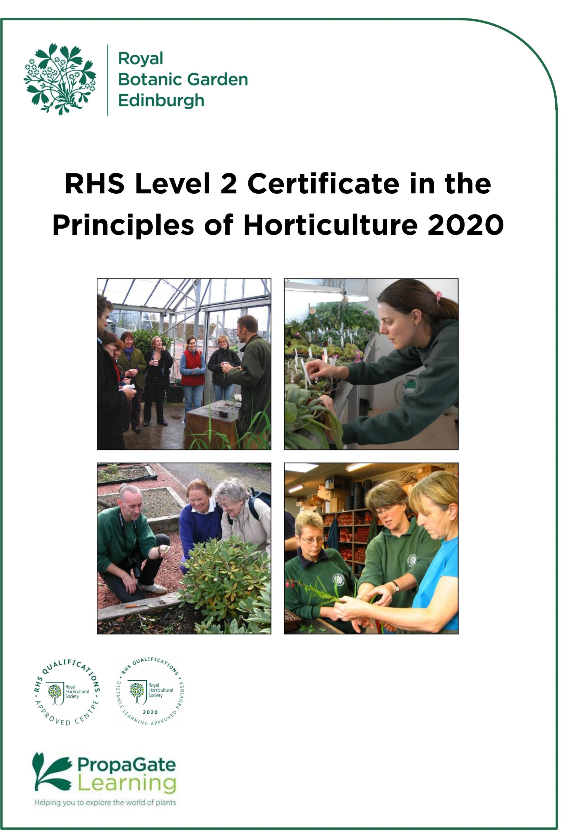

Introduction to the course

Welcome

We are delighted that you are considering joining the RHS Level 2 Certificate in the Principles of Horticulture course here at RBGE.

The RHS Level 2 Certificate in the Principles of Horticulture is the most widely regarded entry-level horticulture course. It is suitable for anyone with a passion for plants and gardens who wants to develop their knowledge. The certificate delivers a broad-based understanding of horticultural techniques and plant biology and provides you with a qualification that is recognised internationally by the horticulture industry. This broad base makes it the ideal starting point or first qualification for those wishing to pursue a career or business in any branch of horticulture or garden design. It is also perfect for leisure gardeners who would like to expand their horticultural knowledge, and to have it formally assessed.

The award of the Certificate is based on written examinations. These are externally set and marked by the RHS. The certificate is accredited by OFQUAL (The Office of Qualifications and Examinations Regulation) in England and Wales.

When you complete the course, you may be able to look at developing your skills to the highest level through RBGE’s HND or BSc in Horticulture with Plantsmanship.

This handbook introduces you to the RHS Level 2 course content and structure. We hope it answers all your questions, but please don’t hesitate to contact us via the details below if you have any further queries.

Education Department
rhslevel2@rbge.org.uk
0131 248 2937

All information is correct at the time of publication and is subject to change.

Contents

1. Course structure and format 4
2. Cert 1: Principles of Plant Growth, Propagation and Development 5
2.1 Introduction to the certificate 5
2.2 Learning hours and QCF credits 5
2.3 Unit Descriptors 6
3. Cert 2: Principles of Garden Planning, Establishment and Maintenance 7
3.1 Introduction to the certificate 7
3.2 Learning hours and QCF credits 7
3.3 Unit Descriptors 8
4. Examinations 9
4.1 Sitting the exams at RBGE 9
4.2 Sitting the exams elsewhere 9
4.3 Sitting exams outside of the UK 9
4.4 Exam fees 10
4.5 Examination dates 10
4.6 Examination dates and enrolment periods 11
5. How does it work? 12
5.1 Learning Online 12
5.2 How can I prepare for studying online? 12
5.3 What hardware or software will I need? 13
5.4 What support is available? 13
6. Course completion deadline 14
7. Study options and course costs 14
8. Study weekends 14
9. Entry requirements 15
10. How to apply 15

1. Course structure and format

The RHS Level 2 course is aimed towards the examinations set by the RHS, so the content is predominantly theory. We provide you with a complete set of information and learning support to help you pass the exams.

The course is broken down into two separate certificates that are designed to stand alone. When combined, they make up the RHS Level 2 Certificate in the Principles of Horticulture.

A third practical certificate is also available and when combined with the theory certificates makes up the RHS Level 2 Diploma in the Principles and Practices of Horticulture. RBGE does not offer the practical certificate, if you wish to find your nearest centre please use the Find a Centre tool on the RHS website.

In light of the uncertainty which continues to surround social distancing and the return to onsite teaching at RBGE, we have taken the difficult decision to not offer an attended version of the RHS course in 2020/21. We appreciate the disappointment this may cause, however we must ensure the safety and wellbeing of all staff, students and volunteers. We will endeavour to return to an attended version of the programme as soon as is safely possible, however at this time it is impossible to provide definitive dates of when this may be.

Despite the current climate, we are delighted to have continued to be able to offer this nationally accredited course in a format which meets the changing world and our online option continues to offer the most flexibility We hope that even if your original interest was towards the attended course, you may consider the online programme as a suitable alternative. Please rest assured that both courses provide you with everything you need to know to pass the exams in order to gain the qualification (if this is your chosen path), although increasingly students are choosing to complete this course for personal interest and it is important to note that there is no obligation to complete any exams as part of this course.

2. Certificate 1: Principles of Plant Growth, Propagation and Development

2.1 Introduction to the certificate

This certificate focuses on many of the processes that go on 'behind the scenes' in a plant. These are the fundamentals that help everything else make sense in plants when you are working with them in the garden.

2.2 Learning hours and QCF credits

Unit | Guided learning hours | Additional  Self-directed studies in hours | Total Qualification Time* | QCF Credits^
R2101: Plant classification, structure and function | 31 | 24 | 55 | 5
R2102: Plant nutrition and the root environment | 23 | 12 | 35 | 3
R2103: Maintaining plant health | 22 | 12 | 34 | 3
R2104: Understanding plant propagation | 23 | 12 | 35 | 3

*The RHS have estimated that the Total Qualification Time required for students to study this certificate is 159 hours. We have apportioned the number of hours required for each unit based on the guided learning hours.
^The total number of QCF credits for this Certificate is 14 Credits.

2.3 Unit Descriptors

R2101: Plant classification, structure and function

This unit provides a solid grounding in basic botany. Considerable time is devoted to understanding the structures and processes that allow plants to survive – from the cellular level right through to the myriad variety of leaves, flowers and fruits that make horticultural plants so interesting. Whilst there is a considerable amount of technical botanical information in this unit, it is geared towards real-life situations, making it easy to understand and apply in gardening and wider horticultural contexts.

R2102: Plant nutrition and the root environment

One of the keys to maintaining healthy plants is, of course, an understanding of plant nutrition. This unit works through plant nutrition from first principles. We cover soil structure and properties – both mineral and organic, as well as looking at the fauna and microflora that the soil harbours and the ways in which these organisms interact with each other, the soil, and the plants growing there. Soil management is an important part of this unit, so we also look at how to use the right compost, fertilizer or mulch for the job.

R2103: Maintaining plant health

This unit discusses weeds, pests and diseases and their control. As well as this, we cover plant physiological problems – such as the effects of nutrient deficiencies, drought, overwatering and excessive sun and shade.

R2104: Understanding plant propagation

Successful, safe propagation is one of the fundamental skills for the horticulturist and gardener. This unit covers propagation, both from seed and using vegetative methods. We discuss the relative merits and disadvantages of each type of propagation and which is the most appropriate for each plant or group of plants. Vegetative propagation includes learning about techniques such as cuttings, layering and grafting, as well as care and safe use of the tools and equipment needed to do the job.

3. Certificate 2: Principles of Garden Planning, Establishment and Maintenance

3.1 Introduction to the certificate

This certificate focuses on gardens and the huge diversity of plants and other materials available to the gardener. Emphasis is placed on the selection and maintenance of plants, with a great deal of information from the first certificate feeding in to support this one.

3.2 Learning hours and QCF credits

Unit | Guided learning hours | Additional  Self-directed studies in hours | Total Qualification Time* | QCF Credits^
R2111: Understanding garden features, plant selection and planning | 29 | 26 | 55 | 5
R2112: Understanding the choice, establishment and maintenance of gardens plants and lawns | 22 | 11 | 33 | 3
R2113: Understanding the production of outdoor vegetables and fruit | 23 | 11 | 34 | 3
R2114: Understanding protected environments and their use in plant cultivation | 23 | 11 | 34 | 3

*The RHS have estimated that the Total Qualification Time required for students to study this certificate is 156 hours. We have apportioned the number of hours required for each unit based on the guided learning hours.
^The total number of QCF credits for this Certificate is 14 Credits.

3.3 Unit Descriptors

R2111: Understanding garden features, plant selection and maintenance

This unit is an introduction to the principles of garden design, from site analysis and identification of purpose and potential, through surveying, to putting together the actual designs. Garden styles, materials and the initial processes of bed layouts are discussed. Soft landscaping and the selection of plants is then introduced with an opportunity to learn about a huge range of horticulturally significant plants – something for every situation - and this theme continues into the next unit.

R2112: Understanding the choice, establishment and maintenance of garden plants and lawns

Continuing on from the previous unit we look at how to select plants for whatever job you have in mind. Everyone will be able to bring some of their own knowledge to this unit as we cover the following topics:-
- Annuals and herbaceous perennials appropriate for bedding, borders and baskets. We also look at the different ways in which to organise these planting schemes for any garden situation.
- Woody plants are a very large group, encompassing ornamental trees, shrubs, climbers, hedging plants and ground cover.
- Lawns and turfing, including choice of plants, establishment of lawns, and annual care.
- Alpine and rock garden plants and choosing and growing these specialised plants.
- Planting and maintaining a garden pool.

R2113: Understanding the production of outdoor vegetables and fruit

Whether you are cultivating fruit, vegetables, or both, food crops are one of the most rewarding groups of plants to grow. This unit provides an overview of the most common food garden and smallholding plants grown in the UK and similar climates. Groups include tree, bush and cane fruits such as apples, currants and raspberries, soft fruits (e.g. strawberries) and a wide range of vegetables such as peas, brassicas, lettuces and carrots. Cultivation strategies and timing, as well as pest control are important elements of this unit. We also discuss the broader theory behind site selection, crop rotation, making beds and soil cultivation.

R2114: Understanding protected environments and their use in plant cultivation

Protected cultivation covers a diverse range of techniques used to cultivate plants in a protected environment. This unit covers the whole spectrum, from simple container grown plants through to cultivation of plants in glasshouses, conservatories and indoors. We look at the ways in which these forms of protected cultivation differ from each other and from the outdoor environment.

4. Examinations

Each unit will be assessed by a separate written examination covering the learning outcomes specified in that unit. The dates and times of the exams are set by the RHS and are usually offered twice a year, in February and June.

The exams are a good challenge, and the qualification is one of the reasons many people join the course. However, the course is designed to be great fun and a valuable learning experience even if you do not do the exams, so there is no obligation to sit them.

4.1 Sitting the exams at RBGE

Due to capacity limits RBGE are only able to accept exam registrations from students in Scotland, Northern Ireland and UK based applicants in and north of Newcastle. However please note that this will not guarantee you a space for the exams. Registrations are usually processed on a first come first served basis.

If you live in the RBGE catchment area and can sit the exams elsewhere, please consider this option.

RBGE Exam Registration forms are issued to students when registrations open. This is usually in October for the February Exams and March for the June Exams.

4.2 Sitting the exams elsewhere

It is possible to study with RBGE and sit the exams elsewhere, however we advise ensuring you will be able to sit the exams at a local centre before signing up for the course.

You should contact your local centre to find out how and when to register for the exams, each centre will have their own system in place.

If you need to find an exam centre near you please check the RHS External Candidate Centre List.

4.3 Sitting exams outside of the UK

It can sometimes be possible to arrange to sit the exams locally if you do not live in the UK. This does come with some additional logistical arrangements and may also include some additional costs.

Students should enquire about the possibility directly with the RHS: qualifications@rhs.org.uk

4.4 Exam fees

The RHS registration fee for the exams is £17 per unit, the total cost to sit all 8 units is £136. These fees are not included in the course fee.

- If you are absent on the day of the exam, you lose your fee. You will have to
re-register and pay again to sit the exam(s) you have missed.
- If you need to re-sit any exams you must re-register and will have to pay again to sit the exam(s).
- Some centres may charge an administration fee on top of the RHS registration fee for external candidates.

4.5 Examination dates

February 2021

Certificate 1
Monday 8th February 2021
- R2101 9:30 – 10:50
- R2102 11:20 – 12:10
- R2103 13:30 – 14:20
- R2104 14:50 – 15:40

Certificate 2
Tuesday 9th February 2021
- R2111 9:30 – 10:50
- R2112 11:20 – 12:10
- R2113 13:30 – 14:20
- R2114 14:50 – 15:40

June 2021

Certificate 1
Monday 21st June 2021
- R2101 9:30 – 10:50
- R2102 11:20 – 12:10
- R2103 13:30 – 14:20
- R2104 14:50 – 15:40

Certificate 2
Tuesday 22nd June 2021
- R2111 9:30 – 10:50
- R2112 11:20 – 12:10
- R2113 13:30 – 14:20
- R2114 14:50 – 15:40

4.6 Examination dates and enrolment periods

The tables below show when the exams are in relation to the month you apply. Note, your access to PropaGate will run for 9 months or 18 months from the date your account is activated by RBGE.

Exam sittings during a 9 month enrolment

Application Month | Sitting 1 | Sitting 2 | Enrolment Ends
July 2020 | February 2021 | June 2021 | April 2021
August 2020 | February 2021 | June 2021 | May 2021
September 2020 | February 2021 | June 2021 | June 2021
October 2020 | February 2021 | June 2021 | July 2021
November 2020 | February 2021 | June 2021 | August 2021
December 2020 | June 2021 | February 2022 | September 2021

Exam sittings during an 18 month enrolment

Application Month | Sitting 1 | Sitting 2 | Sitting 3 | Enrolment Ends
July 2020 | February 2021 | June 2021 | N/A | January  2022
August 2020 | February 2021 | June 2021 | February 2022 | February 2022
September 2020 | February 2021 | June 2021 | February 2022 | March 2022
October 2020 | February 2021 | June 2021 | February 2022 | April 2022
November 2020 | February 2021 | June 2021 | February 2022 | May 2022
December 2020 | June 2021 | February 2022 | June 2022 | June 2022

It is possible to sit exams outside of your enrolment period, it just means you will no longer have access to the course materials on PropaGate. You can also
extend your online support period for an additional 6 months for a fee of £50.

- How does it work?

5.1 Learning Online

Your online learning environment is PropaGate Learning which uses the Moodle learning platform.

PropaGate Learning is a website that you log into in order to access your course. It’s a place for learning and for discussing topics and progress with your tutors and other students. PropaGate Learning allows you to study from home, whilst becoming part of a thriving and enthusiastic learning community.

Your course will consist of a number of elements which include e-books, PDFs, presentations, videos, interactive lessons, quizzes, discussion forums and links to useful websites.

We continually review and update the course and we are in the final stages of updating the course with more videos and interactive lessons. We are also updating the course to ensure it is more accessible.

5.2 How can I prepare for studying online?

You should be a competent computer user with a basic understanding of standard computer applications such as using an internet browser, email and word processing. Experience of participating in online forums would also be a benefit, but not essential.

Our ‘Digital Skills Check’ will help you to identify any areas of IT you may need to brush up on.

When you are first given access to PropaGate Learning, please take time to complete the Orientation Activity. This will give you an essential introduction to the tutors on your course, finding your way around, advice on learning independently and the best ways to communicate with tutors and other students.

Online courses require a much more self-motivated learning style than traditional attended classes. You should plan to set aside a certain amount of time each week to log into the course lessons and carry out activities. The amount of time required depends on the number of units you are studying at a time, however we suggest 2-3 hours per week for 6 months if you want to take 2 exams at the end of that 6 months. Participation in online discussions is also a key part of the course – online learning is much more sociable than you might think!

5.3 What hardware or software will I need?

You will need access to a desktop or laptop computer. Most of the course will be accessible via a tablet, but we recommend using a laptop or desktop computer. You may find some aspects of the course will be easier to use on a computer.

Regarding software, you will need an up-to-date browser (We recommend Firefox, Chrome or Safari). You will also need software that will open PDFs (e.g. Adobe Acrobat Reader).

Most importantly you will need a reliable strong internet connection.

PropaGate Learning is available 24/7 with the exception of any maintenance work which we will inform you about in plenty of time.

5.4 What support is available?

We encourage everyone to make the most of the forums on the course. These provide a way for students to talk to one another and to tutors and ask each other questions. They are also used by us to share information about exam registration and other course-related news.

Tutors check the forums at regular intervals and will usually reply to forum queries within 2 working days.

Our PropaGate Learning team are always available so if you ever feel you are stuck with a course-related technical problem, they can be contacted via the forums or by emailing: propagatelearning@rbge.org.uk

Your online support period will start from the date your PropaGate Learning account is activated and will last:

- 9 months for an individual certificate
- 18 months for the full course

It is possible to extend your online support period for an additional 6 months for a fee of £50.

- Course completion deadline

Due to changes to the RHS qualifications, the last exam offering for this version of the qualification will be in June 2022. You must complete all exams by this time to gain the qualification, it will not be possible to start with this version of the course and finish with the new version.

This should allow more than enough time to complete your studies, while still letting you study in your own time and at your own pace.

Full details on the planned changes to the qualifications have not been released by the RHS at the time of publication of this handbook.

- Study options and course costs

This online course allows students a flexible way to study: You can choose to study the full course (all 8 units) or an individual certificate (4 units).

The fee for the full course is £400 (18 months online support) or £250 for an individual certificates (9 months online support). This is payable on application and includes:

- Access to course materials via PropaGate Learning
- Online support for horticultural study questions

It is possible to extend your online support period for an additional 6 months for a fee of £50.

- Study weekends

We are aware that our study weekends which are offered in addition to our online programme are a big draw for potential students. These weekends provide an opportunity to meet tutors and fellow students whilst also offering a chance to revise prior to exams (if relevant).

In light of recent updates to government advice regarding the Coronavirus and in order to ensure the safety and wellbeing of all staff, students and volunteers, RBGE have taken the difficult decision to suspend all face to face educational delivery until further notice. This includes study weekends for the RHS Level 2 Courses. If/when we are able to offer these weekends we will post details in the Latest News Forum on PropaGate, however as stated previously we cannot guarantee these weekends will go ahead and cannot provide any indication of possible dates at present.

We appreciate your understanding in relation to these changes and your ongoing patience as we adapt to this ‘new normal’. Please rest assured, that whether or not the study weekends go ahead, your learning experience at RBGE will not be affected.
- Entry requirements

The RHS Level 2 Certificate does not require any existing qualifications or experience. All you need is an interest in the subject and a willingness to set aside several hours a week for study. Overall we are looking for keen, enthusiastic ‘plants people’ of all ages, who would value the opportunity to study at RBGE and will contribute to the programme.

We do advise that you should have some basic confidence with computers, as the course makes use of PropaGate learning, our online learning environment. You must be self-motivated, have access to an internet-ready computer and e-mail account for the course. There is further information on this later in the handbook.

- How to apply

Applications for the online learning course will open on Monday 6th July 2020 and will close on Friday 4th December 2020.

To apply all you have to do is complete the course application form: Online Application Form

*Please note the electronic form will not be available until Sunday 5th July 2020.

Your application will be processed within 5 working days of receipt. Once your payment has been received your PropaGate Learning account will be activated and course joining instructions will be sent by email. Please only apply when you are ready to start studying.

Please contact by email at rhslevel2@rbge.org.uk if you have any questions.

