

Access Guide

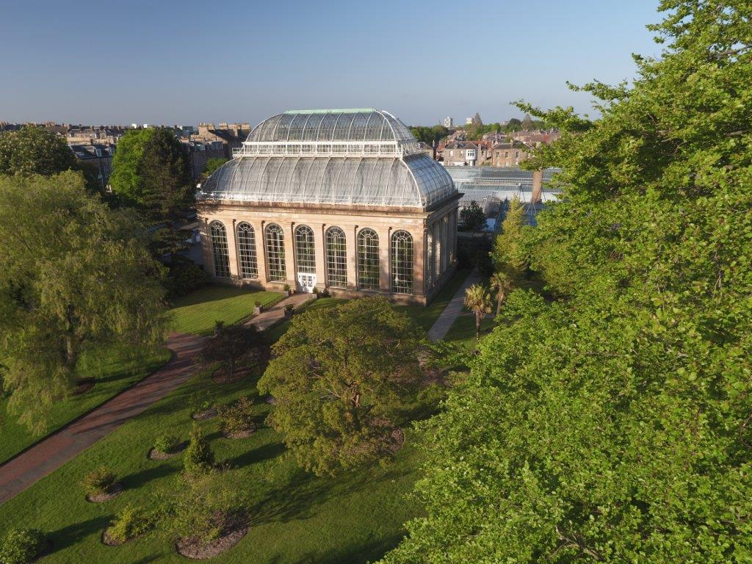

The Royal Botanic Garden Edinburgh

Arboretum Place/Inverleith Row

Edinburgh EH3 5LR

+44 (0) 131 248 2909

rbge.org.uk

   

Contents Page

1.0 Our Accessibility Promise to You 3

2.0 Map of the Royal Botanic Garden Edinburgh 4

3.0 How to reach us 5

3.1 On foot from Waverley Station 5

3.2 Pedestrian crossings 5

3.4 By Rail 5

3.5 By Bicycle 6

3.6 By Bus 6

3.7 Taxis 7

3.8 Car Parking 7

4.0 Garden Entrances 8

4.1 The John Hope Gateway Visitor Centre 8

4.2 The East Gate 9

5.0 The Garden 10

5.1 The Glasshouses 13

5.2 Inverleith House 13

5.3 The Botanic Cottage 13

5.4 The Caledonian Hall 14

7.0 Shop 14

8.0 Accessible Toilets 16

8.1 Changing Places Toilets nearby 16

9.0 Hearing Loops 17

10.0 Assistance Dogs 18

13.0 Evacuation 19

14.0 Future Plans 19

1.0 Our Accessibility Promise to You

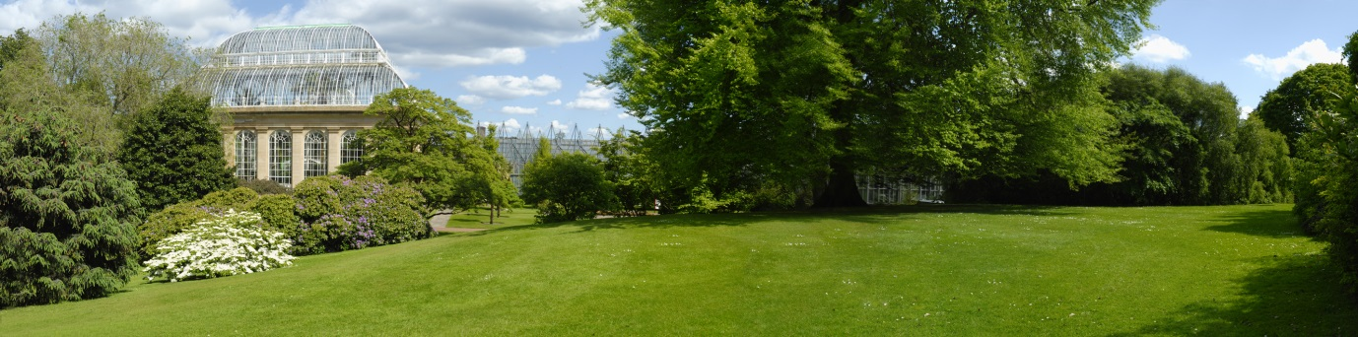

Above: Royal Botanic Garden Edinburgh Glasshouse and lawn

The Royal Botanic Garden Edinburgh welcomes all visitors and aims to provide best possible access to everyone in order that they enjoy their visit to our Garden. **Please note that due to health and safety measures following the Covid-19 outbreak, some of our facilities and services may be limited at this time.**

We provide:

* Accessible toilets in our visitor centre and in the Garden.
* Wheelchairs for visitors to use.
* Seating at regular intervals throughout the Garden.
* Water for trained assistance dogs.
* Pen, paper and magnifying glass at our Visitor Welcome desk.

If you require any further information about specific access or need advice about planning your visit please contact us on: +44 (0) 131 248 2909 or email visitorwelcome@rbge.ac.uk. If we have not covered your access needs in this document, please contact us and we will discuss your needs and offer help where we can.

This Access Guide aims to accurately describe the facilities and services that we offer all our visitors and guests and does not contain personal opinions as to our suitability for those will access requirements.

2.0 A Map of the Royal Botanic Garden Edinburgh

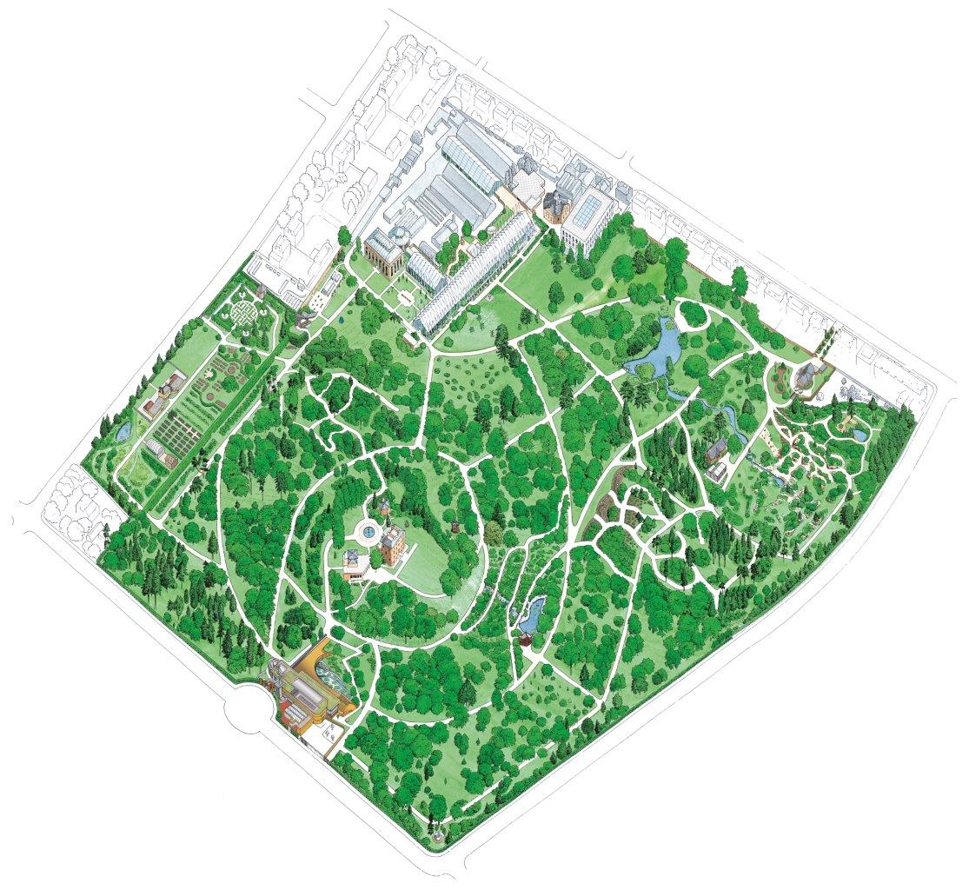

Above: Map of the Botanics

The Weather

Please note that in severe weather conditions the Garden closes for safety reasons. You are welcome to call us to check in advance that the Garden is open on +44 (0) 131 248 2909. Visitors are recommended to take extra care outside when exposed to weather conditions such as wind and rain. Please note that the John Hope Gateway visitor centre remains open even when the Garden closes due to extreme weather.

3.0 How To Reach Us

The Royal Botanic Garden Edinburgh, EH3 5LR, is just one mile north of Princes Street and can be accessed by our West Gate at Arboretum Place or the East Gate on Inverleith Row. You can plan your journey by using [www.transportdirect.info](http://www.transportdirect.info).

3.1 Walking Directions from Waverley Station

When you arrive at Waverley Station make your way to Princes Street.

* Turn left and walk to Hanover Street which is the first street on your right.
* Walk up Hanover Street, crossing George Street and Queen Street, and walk down Dundas Street. Follow this road all the way to Canon Mills.
* At the traffic lights turn left onto Inverleith Row. As you continue onwards up Inverleith Row, you will find the East Gate entrance to the Royal Botanic Garden Edinburgh on the left-hand side.

The distance is one mile approximately.

3.2 Pedestrian Crossings

There is a pedestrian crossing outside the Royal Botanic Garden Edinburgh’s East Gate entrance on Inverleith Row. Currently, there is no pedestrian crossing outside our West Gate entrance on Arboretum Place.

3.4 By Rail

The nearest railway station is Waverley Station which is 1.5 miles away from the Garden. It is possible to use the number 8 bus from North Bridge to the Garden, or the 23 and 27 from The Mound or Hanover Street.

3.5 Bicycles

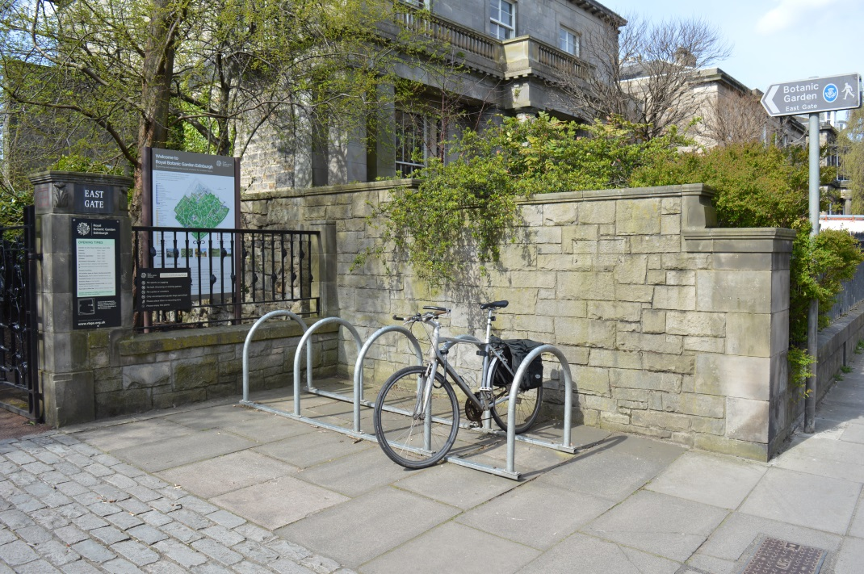

Above: Bicycle stands can be found at the East Gate, and also the West Gate.

3.6 By Bus

The Lothian Buses number 8, 23 and 27 stop on Inverleith Row near the East Gate of the Garden. There is no seating at the bus stops on arrival, but there is seating in the bus shelters on the other side of the road when you depart.

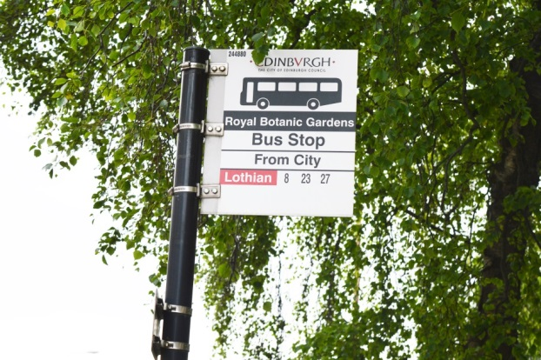

Above: The Royal Botanic Gardens Bus Stop

The West Gate is also serviced by the Majestic Tour Bus but please check that it is operating during this time. For more information, visit edinburghtour.com

Buses also stop outside the Royal Botanic Garden Edinburgh’s main reception and Balfour Building. For timetables visit www.lothianbuses.com.

3.7 Taxis

Taxis can stop right outside the West Gate next to the entrance gates, from where there is easy access into the John Hope Gateway Visitor Centre. There is also a free phone to a local taxi company at the Information desk when you are ready to leave. Taxis can also stop on the roadside outside the East Gate entrance and there is a free phone to call taxis at the East Gate Lodge on departure. Please ask a Visitor Welcome member of staff.

3.8 Car Parking

Royal Botanic Garden Edinburgh has eight blue badge disabled parking bays located outside the West Gate entrance gates on Arboretum Place, offering free parking. **However, please note that access to the Garden is currently through the gates approximately 100 metres south of this entrance.** Parking is also available on Arboretum Place (although there may be some restrictions in place during the first weeks of the Garden re-opening), Inverleith Terrace and Inverleith Row opposite the East Gate.

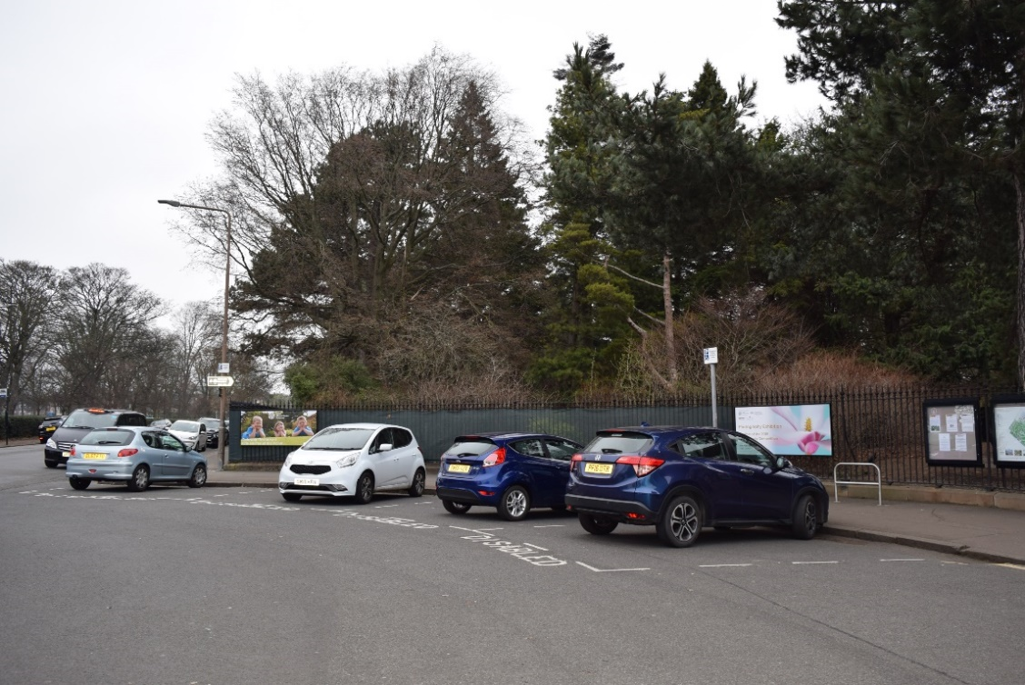

Above: Disabled spaces at the Garden’s West Gate at Arboretum Place.

4.0 Garden Entrances

There are two Garden entrances.

* The West Gate at Arboretum Place
* The East Gate at Inverleith Row.

4.1 The West Gate, Arboretum Place

The West Gate is the main entrance to the Royal Botanic Garden Edinburgh, where the

John Hope Gateway visitor centre (below) is located. **However, this entrance is currently closed. Visitors are required to enter through the Garden gates 100 metres south of the main entrance**. Note, there is a foot mat at the gate which protects the Garden’s plants from external plant diseases.

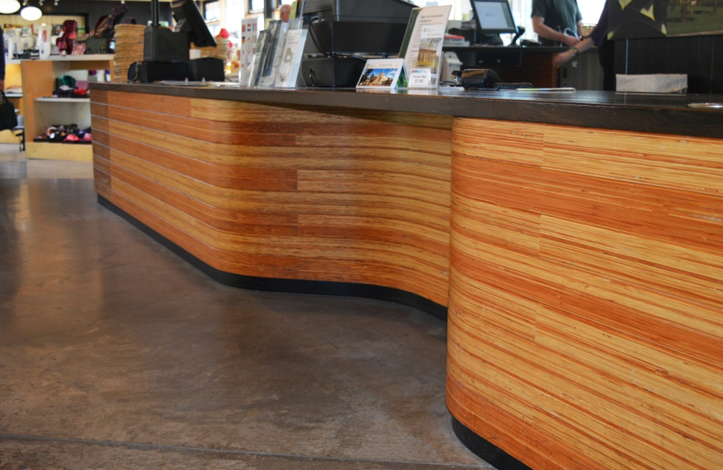

Above: The information desk in the visitor centre has a lowered section to the till point and a hearing loop.

The visitor centre has two wheelchairs for visitors to use. If possible, please book these in advance by calling 0131 248 2909. **Unfortunately, mobility scooters will be unavailable to use at this time of re-opening following the Covid-19 outbreak. This is for health and safety reasons – we are unable to demonstrate safe usage at an appropriate distance.** Visitors are welcome to bring their own mobility scooters.

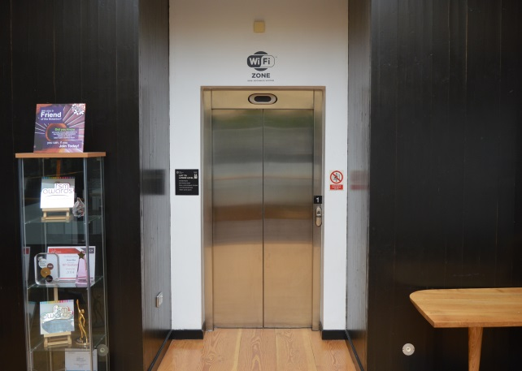

Above: A lift, large enough to accommodate a person using a standard wheelchair or mobility scooter and at least one companion, is available to take visitors to the first floor of the visitor centre. It measures 90cms wide x 135cm depth x 190cm height.

There are three accessible toilets in the John Hope Gateway visitor centre (see page 20).

4.2 The East Gate, Inverleith Row – East Gate Lodge

The East Gate on Inverleith Row is well serviced by Lothian Buses (see page 6).

* The entrance is accessible by wheelchair. This entrance has one wheelchair to use – please call 0131 248 2909 to book in advance.
* Note, there is a foot mat at the gate to protect the Garden’s plants.
* The East Gate Lodge where you will find a ‘Welcome, Tickets and Information’ window (below) with a portable hearing loop.
* There is one accessible toilet.

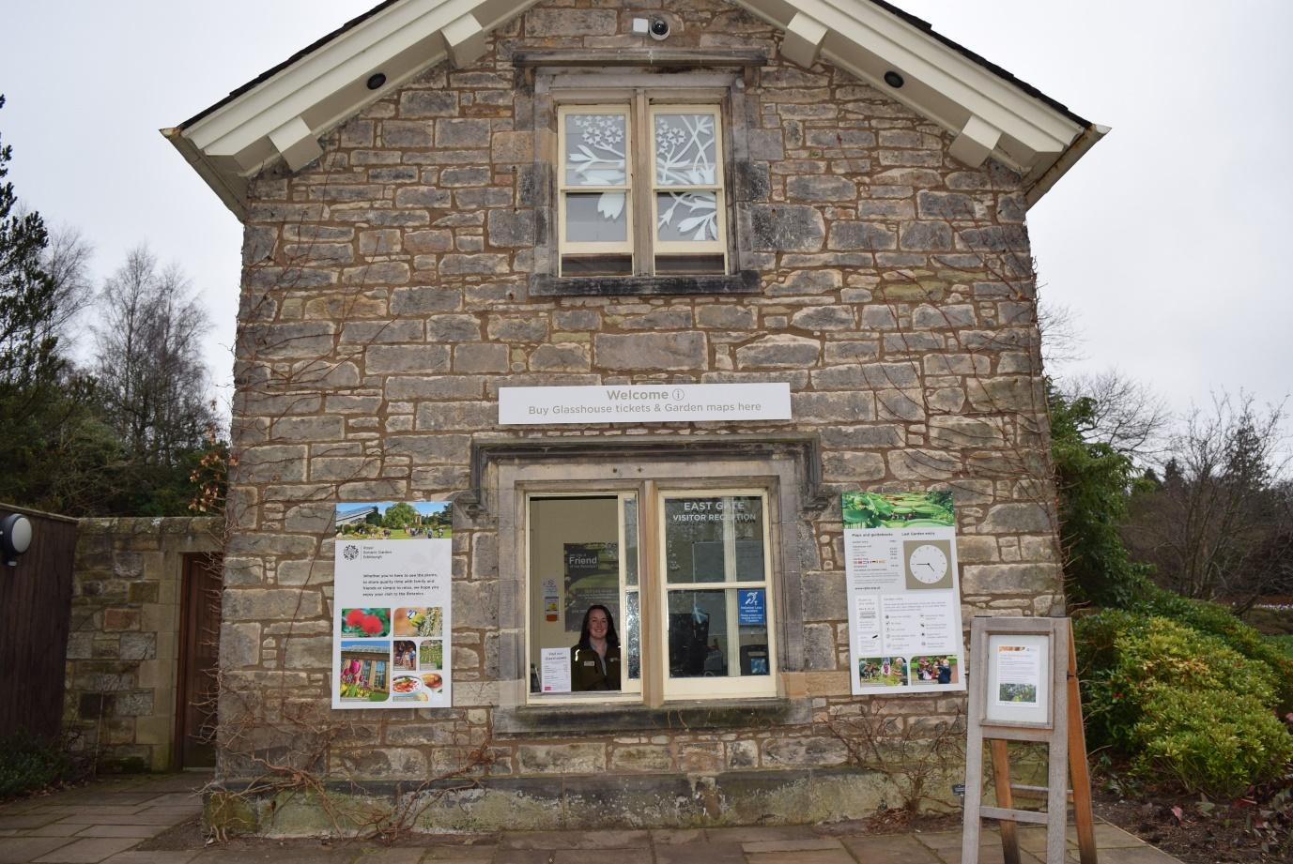

5.0 The Garden

The Royal Botanic Garden Edinburgh is one of the leading botanic gardens in the world. It is largely accessible to wheelchair users, with marked routes, and its public buildings have level or ramped ground floor access. There are tarmac paths in most places. Any paths which are not wheelchair accessible are sign-posted. Beware that some of the Garden’s paths can be a little steep, due to the gradient and/or camber.

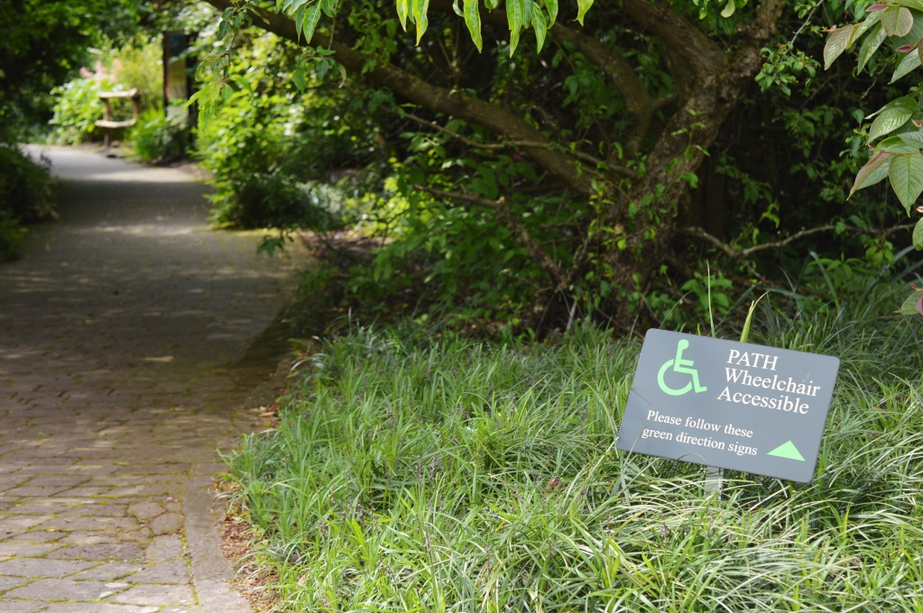

Above: Signage indicating wheelchair accessible paths

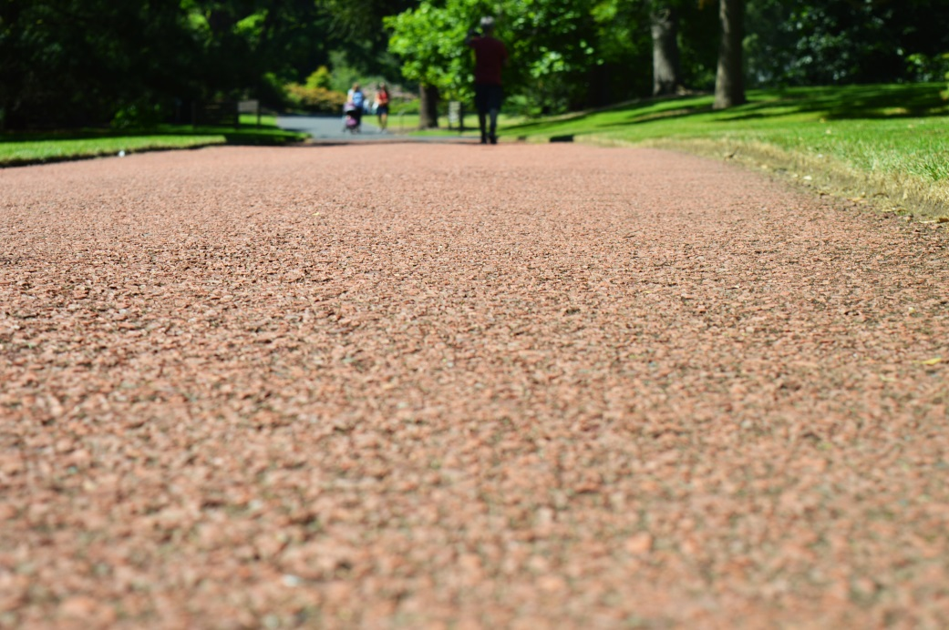

Above: Typical paths are tarmac

Throughout the Garden, signage is at ground or low level so that information can be readily seen by a child’s eye or when in a seated position. **Please note that during this time of reopening following the Covid-19 outbreak, there is extra signage to encourage physical distancing and also to identify one-way systems or areas which are currently closed.**

The Garden provides 140 benches across the Garden with arms and without.

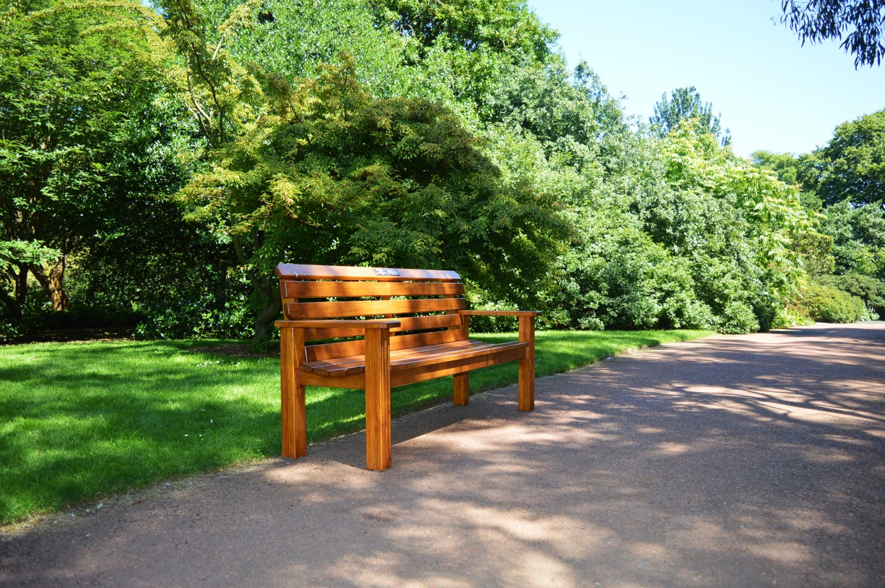

Above: Garden benches with arms

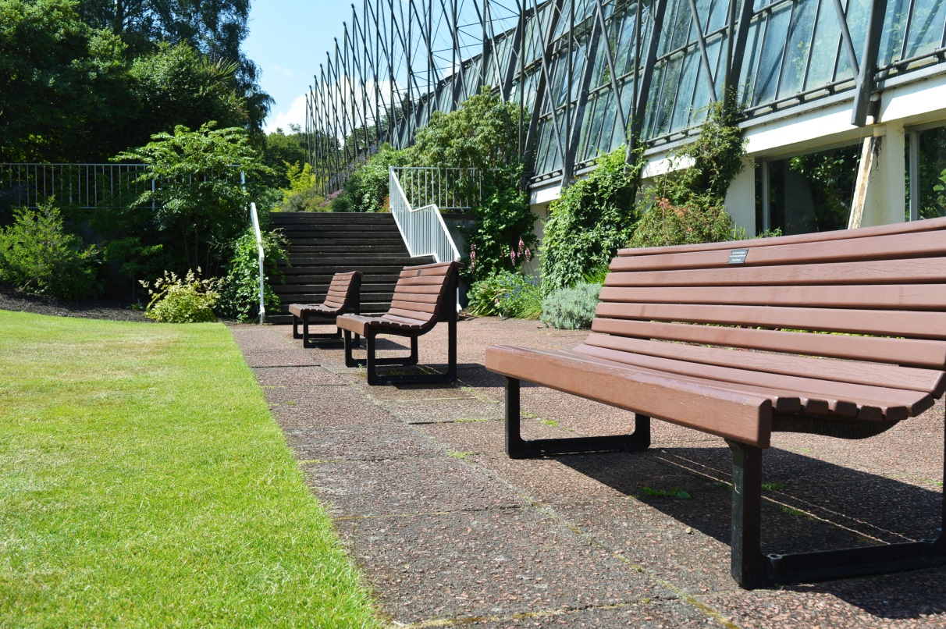

Above: Garden benches without arms

5.1 The Glasshouses

The Glasshouses are currently closed.

5.2 Inverleith House

Inverleith House, the Garden’s gallery and exhibition space, is currently closed.

5.3 The Botanic Cottage

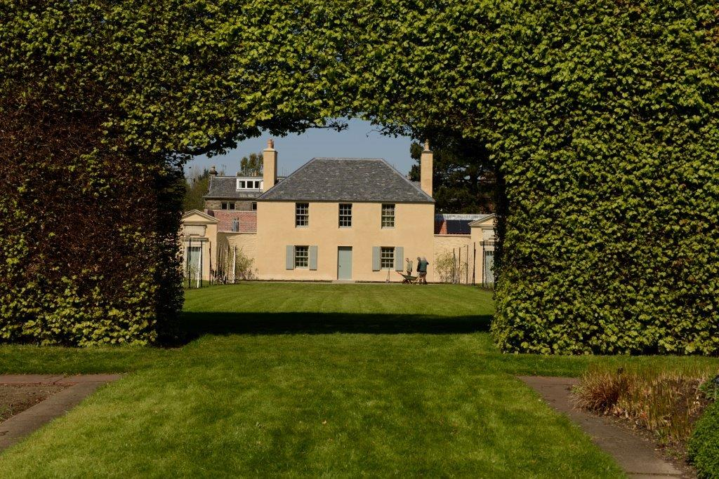

The Botanic Cottage is a community and education centre, primarily for use by pre-booked groups, but open to the public on selected days. It is currently closed. The core of the building is 250 years old but during its re-build at the Garden in 2015, efforts were made to ensure that this historic building is suitable for 21st century needs, particularly with regards to accessibility.

5.4 The Caledonian Hall

The Caledonian Hall, built in 1842, overlooks the famous Rock Garden and is often used for weddings and public engagements for up to 100 people. It is all ground level, has a step free entrance and an accessible toilet inside. It is currently closed.

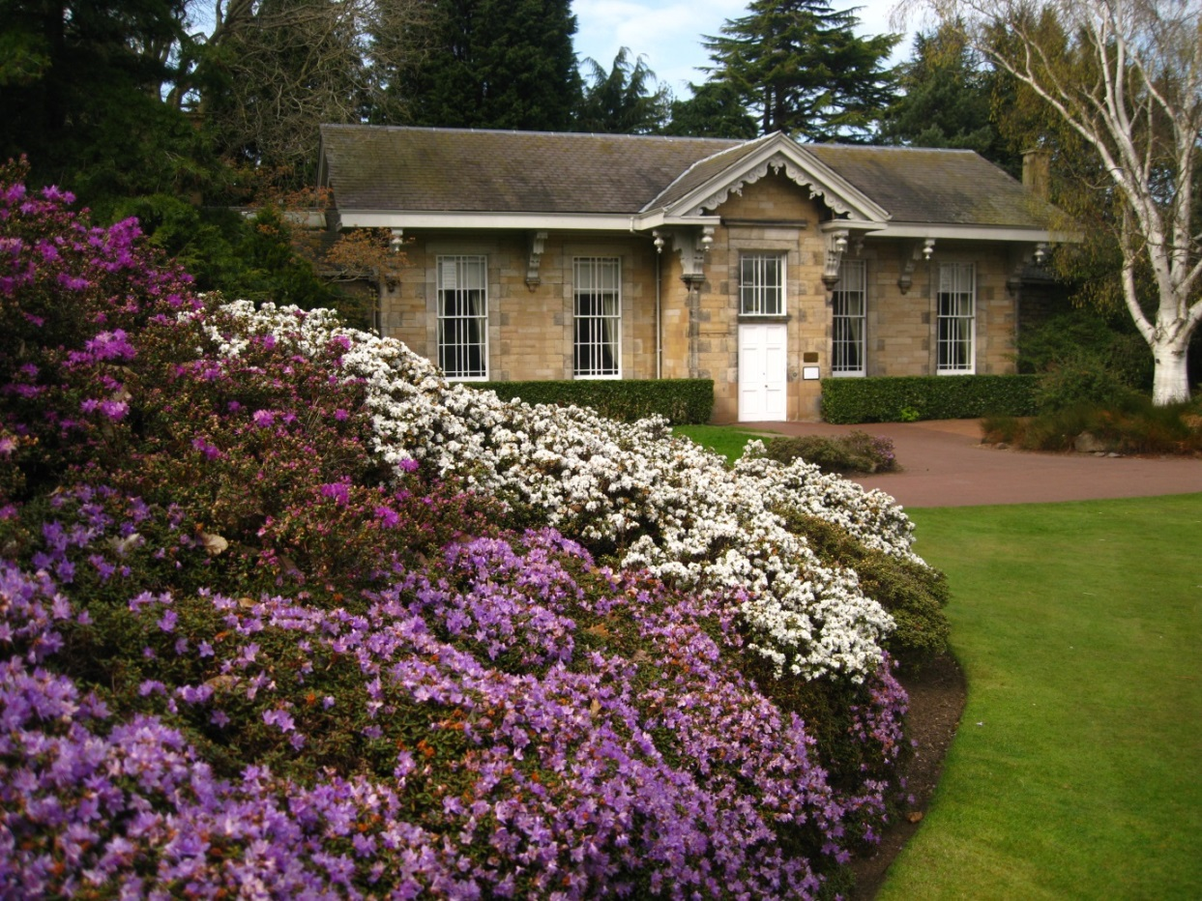

6.0 Shop

There is a shop in the John Hope Gateway, easily accessed directly from the entrance foyer, which offers a wide range of quality gifts, souvenirs, books and plants.

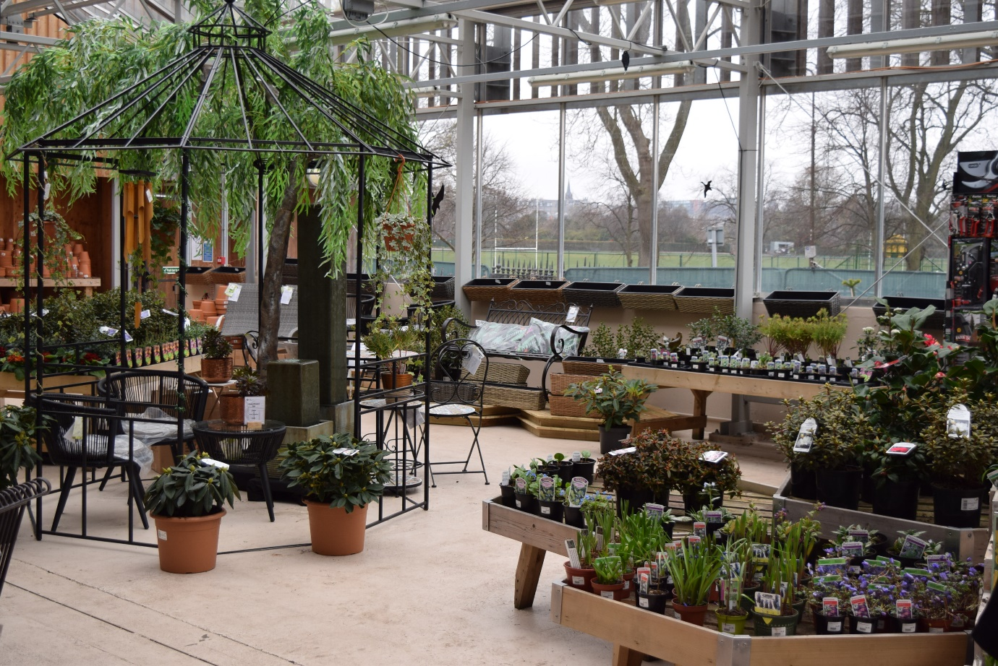

Above: Wide aisles in the John Hope Gateway shop.

Features of the shop:

* Step free access and spacious placement of shop fixtures to allow ease of movement for wheelchairs and motorised scooters.
* The indoor plant area is accessed through automatic doors and there is ramp access to the outdoor plant area.
* The shop is evenly and well lit.
* There is a hearing loop at the till point, a magnifying glass, pen and paper.
* Shop staff are always on hand to help.

7.0 Accessible Toilets

These are the locations of accessible toilets at the Royal Botanic Garden Edinburgh:

* Three in the John Hope Gateway visitor centre at the West Gate (two at the entrance and one on the first floor)
* One in the East Gate Lodge at the East Gate
* One located centrally in the Garden outside the Fern House

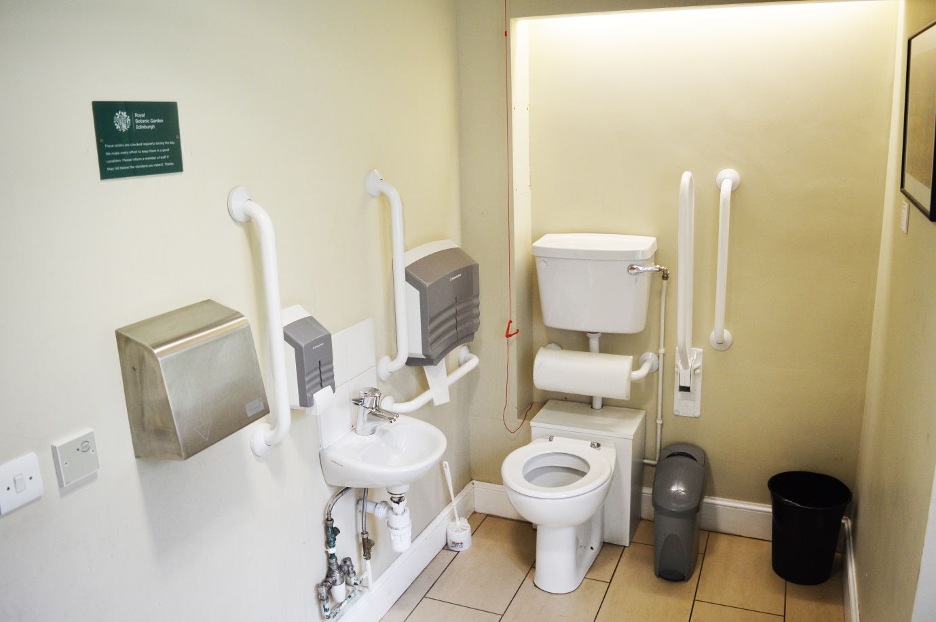

Above: An accessible toilet at the Royal Botanic Garden Edinburgh

7.1 Changing Places WCs nearby

There are two Changing Places WCs in the area at the following locations. For more information, please visit www.changing-places.org:

1.2 miles from the Royal Botanic Garden Edinburgh:

The Booking Office

JD Wetherspoons

17 Waverley Bridge

Edinburgh EH1 1BQ

Open Sunday to Thursday: 6am to midnight

Friday and Saturday: 6am to 1am

Tel: 0131 558 1003

This toilet is located on the ground floor level via a short ramp from the bar. Locked by radar key with a spare key at the bar. It provides a height adjustable, adult sized wall mounted bench and hoist (ceiling, loop).

8.0 Hearing Loops

A permanent Induction Loop is fitted at the John Hope Gateway Visitor Centre Information Desk. There is also another loop at the East Gate Visitor Welcome counter.

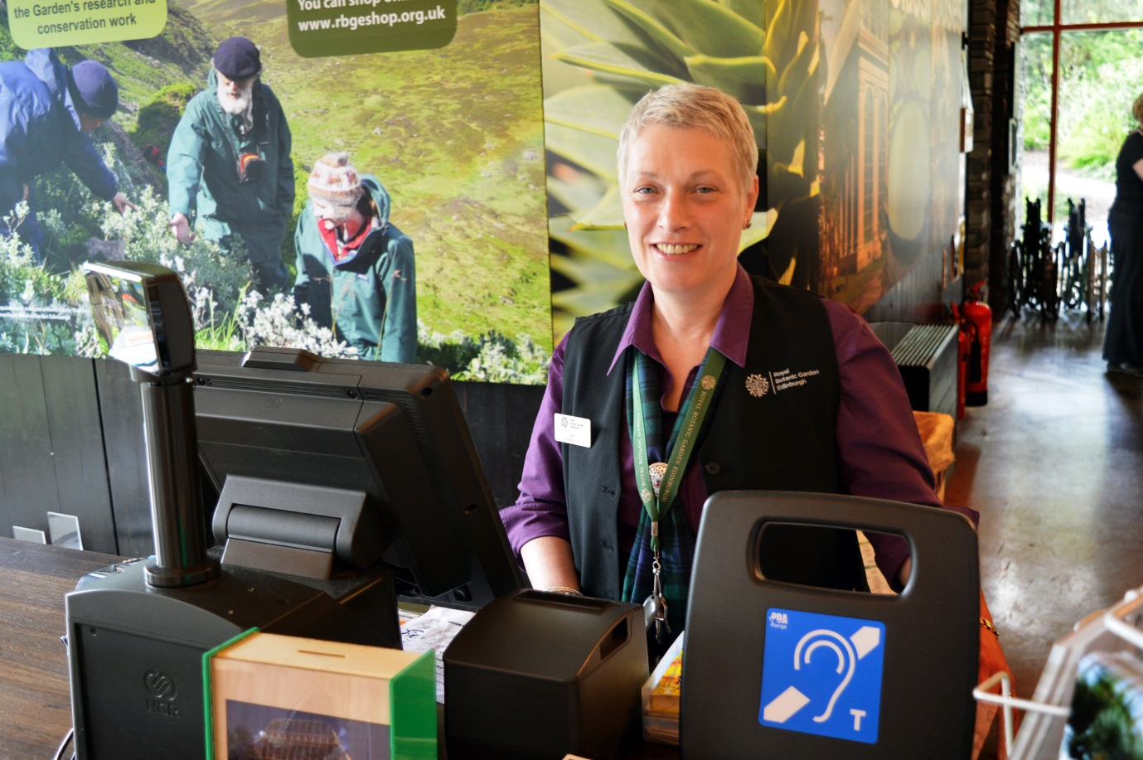

Above: The induction loop in the shop at the John Hope Gateway

9.0 Assistance Dogs

The Royal Botanic Garden Edinburgh welcomes all trained assistance dogs to the Garden. Dog bowls of water are available on request. The Garden has a world-leading collection of plants that it has a duty to protect and a responsibility of care to all visitors. Therefore, we ask that assistance dogs are registered or that owners provide confirmation that they are highly trained, and that they are kept on a lead during their visit to the Garden.

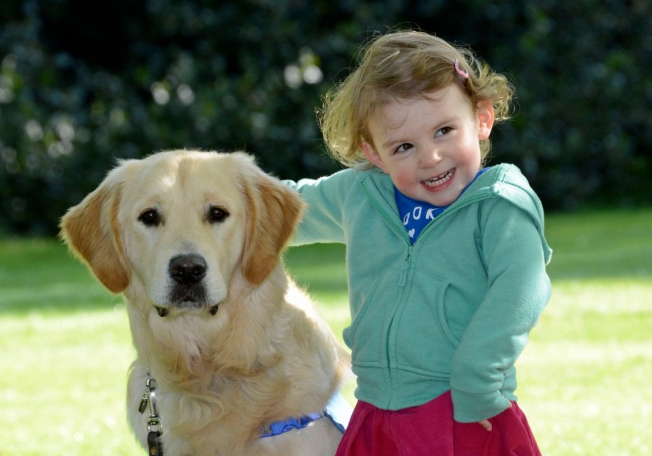

Above: Guide dog Huxley with toddler Francesca at the Garden

10.0 Evacuation

Should a fire alarm sound and an evacuation take place, the Visitor Welcome team or other Garden staff will assist those with specific needs to evacuate. Within the John Hope Gateway, there are two dedicated refuge points for visitors and staff in the North and South stairwells. Our Visitor Welcome team will assist those who require help to those areas, and wait with them until the fire services arrive. Accessible toilets in all buildings are physically searched in the event of an emergency evacuation.

11.0 Future Plans

The Royal Botanic Garden Edinburgh is part of the VisitScotland Inclusive Tourism Group and aims to continue to enhance its offering to those with specific needs. Our future plans:

* The Garden participates in Disabled Access Day, run in association with Euan’s Guide, and collaborates with VisitScotland on inclusive tourism.
* A Changing Places Toilet is planned in the new Edinburgh Biomes Glasshouse. For more information about this project, visit rbge.org.uk/edinburghbiomes.
* We continue to provide equality awareness training for our staff and inclusivity is one of our main values at the Royal Botanic Garden Edinburgh.

If you would like to provide any feedback on this Access Guide, we would welcome your comments. We would be interested to hear if there is any information we may have missed, or things you think might help us to improve accessibility in terms of services and facilities. Please contact us at [marketing@rbge.org.uk](mailto:marketing@rbge.org.uk)