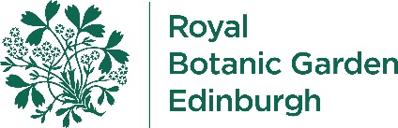

Self-Guided Visit/Art Permit Booking Form

The Garden is a great place for self-guided learning. Entrance to the Garden is free and schools, colleges & universities can book in advance to take advantage of our 'education group rate' for entrance to our world famous Glasshouses. (This is not offered to adult education courses, although they can benefit from group rates).

Any school, college or university groups wishing to sketch, draw, photograph or paint within the Garden must apply for a non-commercial art permit. This must be shown on arrival at the garden and when requested if approached by a member of staff.

Bookings for self-guided access or art permits must be arranged at least two weeks in advance of the visit.

Please provide the following information and return to education@rbge.org.uk

Type of Booking (please delete as appropriate)
Self-Guided Visit | Art Group Permit Request
Name of Group Leader
Enter text here
Name & Address of School/College/University
Enter text here
Contact Telephone Number of Group Leader
Enter text here
Contact Number whilst in the Garden (mobile number of someone who will be present)
Enter text here
Date of visit | Time of visit
Enter text here | Enter text here
Number in Group (Students & Accompanying Staff/Adults)
Enter text here
Reason for visit
Enter text here
What activities will you be doing while here?
Enter text here
Location of activity e.g. Chinese Hillside, Glasshouse Lawn, Tropical Palm House etc.
Enter text here

Art Permits Only:

Type of art activity e.g. sketching, painting, photography etc.
Enter text here
Type of Materials group will be using
Enter text here

