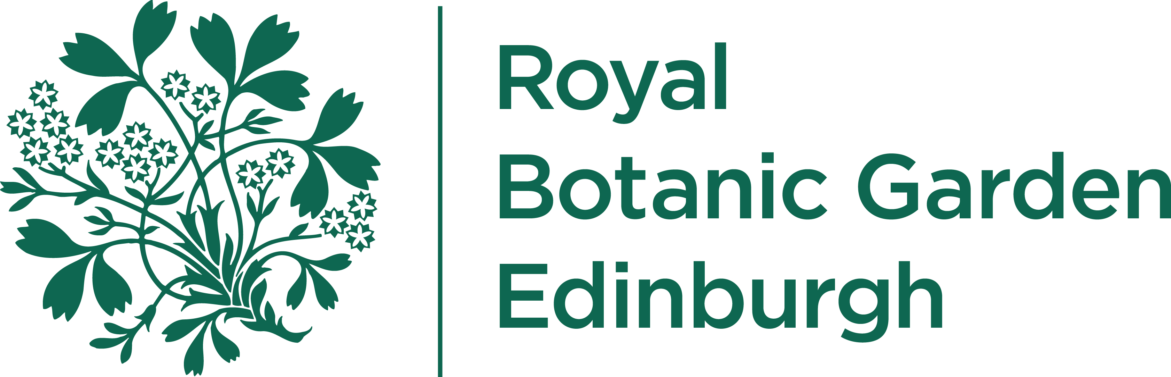
RBGE Ref:

Destructive Sampling of Herbarium Specimens

Conditions of use of material derived from the Royal Botanic Garden Edinburgh (RBGE) Herbarium Collection

- In response to the Convention on Biological Diversity (CBD), the RBGE supplies plant material, including seeds, DNA and pollen samples on condition that:

- The plant material is used for the common good in areas of Research, Education, Conservation and the development of Botanic Gardens.

- Access to material from RBGE’s Collection is for non-commercial use only. Any commercial exploitation of material must be carried out under the terms of the Convention on Biological Diversity and will require the full agreement of the host country that provided the source material.

- The genetic material, its products or resources deriving from it are not passed on to a third party for commercialisation without written permission from the country of origin and RBGE, in accordance with the Convention on Biological Diversity

- No material may be removed from specimens without prior consent from the Herbarium Curator.

- No material will be taken from Type Specimens, “historically important” specimens, or specimens dried in alcohol.

- It is a condition of supply that any publication resulting from the use of plant material should acknowledge RBGE as supplier or, under certain circumstances, be published in collaboration with staff from RBGE. A copy of any publication, report or data gained from the material MUST be lodged with the Royal Botanic Garden Edinburgh via herbarium@rbge.org.uk

- An aliquot from each DNA sampling should be returned to RBGE. Where palynological or anatomical preparations are made, duplicate slides or, in the case of SEM/TEM work, high quality photographs must be sent to RBGE.

- RBGE reserves the right to refuse, without explanation if necessary, to supply genetic resources to a recipient.

- The RBGE cannot guarantee the material as verified. Any queries should be sent to the Herbarium Curator at herbarium@rbge.org.uk


RBGE Ref:

Please return this form to:

Herbarium Curator
Royal Botanic Garden Edinburgh
20A Inverleith Row

Edinburgh
EH3 5LR
Scotland, UK.

Fax: +44 (0)131 248 2901
Email:
mailto:herbarium@rbge.og.uk?subject=RBGE Herb Condition of use form

For internal RBGE use
Herbaria:
Data Source #
Psource #
Internal contact

For requester use:
Requested by: |  | Position:
Supervisor:
(if appropriate)
Organisation: |  |  | Index Herbariorum  Code
Department:
Address:
Post/Zipcode: |  | Tel. Number
Country: |  | Fax. Number:
Email: |  | Web site:
Signed:
Supervisor Signed: |  | Date: dd/mm/yy

I agree to comply with the conditions above.

