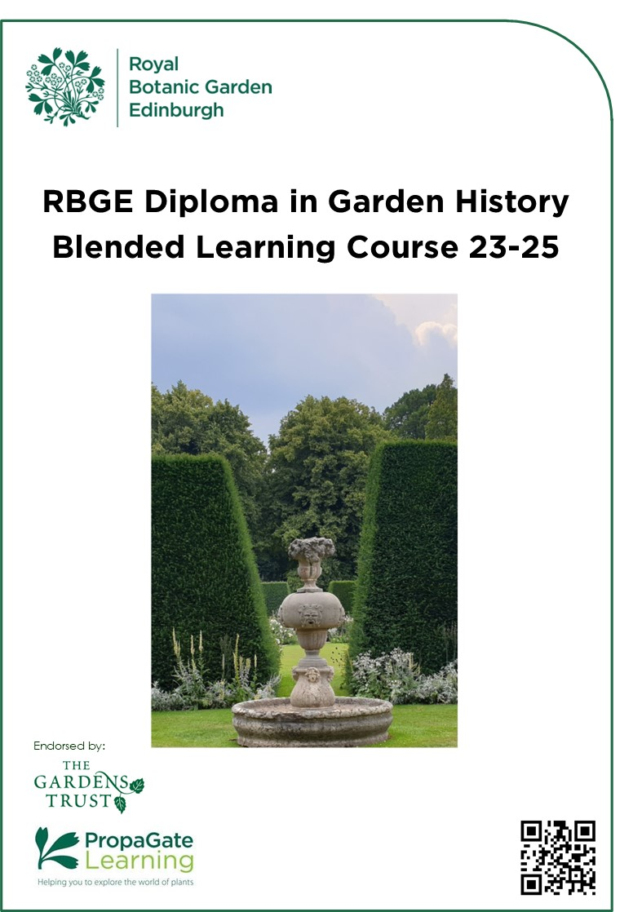
RBGE Diploma in Garden History Online Course 2023-25
Contents

Introduction 4
Course tutors 5
Course Aims 6
Course Structure 6
Course Content 7
Unit 1: History of British Garden Design 7
Unit 2: Italian Gardens and their Influence 7
Unit 3: Nineteenth Century Horticulture 8
Unit 4: Historical Aspects of Gardening 9
Unit 5: Conservation of Gardens and Designed Landscapes 9
Assessments 11
Course Dates 13
Online Learning: How does it work? 15
The Gardens Trust Membership 17
Course Fees 18
Entry Requirements 19
Application Procedure 20
Terms and Conditions 20
Privacy Notice 21

Welcome…
… to the Royal Botanic Garden Edinburgh (RBGE) thank you for taking an interest in the course and we are delighted that you are considering joining our Diploma in Garden History.

This two-year course offers the unique opportunity to explore the history of gardens in Britain. RBGE was founded as a physic garden in 1670 to further the study of plants and medicine and is therefore perfectly suited as a centre for this topic as one of the oldest botanical and horticultural teaching institutions.

Garden history is a fascinating subject that brings together many disciplines since the design of gardens not only reflect the often unique passions and interest of the owner but also current cultural and political contexts. The course is geographically concentrated on Britain but will look at other influences from Europe and a unit is dedicated to Italian gardens since they have been so influential throughout the centuries. Another emphasis of the course is on horticultural and botanical aspects such as the plants themselves and the gardeners’ skills of managing a diverse range of garden features.

Through PropaGate, our virtual learning environment, you will be able to work remotely throughout the two-year course. Online forums and two attended study blocks per year at RBGE support you through the course, provide a chance to meet fellow students and tutors and to see the world-renowned collections at RBGE. Local visits to historic gardens and research institutions provide a stimulating introduction to research methods.

I do hope the Handbook answers all your questions about the course, but please don’t hesitate to contact us if you have any further queries and we look forward to receiving your application.

education@rbge.org.uk

Introduction

‘God Almighty first planted a Garden; and, indeed, it is the purest of human pleasures; it is the greatest refreshment to the spirits of man; without which buildings and palaces are but gross handy-works…’ Francis Bacon, 1625

The history of gardens and gardening stretches back to the beginnings of human civilisation where the first evidence of ornamental planting is difficult to separate from the practices of agriculture and growing plants for medicine - challenging the clear definition of what constitutes a garden. Changes and differences in garden design and practice throughout history result from a wide range of causes among which are political and religious belief, perception of the relationship between art and nature, and concerns regarding the interaction between buildings, gardens and the countryside. Added to these is the steady increase in influence of new plants introduced mainly over the last four centuries through botanical exploration and plant breeding and selection.

The subject of garden history is therefore very wide and although this course has a broad compass, selection of the main topics is necessary. Geographically, the main context is British garden history but as the development of our gardens has been profoundly affected by European influences some of these are considered. A main aim of this course is to provide a firm foundation of knowledge in the discipline and to stimulate the student to explore further branches of the subject. We also hope to present a context in which to link existing knowledge and encourage interest in the history of the related fields of art, architecture and botany.

Course tutors

Johanna Lausen-Higgins

Johanna completed an apprenticeship in organic gardening in 1998 at the foot of the Alps and subsequently moved to Britain to work at The Lost Gardens of Heligan where she tended the Victorian pineapple pit which has started her passion and interest for garden history. Johanna then worked at several historic gardens across Britain. After completing a BSc (Hons) in Horticulture at RBGE and an MA in Garden History at the University of Bristol Johanna joined the Education team at RBGE in 2012 and was thrilled when her former mentor Phil Lusby asked her to teach on the newly established Diploma in Garden History. Since Phil retired last year Johanna has taken on the role of course director. Her special interests include the history of fruit growing and Renaissance gardens. She has published on various garden historical topics such as the cultivation of pineapples in Britain, the grotto of the animals at Villa Castello in Florence and the eighteenth century botanic garden once situated on Leith Walk in Edinburgh.

Philip Lusby MBE
Phil, the former Course Director retired in 2020. Phil worked and studied horticulture at the Royal Botanic Gardens, Kew. His interest in garden history was stimulated whilst maintaining the Queen’s Garden, a re-creation of a seventeenth century garden at Kew. After completing the Kew Diploma and graduating in botany at Aberdeen he worked as a botanical surveyor in the Nature Conservancy Council and then returned to horticulture in 2000 when he joined the education department of RBGE as a senior lecturer. Garden history had been an intended subject for many years in horticultural education at RBGE and Phil was able to realise this during a major course re-structure in 2005. The subject is now an integral part of the BSc Horticulture with Plantsmanship course and several successful short courses have been run as evening classes within the RBGE Adult Education Programme. The RBGE Diploma in Garden History builds on this foundation with the intention of providing an exciting and fulfilling programme of study.

Course Aims
- Explore the history and diversity of historic gardens in Britain
- Examine the influence of related subjects of literature, art and architecture
- Explore the origins and development of cultivation methods of selected plants and crops
- Create a list of period plants, with their dates of introduction and their use in gardens
- Appraise how gardens are evaluated and graded across Britain

Course Structure

The duration of this online course is just under two years. Each year is divided into two terms: Autumn/Winter and Spring/Summer. As study for this course is largely independent, the timetable is provided to enable the student to progress through the course at an optimal pace for completion within the allotted time.

It is expected that students will read the notes for each topic including any further reading in order to keep to the unit timetables. Expected student study time per week is in the region of 4-6 hours which should be adequate for assignments and online activities but can vary depending on level of further reading students would like to engage with.

Assignments and unit revision quizzes will be set in accordance with the suggested rate of course progression.

Tutorial guidance and online discussions are available throughout the course.

The attended study blocks give you an excellent opportunity to meet fellow students and tutors and attend a stimulating series of lectures as well as visits to gardens and research institution whilst using RBGE as a base.

Course Content

The course is divided into the following five Units:

1. History of British Garden Design
2. Italian Gardens and their Influence
3. Victorian Horticulture
4. Historical Aspects of Gardening
5. Conservation of Designed Landscapes

Unit 1: History of British Garden Design

This unit provides an overview of gardens and garden design in Britain since the earliest evidence of Roman gardens to the late twentieth century. With a brief introduction of Egyptian, Persian and Islamic gardens to explore how they influenced gardens in Europe. The characteristics of the changing design styles, their designers and the multifarious reasons behind changes in design layouts are considered. The history of garden design is best appreciated within its wider historical context and wider reading and study is encouraged.
This unit forms the foundation of the course and underpins the following more specialised topics which build upon and assume familiarity with the content of this one

Unit 2: Italian Gardens and their Influence

Influences on the design of gardens in Britain come from a number of geographic sources throughout history including The Middle East, Italy, France, Holland, Japan and, more debatably, China. It is, however, generally accepted that the most profound and recurring impact over the centuries has come from Italy. It seems that the British have always had an admiration and empathy for Italian gardens so the Italianate style of gardening has regularly surfaced to popularity and continues to do so.

This unit traces the development of Italian gardens from classical Roman times but focuses on the Renaissance gardens of the fifteenth and sixteenth centuries. The layout, planting, and soft and hard landscape features will be considered as well as the contemporary perception of the function and meaning of Renaissance gardens. Many of these gardens carried various messages in their rich sculpture that invited visitors to decipher them.
The last part of this unit considers how various influential designers interpreted Italian garden style within the design and construction of gardens in Britain from the seventeenth to the twentieth century.

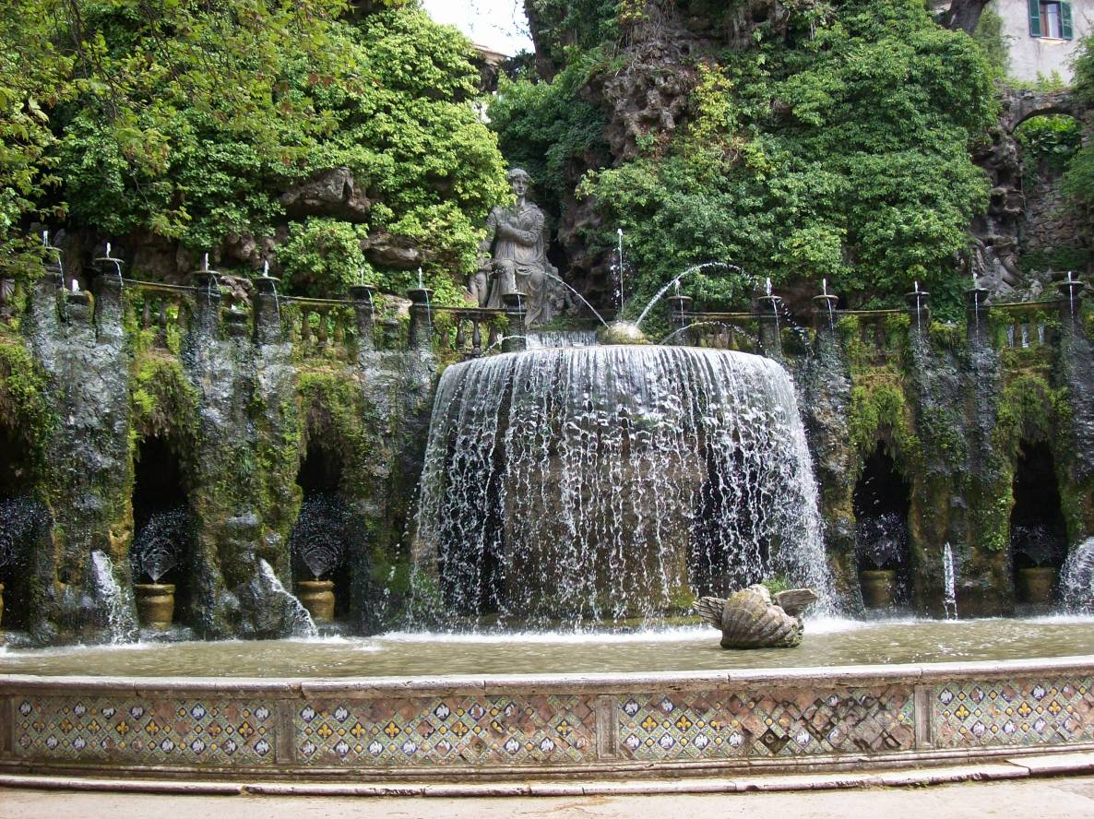
Unit 3: Nineteenth Century Horticulture

Any period of garden history may deserve more detailed scrutiny than an overview may provide, so in any course of study choices must be made.
Here, the complex and contrasting design preferences of nineteenth century horticulture are considered, a particularly complicated (but not always tasteful!) period. It is characterised by intense debate, innovation and variation of gardening styles fuelled by the full effects of the Industrial Revolution. Coupled with this, the great influx of plant introductions increased the influence of plants to drive change in garden design.
This unit introduces the development and achievements of important and influential people and the effects of their garden styles. Such as the reaction against naturalism resulting in the dominance of artifice championed by Loudon. Towards the end of the period intense argument and debate resulted in the search for the quintessential English garden and was accompanied by a national identity crisis. The balanced compromise of formal and naturalistic approaches to garden design (exemplified by the work of Gertrude Jekyll and Edwin Lutyens) provided the solution and resulted in some of the most cherished gardens of today and a genre of gardening that carried on through the twentieth century.

Unit 4: Historical Aspects of Gardening

The focus of this unit are the plants themselves. The development of a selection of historical garden features are explored such as topiary and lawns, knots and parterres, ornamental uses of roses and historical fruit cultivation in Britain including pineapples. The development of garden tools and glasshouses which relate closely to the management of plants are covered too. Some of the most important plant collectors and the challenges they faced in bringing back plants that we cannot imagine being without are introduced here.

Knowledge of a range of period plants not only informs a deeper understanding of the appearance of historic gardens over time but can also aid in the restoration, or re-construction of gardens of specific historic periods. Some plants, first fashionable and cherished by some of the most eminent gardeners, now cause problems in the natural environment through their too efficient dispersal and subsequent escape from gardens to out-compete native species and alter more natural vegetation.

Unit 5: Conservation of Gardens and Designed Landscapes

This brief module is necessarily placed as the last in the Diploma programme builds on the areas covered in this course and considers other closely allied land use interests that interact with designed landscapes such as the conservation of nature and biological diversity.
Various methods and techniques to evaluate our heritage gardens and landscapes are introduced followed by the processes involved in the production of conservation and management plans. This involves investigating the wide and varied documentary evidence and other information relating to the evolution of gardens, and the possible pitfalls in attempting to establish from the evidence what was constructed.
Perhaps the most challenging aspect of this discipline is in the field of garden restoration. Because of our very long and rich garden history, many of our most cherished sites exhibit several historical layers with some of the best examples of features belonging to different time periods. How do we choose the most important and most appropriate historical layer to restore? How do we reconcile and incorporate features of other eras or do we remove them in the interests of purism? This unit addresses such questions, provides the background for informed consideration.
Finally, having made the best possible decisions based on historical interests and accuracy, how do we cope with the demands of today in terms of visitor numbers, especially if the garden is open to the public?

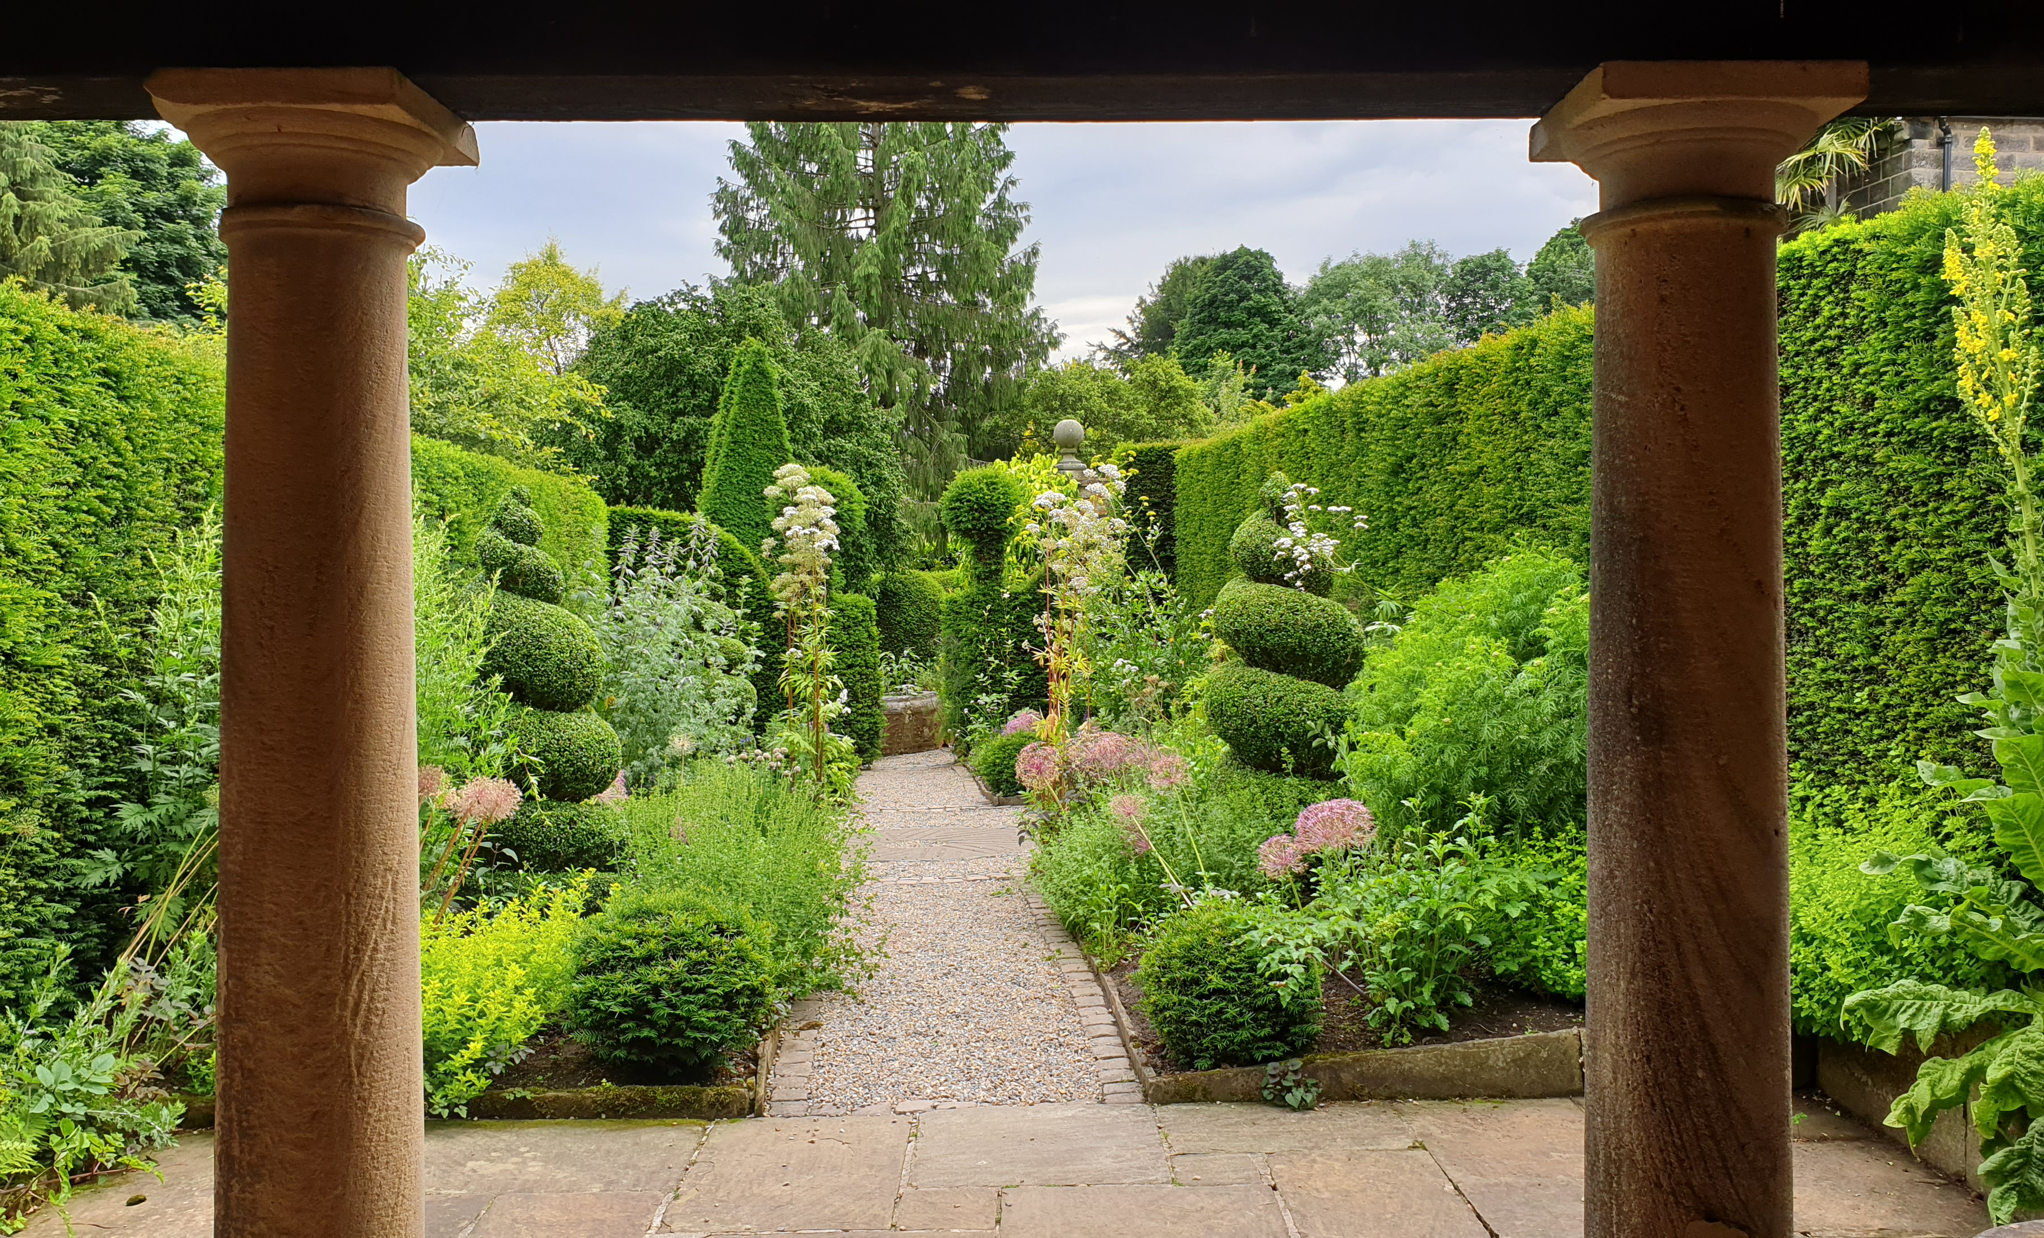
York Gate, listed Grade II in 2020

Assessments
For the award of RBGE Diploma in Garden History, all five units must be successfully completed and all assessments passed by the end of August 2025 following the completion of the course.

Revision quizzes: There will be no ‘closed-book’ tests but for each unit there will usually be a short online quiz that will consist of short answer or multiple choice questions which must be completed before moving on to the next unit. These will go live at the end of each unit and the completion date is a week after the issue date. The revision quizzes will count for 10% of the Diploma.

Topical forum posts: Each unit has a number of topical forum posts that engage with further reading, or the course material and participation is expected. 5% of Diploma marks.

Historic garden reports: This assignment requires the student to compile a report on two contrasting historic gardens, each of a different style and historic period. 30% of Diploma marks.
Note: additionally, students will create blogs on one historic garden of their choice to post on the class forum. Advice will be given about how this is done.

Portfolio of ‘period’ plants: An illustrated portfolio of plants arranged chronologically by their date of introduction. To evaluate the appearance of gardens and a potential future reference source for historically accurate planting plans. 15% of Diploma marks

Specialist study on a topic of your choice: An illustrated essay of up to 4000 words that allows you to draw together your learning and interest in almost any aspect of garden history. It is also possible to link this essay into your plant portfolio or historic garden reports to produce a larger, thematic thesis. 45% of Diploma marks
The Diploma will be awarded at Pass, Merit and Distinction levels; the thresholds for each grade are: For all assessments a maximum of two attempts are allowed (1st attempt and re-sit).

Referral under 50%
Pass 50 – 59%
Merit 60 – 74%
Distinction over 75%

Plagiarism Checking Software
RBGE currently has access to a tool called ‘Turnitin’. Turnitin is an online service that promotes academic integrity helps you to submit your best original work. It also aids your tutor to give meaningful feedback. Some of your assessments will make use of this tool.

By submitting your work to PropaGate Learning, you agree that your work will be subject to submission for textual similarity review to Turnitin for the detection of plagiarism. When you upload your first piece of work, you will have to agree to the End User Licence Agreement. You will not have a separate username or password because it is integrated into our site. Personal data will only be shared with Turnitin if you have your name or other personal data on your paper or in the file name.

You will be able to view the similarity report before final submission and adjust submissions as appropriate.

See www.turnitin.com for more info. Use of the Turnitin.com service is subject to the Usage Policy posted on the Turnitin.com site. Papers can be removed from these databases by request to Turnitin. If any of this information changes, we will inform you during your course.

Course Dates

Year 1
Term | Dates | Units
Autumn/Winter | November - December 2023 | 1. History of British garden design
Early spring/Summer | February – May 2024 | 2. Italian gardens and their influence

Year 2
Term | Dates | Units
Autumn/Winter | October 2024 - Mar 2025 | 3. Victorian Horticulture  4. Historical aspects of gardening
Spring/Summer | April- June 2025 | 5. Conservation of gardens and designed landscapes

Material for each unit will be available online from the relevant start date.

Garden Study Excursions

Some garden visits are scheduled during the attended study blocks (details below) to areas within easy reach of Edinburgh. Students are also required to see a range of gardens throughout the course within their locally accessible area.

Attended study blocks schedule 2023–2025

All attended study blocks will run on-site at RBGE with some visits to local sites of interest. Full details will be given following registration to the course. Some timings, topics and activities may alter but will be confirmed nearer the time.

Attended Study Block 1
Day | Times | Topic | Location
Friday 3 Nov 2023 | 10.00 –  16.15 | Resources and Researching (1) intro to online sources & gems from the specialist collection | RBGE
Saturday 4 Nov 2023 | 10.00 – 17.00 | Resources and Researching (2); Botanical nomenclature workshop; RBGE herbarium | RBGE

Attended Study Block 2
Day | Times | Topic | Location
Wednesday 22 May 2024 | 10.00 – 17.30 | Garden visits | RBGE
Thursday 23 May 2024 | 10.00 – 18.30 | Resources and researching (3) historic maps and plans NLS map library | RBGE
Friday 24 May 2024 | 10.00- 16.00 | Guest speakers | RBGE

Attended Study Block 3
Day | Times | Topic | Location
tbc | 10.00 – 17.00 | Garden visit tbc | RBGE
tbc | 10.00 – 17.00 | Guest speaker tbc | RBGE

Attended Study Block 4
Day | Times | Topic | Location
tbc | 10.00 – 17.00 | Guest speaker tbc | RBGE
tbc | 10.00 – 16.00 | Garden visit tbc | RBGE

Online Learning: How does it work?

Introduction
Your online learning environment is PropaGate Learning which uses the Moodle learning platform. It can be found at propagatelearning.rbge.ac.uk.

PropaGate Learning is a website you log in to access your course(s). It’s a place for learning and for discussing topics and progress with your tutors and other students. PropaGate Learning allows you to study from home, whilst becoming part of a thriving and enthusiastic learning community.

Your course will consist of a number of elements which may include documents, presentations, videos, interactive lessons, quizzes, discussion forums and links to useful websites.

We continually review and update the course and we are currently updating the course to ensure it is more accessible.

How can I prepare for studying online?
We would expect you to be a competent computer user with a basic understanding of standard computer applications such as using an internet browser, email and word processing. Experience of participating in online forums would also be a benefit, but not essential as these skills can be learned while participating in an online course.

Our Help and support for online learning courses will help you to identify any digital skills you may need to brush up on.

When you are first given access to PropaGate Learning, please take time to complete the Orientation Activity and complete some other initial activities including introducing yourself on the forum, updating your profile and familiarising yourself with the site. This will give you an essential introduction to the course, finding your way around, advice on learning independently and the best ways to communicate with tutors and other students.

Online courses require a much more self-motivated learning style than traditional attended classes. Participation in online discussions is a key part of the course – online learning is much more sociable than you might think! We encourage you to set aside a certain amount of time each week to log into the course to watch presentations and carry out activities. The minimum for this course is around two hours.

What hardware or software will I need?
You will need access to a desktop or laptop computer. Most of the course will be accessible via a tablet/phone, but we recommend using a laptop or desktop computer as you will find some aspects of the course will be easier to use on a computer.

Regarding software, you will need an up-to-date browser (we recommend Firefox, Chrome or Safari). You will also need software that will open Word documents or PDFs. Most importantly you will need a reliable strong internet connection.

PropaGate Learning is available 24/7 with the exception of any maintenance work which we will inform you about in plenty of time.

What support is available?
We encourage everyone to make the most of the forums on the course. These provide a way for students to talk to one another and to tutors and ask each other questions. s.

Tutors check the forums at regular intervals and will usually reply to forum queries within 5 working days, although usually sooner.

Our PropaGate Learning team are always available so if you ever feel you are stuck with a course-related technical problem, they can be contacted via the forums or by emailing: propagate@rbge.org.uk where you will receive a response within 1 working day.

The Gardens Trust Membership

The Gardens Trust was formed in 2015 following the merger of The Garden History Society (founded in 1966) and the Association of Gardens Trusts in England. The Gardens Trust recognises the value and relevance of garden historical study and the need to conserve the most important examples of these fragile creations. We are delighted that this course has been formally supported by The Gardens Trust.

In accordance with this association, all students will be members of The Gardens Trust for the duration of the course and will receive a copy of the renowned and internationally recognised academic journal Garden History published twice a year with a Spring and Winter edition.

Naturally it is hoped that all students will be inspired to continue their membership of the Trust after completion of the course.

For students resident in Scotland we also recommend becoming members of, Scotland’s Garden and Landscape Heritage (SGLH) which publish an annual journal called The Pleasaunce. Please see website for further information and membership http://sglh.org/

Course Fees

The tuition fee for the Diploma in Garden History 2023-25 is £2,800. Fees are non-refundable and must be paid in full by the start of the course.

Fees include:
- Full access to our suite of garden history learning resources on PropaGate Learning, RBGE’s online learning resource for duration of the course. These include course notes, presentations and revision quizzes.
- Tutorials, discussion forums and assessments available online and in person.
- Garden visits, tours/instruction at the National Library of Scotland – Map Collections, and Historic Environment Scotland – Search Room as part of the RBGE Study weekends.
- Membership of The Gardens Trust
- A copy of Three Centuries of Garden Lists (2009) by Brian Halliwell

Additional costs to be borne by students:
- Travel to and from Edinburgh, plus accommodation while you are here.
- A computer with reliable internet access

Entry Requirements

No specific formal qualifications are necessary for admission onto the course. There will be an introductory session on elements of botanical terminology and plant classification and naming (nomenclature). Further supplementary material and key references will be available on RBGE’s online learning environment, PropaGate Learning which will be the main forum for this course.

No previous knowledge about garden history is required. Nevertheless, those with botanical and/or horticultural backgrounds will be more familiar with some concepts whilst students with previous historical knowledge will be able to appreciate the changes in garden design and gardening in a wider context.

For those with little experience and who wish to increase or progress their horticultural or botanical knowledge either prior to application or during the Diploma, one of the following courses run by the RBGE is recommended: RHS (Level 2) Horticulture, The RBGE Certificate in Practical Horticulture or the short course Getting started with…Botany.

Please note RBGE does not have ability to recruit students from outside UK as we are unable to sponsor student visas for entry into the country. We apologise for any inconvenience.

Application Procedure

To apply for the course, you must complete our online application form. Applications for this course will open at 9:00am on Monday 10th July 2023 and will close at 5:00pm on Monday 7th August 2023.

Spaces on this course are limited. Candidates will be selected on the basis of the answers given to the questions on the application form. Applicants may also be invited by the course tutors Johanna Lausen-Higgins and Phil Lusby for an interview or contacted by telephone for any points of clarification.

If all applications are of a sufficient high standard, spaces may be allocated based on the order that applications were received.

Successful applicants will be informed in writing within 2 weeks of the application deadline and will be asked to pay a deposit of £500 to secure their place.

Terms and Conditions

- Royal Botanic Garden Edinburgh (RBGE) reserves the right to cancel this course.
- RBGE cannot be liable for additional costs incurred by the student (travel, accommodation etc) in the event of cancellation.
- If the course does not go ahead any money paid to RBGE would be refunded in full.
- There is a time limit of three years to complete the course in order to achieve the Diploma. For every additional year (after the initial two years) a fee of £250 is payable.
- We recommend that all students travelling to Edinburgh take out travel insurance for the duration of the trip to Edinburgh. Please check with your insurer whether your flights and accommodation would be covered in the event of a cancellation.

What if I change my mind?
You will receive a full refund within the 14 day cooling off period, but if you have started the course within this time, the following conditions apply:

Diplomas and Certificates
You are eligible to a full refund within 14 days minus the value of the learning materials you have accessed.

Any exceptions to the refund policy outlined above will be considered on a case by case basis and will be at the discretion of the Education Department and may be subject to a £50 administration fee.

Refunds after 14 days
We do not offer refunds after 14 days of payment except in exceptional circumstances and this would be at the discretion of the Education Department. If you wish to exercise your right to cancel within the 14 days, you must inform us of your decision within the cooling off period. Cancellation by email or by post is effective from the date on which you send us your message.

Fees will not be refundable if you do not complete or pass the course.

Privacy Notice
RBGE will process your personal data for the administration of your course, to create your account on PropaGate Learning and to take payment (where relevant). RBGE will also process your personal data to inform you of any updates to the course, the admissions procedure, course dates, as well as any special offers. For more information see our privacy notice.

