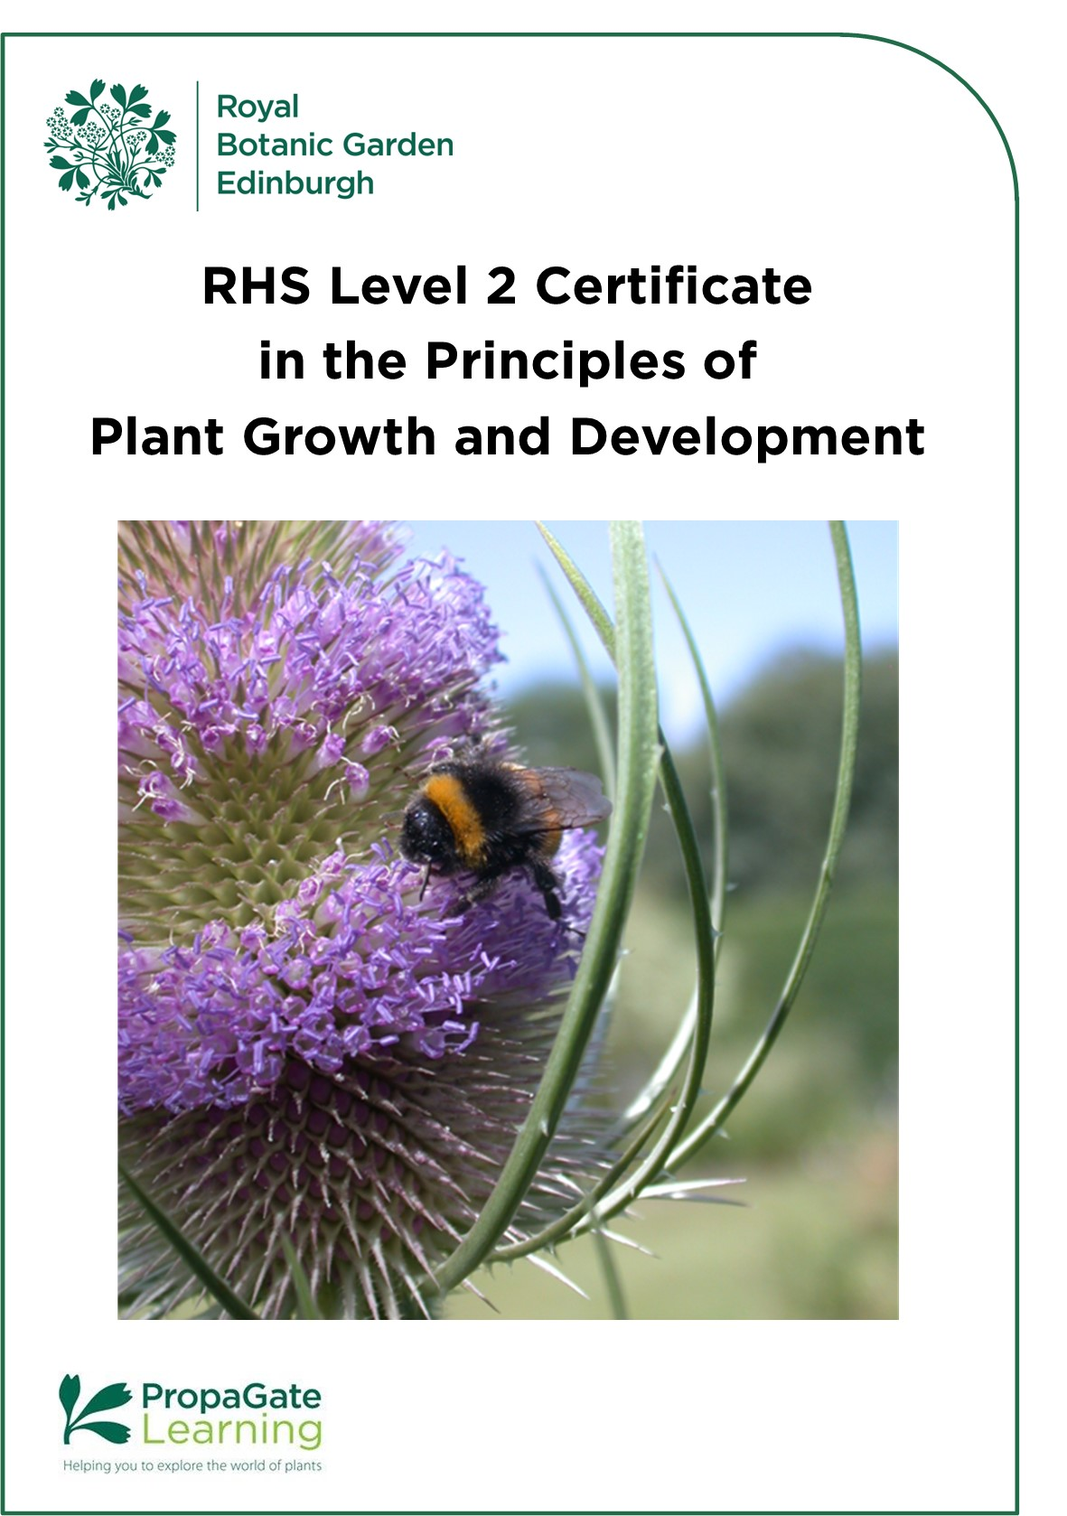
RHS Level 2 Certificate in the Principles of Plant Growth and Development
Contents

Welcome 3
1. Course structure 4
2. Course dates and timetable 5
3. Course content 6
Unit 1 7
Topic 1 - Plant Science 1 7
Topic 2 - Plant Health 7
Topic 3 - Plant Nutrition 7
Topic 4 - Plant Specification 8
Unit 2 8
Topic 1 - Plant Science II 8
Topic 2 - Planting Styles 8
Topic 3 - Horticulture and Society 8
Topic 4 - Biodiversity 9
4. Learning online 9
4.1 How can I prepare for studying online? 10
4.2 What hardware or software will I need? 10
4.3 Support for learners 12
5. Examinations 12
5.1 Exam Format 13
5.2 Registering for Exams 13
5.3 Examination Fees 13
5.4 Examination Dates 14
6. Entry requirements 14
7. Course costs 15
8. How to apply 15
9. Terms and Conditions 16

Welcome
Welcome to the Royal Botanic Garden Edinburgh (RBGE) and this document gives you information on the RHS Level 2 Certificate in the Principles of Plant Growth and Development online course. This course replaces all previous RHS Level 2 Theory Courses.

The RHS Level 2 qualifications are among the most widely regarded entry-level horticulture qualifications. When combined with the RHS Level 2 Certificate in Practical Horticulture* course, learners will be awarded with the RHS Level 2 Certificate in the Principles and Practices of Horticulture, a broad based internationally recognised qualification. This qualification is the ideal starting point or first qualification for those wishing to pursue a career or business in any branch of horticulture or garden design. It is also great for leisure gardeners who would like to expand their knowledge and have it formally assessed.

The award of the RHS Level 2 Certificate in the Principles of Plant Growth and Development is based on written examinations. Currently the online version of these exams is the only option available for this course at RBGE. These are externally set and marked by the RHS. The certificate is accredited by OFQUAL (The Office of Qualifications and Examinations Regulation) in England and Wales.

When you complete the course, you may be able to look at developing your skills to the highest level through RBGE’s HND or BSc in Horticulture with Plantsmanship.

This handbook introduces you to the RHS Level 2 course as it runs at RBGE. We hope it answers all your questions, but please don’t hesitate to contact us via the details below if you have any further queries.

Education Department
rhslevel2@rbge.org.uk

*RBGE does not run the RHS Level 2 Certificate in Practical Horticulture. If you wish to study this part of the course, it must be done with another centre.

1. Course structure

The RHS Level 2 Certificate in the Principles of Plant Growth and Development is a course made up of two Units, each of which has one exam associated with it. Both exams need to be passed to gain the qualification.

This course is a theory Certificate and is designed to combine with the RHS Level 2 Certificate in Practical Horticulture. Both these qualifications together make up the Level 2 Certificate in the Principles and Practices of Horticulture. Please note that RBGE does not deliver the RHS Level 2 Certificate in Practical Horticulture and our own RBGE Certificate in Practical Horticulture does not count towards the RHS award.

Each Unit contains four Topics, and each Topic contains between four and seven Elements. Each of these Topics covers a broad subject area, with the Elements focusing on particular aspects within that area.

We provide you with a complete set of course resources and learning support to help you pass the exams.

This academic year RBGE will be continuing to offer intakes with a fixed start date. We realise this is different from previous years’ offers, however, it is important to recognise that the format of the course has changed. It will be more structured with all students following a timetable and elements being released weekly. The changes in the course qualification have also affected the number of students we can support in each intake.

Due to the differences in syllabus and course structure, a transfer from the old version of the RHS Level 2 Certificate in Principles in Horticulture to the new course RHS Level 2 Certificate in the Principles of Plant Growth and Development will not be possible.

2. Course dates and timetable

The course is run in a timetabled format. One or two elements will be released weekly. We release elements at least 2 weeks in advance to allow to you get ahead if you have holidays organised etc. Time is scheduled in for exam revision and you will also receive additional access for a few months at the end of the course. We will contact you to ensure you are ready to sit the exam before registering you for each exam.

Unlike with our previous courses, learners will not be able to start the course at any time. Learners will be expected to follow the course timetable and to take part in course activities/online discussions at specified points in the timetable. Please ensure that you can commit to the following timetable before applying for the course!

Timetable for the May 2024 intake
This intake of the course is run in a timetabled format, over 14 months. Learners will normally be entered for the Unit 1 exam in October 2024 and Unit 2 exam in February 2025.

The timetable will run from May 2024 until February 2025, although learners will have access to the course until the end of June 2025 (when a further set of exams is available). From February to June 2025 tutor support will be reduced, with the taught element of the course having concluded in February 2025.

Access the course for induction: Thursday 2nd May 2024
Unit 1 commences: Monday 6th May 2024
Unit 1 concludes: Friday 6th September 2024
Unit 2 commences: Monday 9th September 2024
Revision weeks: Monday 30th September - Friday 11th October 2024
Unit 1 Exam: Monday 14th October 2024 - 9.30-11.30
Winter break Monday 23rd December – Sunday 1st January 2025
Unit 2 concludes: Friday 17th January 2025
Revision weeks: Monday 20th January- Friday 31stJanuary 2025
Exam: Early February 2025 (TBC)
Continued access with reduced tutor support is available from end February – June 2025 in the event that you need to re-sit any exams.

How much time do I need to dedicate to this course?
The RHS has estimated that the Guided Learning Hours for this course are 120 hours. This time includes all study time covered by the course materials we provide and tutor support, as well as exam time. The RHS has estimated that the Total Qualification Time required for learners to study this Certificate is 180 hours. This includes everything covered by the Guided Learning Hours, plus the time learners use in self-study. We therefore recommend that learners commit to 5-6 hours per week on average – this includes guided learning as well as self-study.

What if I fall behind?
Please contact us as soon as possible if you fall behind or need extra support and we will help you to get back on track. We have built in revision weeks throughout the course to help you catch up, and we have also added an extra period of study time at the end of the course to allow you to continue your studies if you have not completed the qualification within the timetabled part of the course. This will see you through to a further set of exams which gives flexibility for those requiring extra time to complete or to facilitate re-sits.

3. Course content

This course is designed to give learners the knowledge and understanding of horticulture needed to:
- Begin a career in horticulture.
- Develop a current career in horticulture.
- Develop transferable skills.
- Progress to further learning.

The course Assessment Outcomes break down how the subjects in the course are covered and how each will be assessed. They encompass knowledge of subjects, the application of knowledge and understanding, and the ability to integrate this knowledge and understanding.

The Assessment Outcomes are available to view in the RHS qualification specification. It is very important to read through the qualification specification, as this details what the course will cover and what information and skills you need to learn to pass the exams. It will also help you decide if this course is right for you.

3.1 Topic descriptors
All these topics are studied in the context of health and safety, sustainability, professional best practice and equality and diversity.

Unit 1

Topic 1 - Plant Science 1
This is an introduction to plants, how they are named, described, and identified, their internal and external structures and their functions. This topic provides a foundation to build on for the rest of the course. We look at photosynthesis, respiration, pollination, fertilisation and the movement of water and nutrients within the plant – the processes that allow a plant to survive. Knowledge of these processes allows us to choose or create the environment in which a plant will thrive.

Topic 2 - Plant Health
In this topic we look at the factors that affect plant health, including the weather and climate, the environment in a greenhouse, pests, weeds and diseases. We look at how to prevent plant health problems and what to do when they arise. Plant health is a fast-moving area of horticulture, with the introduction of new pests and diseases, resistance to existing controls, and a growing awareness of the wider impact of existing pest and disease controls.

Topic 3 - Plant Nutrition
In this topic we look at the nutrients that plants need to grow and thrive. The soil provides plants with nutrients, so we begin by focusing on soil types and the maintenance of healthy soil. We learn about the essential nutrients that plants need and how plants use and obtain them. Finally, we learn about the ingredients that can be included in growing media, their benefits and limitations and their environmental impacts.

Topic 4 - Plant Specification
When creating a garden or designed landscape, it is important that the site and the plants are well suited to each other. Though it is possible to make some changes to a site to allow the growing of plants that are less suited to it, it may be better to choose sites and plants that work well together without too much intervention, to reduce the inputs needed. As well as looking at plant selection, planting and care, we look at sourcing and specifying plants in good condition, taking into account biosecurity and the sustainability of how they are grown and transported.

Unit 2

Topic 1 - Plant Science II
Plants have adapted to a wide range of environments. As well as their lifecycle adaptations, they have adaptations to their leaves, stems, roots, flowers, seeds and growth habits that allow them to survive. In this topic we look at the range of plant adaptations, their role in plant survival and their garden merit. We see how plant breeders have enhanced plant adaptations to produce features such as aesthetic value, disease-resistance, and productivity.

Topic 2 - Planting Styles
Gardens and designed landscapes take a huge range of forms. This topic introduces garden styles from the Renaissance to the present day, short-term plantings, as well as edible landscapes. We will look at the concepts of formal and informal planting, the characteristics that define different garden styles, and how to use plants functionally and to create an attractive and cohesive garden. Through the unit we consider the effects on biodiversity and how we can use gardens to tell stories about history and heritage.

Topic 3 - Horticulture and Society
This topic looks at the role of horticulture in wellbeing, the environment, the economy and community. We look at the social and health benefits of gardening and nature in historical as well as modern day contexts. The positive and negative impacts of horticulture on the environment are explored, we look at the effect of climate change, sustainable practices and at how horticulture can have a net positive effect on the environment. We look at key sectors in the UK horticultural industry and consider their economic impact and the additional value they bring in social inclusion, health and wellbeing, biodiversity and reduced crime. Community horticulture projects and their benefits are investigated.

Topic 4 - Biodiversity
In this topic we focus on biodiversity, what it is and why it is important. We look at the impact horticulture can have on biodiversity, both positive and negative, and how we can create habitats to encourage biodiversity. We consider how climate change is affecting plants and existing plantings and how we can make gardens more resilient to a changing climate. We look at how changes to biodiversity are monitored and reported through citizen science projects and species surveys.

4. Learning online

The course is accessed via our online learning platform, PropaGate Learning. Learners will have their own account created on the PropaGate Learning website, and you will log into this site to access your course. PropaGate Learning allows you to study from home, and is a place for learning, for discussing topics and communicating with your tutors and fellow learners. The whole of the course is delivered via asynchronous distance learning. Please note, there are no live face-to-face lessons in the course, although occasionally we may organise some one-off sessions.

The course itself consists of lessons, activities, discussions, quizzes, and additional resources such as links to useful sources of further information.

We aim make all our course lessons and resources as accessible as possible e.g. we include captions on our videos and create resources according to accessibility standards. We also provide PDF versions of lessons for people who need to download resources for viewing offline or who would like to keep a copy.

We will regularly review and update the course to ensure it covers everything required and remains engaging for learners.

PropaGate Learning is available 24/7. Occasionally site maintenance is required, however we will ensure this is communicated in advance.

4.1 How can I prepare for studying online?

With this course being entirely online, learners will need to be competent computer users with a basic understanding of standard computer applications. Familiarity with browsing and navigating websites, engaging in online forums/discussions, reading/editing word processing documents and viewing media will stand you in good stead for learning online.

Our Help and support for online learning pages will help you to identify any digital skills you may need to brush up on.

When you are first given access to PropaGate Learning, please take time to complete the
‘Getting started with online learning’ and ‘Course Overview’ lessons. These will give you an essential introduction to the tutors on your course, finding your way around, advice on learning independently and the best ways to communicate with tutors and other learners.

Online courses require a much more self-motivated learning style than traditional attended classes. You should plan to set aside around 3-4 hours per week to log into the course lessons and carry out activities, plus 1-2 hours of self-directed learning. Participation in online discussions is also a key part of the course. Online learning can be more sociable than you might think! With everyone learning at the same pace it will be easy to have discussions about the topic you are learning.

4.2 What hardware or software will I need?

You will need a desktop or laptop computer. While most of the course will be accessible via a mobile device, we recommend using a laptop or desktop computer. You may find many aspects of the course easier to use on a computer. It will not be possible to sit the exams using mobile phone or tablet. Please keep your device up to date.

You will need an up-to-date internet browser such as Mozilla Firefox, Google Chrome, Microsoft Edge or Safari. You will also need software that will open Word documents and PDFs. Most importantly, you will need a reliable, strong internet connection.
A laptop or desktop computer, internet connection and a webcam will be required for sitting online exams.

System requirements for the online exams

- Latest version of Google Chrome or Microsoft Edge
- A screen resolution of at least 1280x800
- An internet speed of at least 1mbps per candidate
- A webcam of 320x240 VGA minimum resolution
- At least 2GB of free RAM
- At least 250MB of free disk space
- Processor (CPU) – minimum 1.5GHz
- Operating system – Windows 10+, MacOS12+

The RHS use two pieces of software for online exams. Cirrus assessment is the actual platform that hosts the examination, and Proctorio is the invigilation software which we need to use to meet the regulatory requirements to run online examinations in an appropriate manner.

Candidates will be invigilated online using the Proctorio software, you will be asked to install the Proctorio extension on your browser. The system will guide candidates through setting this up. Proctorio offer a helpdesk which is accessed through a live chat, they can help candidates who experience problems setting up the Proctorio software or who experience connection issues during their exam.

Candidates identity will be verified using the online system.

The set-up process will check that you have the minimum system requirements to run the software and you haven’t anything running in the background to interfere with the exam test.

4.3 Support for learners

As part of enrolment, all learners have access to peer-to-peer communication, communication with tutors and technical support.

Learners will be randomly allocated to a study group of fifteen learners upon enrolment. This study group will be private, with only fellow study group members, the course tutors, and administrative and learning technology staff able to access it. This study group will allow you to collaborate and discuss subjects with a small group of fellow learners, which we encourage you to do, to make the most of the course.

There are course forums available that all learners on the course have access to. We encourage everyone to make the most of these forums. They provide a way for you to talk to one another and to tutors, and to ask both tutors and each other questions. They are also used by us to share information about exam registration and other course-related news. You will be able to contact tutors by email directly if you need to.

Our PropaGate Learning team is always available if you ever feel you are stuck with a course-related technical problem. They can be contacted via the forums or by emailing propagate@rbge.org.uk

5. Examinations

This qualification will be entirely assessed by a written examination for each unit. Examination 1 will cover Unit 1 (Topics 1 - 4) and examination 2 will cover Unit 2 (Topics 1 – 4). In each examination, all assessment outcomes specified in the unit will be covered.

If RHS examinations are not passed, then you will not be awarded an RHS Qualification and will not receive a formal certificate. In addition, you will not be able to state achievement to employers if you are looking to enter the industry as a career. Course providers are not permitted to issue a certificate of attendance for RHS courses.

The exam fees are included in the course fee and payable on acceptance of place. If you later decide not to sit exams, we will not be able to refund the exam fees.

5.1 Exam Format

With work underway as part of the Edinburgh Biomes Project at the Royal Botanic Garden Edinburgh (RBGE), it will not be possible for RBGE to offer in person exams for this course. The noise and disruption from the building works will be significant and it would not be an appropriate setting for exams to take place. Therefore, any learners looking to study with RBGE must be able to sit online exams.

The RHS use two pieces of software for online exams. Cirrus assessment is the actual platform that hosts the examination, and Proctorio is the invigilation software which we need to use to meet the regulatory requirements to run online examinations in an appropriate manner.

Candidates will be invigilated online using the Proctorio software, you will be asked to install the Proctorio extension on your browser. Candidates identity will be verified using the online system.

The set-up process will check that you have the minimum system requirements to run the software and you haven’t anything running in the background to interfere with the exam test.

5.2 Registering for Exams

RBGE will contact you in advance of the registration deadline to ensure you are ready to sit the exams according to the course timetable.

5.3 Examination Fees

The exam registration and online registration fees for one sitting of Unit 1 and Unit 2 exams are included in the course fees. If you need to re-sit any units, the RHS has additional fees: re-sit fee for theory Unit 1 or Unit 2 of £75 plus the online registration fee of £20 per re-sit, these will be payable upon registration.

5.4 Examination Dates

Learners should be aiming to sit the exams for Unit 1 and Unit 2 as detailed in the course timetable on the website, however there is flexibility on when you can sit exams built into the qualification.

6. Entry requirements

The RHS Level 2 Certificate does not require any existing qualifications or experience. All you need is an interest in the subject and a commitment to set aside time each week and keep to the pace of the course. Overall, we are looking for keen, enthusiastic ‘plants people’ of all ages, who would value the opportunity to study at RBGE and will contribute to the programme.

We do advise that you should have some basic confidence using websites, as the course makes use of PropaGate learning, our online learning environment. You must be self-motivated, have access to the internet and have an e-mail account.

As we are unable to offer in person exams, students must be able to complete the exams for this qualification online. It is no longer possible for students to register as an external candidate in order to sit exams at another centre.

7. Course costs
The fee for the full course is £960 (online support and access for the timetabled part of the course, plus access and limited support through to the next set of exams. This is normally around 14 – 18 months depending when the course starts). This is payable on acceptance to the course. Instalments for the payment of the fees are not available for online courses.

Course fees include access to PropaGate Learning course materials and tutor support as well as the following RHS Fees:
- Exam and Certification Fees for Unit 1 and Unit 2 (£150, £75 per exam)
- Online Exam Administration Fee (£40, £20 per exam)
- Learner Registration Fee (£20)

The RHS fees are set by the RHS and paid to them on your behalf at the start of your course.

8. How to apply
To apply please complete the course application form: Online Application Form.*

Applications for the course will open at 10.00am on Thursday 25th January 2024 and will close at 5.00pm on Sunday 25th February 2024.
*Please note the electronic form will not be available until 10.00am on Thursday 25th January 2024.

We have a cap on learner numbers. Applications are processed on a first come first served basis, so we recommend registering as soon as possible to give yourself the best chance of being successful. In the event the course fills up before the application deadline, applications will close early.

Successful candidates will be notified within 2 weeks of the applications closing.

Access to PropaGate Learning and the course induction materials commences the week before the course starts. Course joining instructions will be sent by email after we have enrolled you on the course.

Please contact us by email at rhslevel2@rbge.org.uk if you have any questions.

9. Terms and Conditions

- RBGE reserves the right to cancel this course
- RBGE cannot be liable for additional costs incurred in the event of cancellation
- If the course does not go ahead, any money paid to the RBGE would be refunded in full
- Fees will not be refundable should you not complete or pass the course.

Course Completion / Extensions
This course is timetabled with the aim of students completing their studies in February 2025. It will not be possible to extend your access to this course, however we understand that sometimes it’s easy to fall behind when life begins to take over. In order to help we have built in access through to the June 2025 exams just in case.

In certain situations, you may be able to apply to defer your studies to a future intake to allow you to resume your studies when you are able. This will depend on your circumstances and may be subject to RBGE and RHS fees.

What if I change my mind? (Refunds)
You will receive a refund minus a £50 administration fee if you withdraw from the course prior to it starting or within 14 days of it beginning.

If you wish to exercise your right to cancel, you must inform us of your decision within the 14-day cancellation period. Cancellation by email is effective from the date on which you send us your message.

Fees will not be refundable should you not complete or pass the course.

Privacy Notice
RBGE will process your personal data for the administration of your course, to create your account on PropaGate Learning and to take payment (where relevant). RBGE will also process your personal data to inform you of any updates to the course, the admissions procedure, course dates, as well as any special offers. For more information see our privacy notice.

